Remote Learning Policy

Rush Green Primary School

Date created: October 2020

Aim
To provide clear guidance to all stakeholders on our approach to remote learning, outlining our general practice and adapted procedures for various scenarios, including pupils in self-isolation and a partial or full closure of the school during the Covid-19 pandemic.

We must appreciate that the ever changing impact of the Covid-19 pandemic on education could result in certain aspects of this policy becoming outdated, which is why it will be reviewed at least each term until the situation stabilises, it is vital that we apply a degree of flexibility to teaching and learning in school and remotely.

Whilst we will do our best to support the progress of all pupils at Rush Green Primary School during these times, our main priorities will always be the safety and wellbeing of all members of our community. There is no single, defined distance learning practice that is likely to meet the expectations of all stakeholders but we will remain committed to success for all of our students and support them with a range of approaches that we feel best meet their needs.

Please note, that there is no requirement for the school to provide home/remote learning for those children that are simply absent or whose parents are claiming that their child/ren is/are self-isolating when there is no reason for them to do so.
.

 | *Please note: In all cases of self-isolation, children will be tracked on by the School Pastoral Team to ensure that children return at the end date of their isolation period.*
Tier 1 | Individual pupil is self-isolating  In this case, the class teacher will have a full-time commitment to the remaining children in the class and will be unable to deliver lessons to individual pupils at the same time as working with the other children. Filming/streaming the Class Teacher ‘live’ teaching presents too many safeguarding issues and so we have made the decision not to provide this.  The teacher will plan and assess for the individual child and will make sure that work is set, which is in line with the objectives being taught in school, so that children do not miss out on learning.  Work will be set on the school website, using a timetable for the 2 week isolation period with links to White Rose maths and The Oak Academy sites. The objectives will be in line with that taught in class and the teaching point will be covered by short videos.  Remote working will be arranged within the first 24hours of self-isolation.  Work completed at home is submitted and marked online via Google Classroom or in a few cases (where online learning has failed) hard copies are returned to school.  KEY RESPONSIBILITIES:  - A letter, explaining the process for accessing work, will be sent to the family within 1 day of the school receiving self-isolation notification. This will be sent out via Parentmail by the School Office, who will also notify the Pastoral Team, Phase Deputy, Year group Leader and Class Teacher  - The Pastoral Team will be responsible for making sure that isolation periods are recorded and tracked  - Parents must contact the school if they are having trouble accessing work  - The Pastoral Team will liaise with the Class Teacher or Year Group Leader (if Class Teacher is ill/self-isolating) to arrange for a timetable of work to be organised and placed on the website with associated links to video  - Where IT is unavailable, printed work packs are to be made by the Class Teacher/Year Group Leader and collected or sent to the child’s home. Gathering these documents and making sure these are collected or sent, remains the responsibility of the Pastoral Team  - The Pastoral Team will call children of vulnerable families once per week to ensure that the family are well  - The Class Teacher or Year Group Leader will call the family at least twice per week, to ensure that the child is able to access the work and understands what it is they have to do (any conversations will be noted)  - Phase Deputies will be responsible for ensuring that work is sent home and returned for marking via online or paper platforms. This will be marked by the Class Teacher or Year Group Leader (in the Class Teacher’s absence)  - Phase Deputies will ask for feedback from families at the end of the self-isolation period. This will be used for school improvement purposes.
Tier 2 | Small group of pupils within a class or across a bubble are self-isolating  Similar as for individuals, the class teacher will have a full time commitment to the remaining children in the class and will be unable to deliver lessons to a group of pupils at the same time as working with the rest of the class. Filming/streaming the Class Teacher ‘live’ teaching presents too many safeguarding issues and so we have made the decision not to provide this.  The teacher will plan and assess for the group of children and will make sure that work is set, which is in line with the objectives being taught in school, so that the children do not miss out on learning.  Work will be set on the school website, using a timetable for the 2 week isolation period with links to White Rose maths and The Oak Academy sites. The objectives will be in line with that taught in class and the teaching point will be covered by short videos.  Remote working will be arranged within the first 24hours of self-isolation.  Work completed at home is marked online via Google Classroom or in a few cases (where online learning has failed) hard copies are returned to school.  KEY RESPONSIBILITIES:  - A letter, explaining the process for accessing work, will be sent to the family within 1 day of the school receiving self-isolation notification. This will be sent out via Parentmail by the School Office, who will also notify the Pastoral Team, Phase Deputy, Year group Leader and Class Teacher  - The Pastoral Team will be responsible for making sure that isolation periods are recorded and tracked  - The Pastoral Team will liaise with the Class Teacher or Year Group Leader (if Class Teacher is ill/self-isolating) to arrange for a timetable of work to be organised and placed on the website with associated links to video  - Where required, resources such as some maths equipment, will be made available to support home learning  - Parents must contact the school if they are having trouble accessing work  - Where IT is unavailable, printed work packs are to be made by the Class Teacher/Year Group Leader and collected or sent to the child’s home. Gathering these documents and making sure these and any additional resources (such as maths equipment) are collected or sent, remains the responsibility of the Pastoral Team  - The Pastoral Team will call families of vulnerable children once per week to ensure that families are well – this is in addition to the class teacher calls  - The Class Teacher or Year Group Leader will call the families at least once per week, to ensure that children are able to access the work and understand what it is they have to do (any conversations will be noted)  - Phase Deputies will be responsible for ensuring that work is sent home and returned for marking via online or paper platforms. This will be marked by the Class Teacher or Year Group Leader (in the Class Teacher’s absence)  - Phase Deputies will ask for feedback from families at the end of the self-isolation period. This will be used for school improvement purposes.
Tier 3 | Class of pupils are self-isolating  In this case, unless the Class Teacher is ill, remote education will be provided for all pupils in the class. This will be through ‘live’ teaching sessions in maths and English held in small groups of 10 at specific times of the day (will be arranged by Class Teacher). Other subjects will be aligned with the year group planning objectives but will be delivered via Oak Academy video lessons. The links to these lessons and the timetable for the week, will be put onto the school website within 24 hours of notification of self-isolation. This is so that the school’s limited resources can be deployed to the relevant staff and so that resources can be set up according to need.  Work completed at home is marked online via Google Classroom or in a few cases (where online learning has failed) hard copies are returned to school.  If the class teacher is ill, the year group leader/phase leader will be responsible for making sure that Oak Academy materials are made available for all pupils.  KEY RESPONSIBILITIES:  - A letter, explaining the process for accessing work, will be sent to all families affected within 1 day of the school receiving self-isolation notification. This will be sent out via Parentmail by the School Office, who will also notify the Pastoral Team, Phase Deputy, Year group Leader and Class Teacher that this has been done  - The Pastoral Team will be responsible for making sure that isolation periods are recorded and tracked  - The Pastoral Team will liaise with the Class Teacher or Year Group Leader (if Class Teacher is ill/self-isolating) to arrange for a timetable of work to be organised and placed on the website with associated links to video  - Where required, resources such as some maths equipment, will be made available to support home learning  - Parents must contact the school if they are having trouble accessing work  - Where IT is unavailable, printed work packs are to be made by the Class Teacher/Year Group Leader and collected or sent to the child’s home. Gathering these documents and making sure these and any additional resources (such as maths equipment) are collected or sent, remains the responsibility of the Pastoral Team  - The Pastoral Team will call families of vulnerable children once per week to ensure that families are well – this is in addition to the class teacher calls  - The Class Teacher or Year Group Leader will call the families at once per week, to ensure that children are able to access the work and understand what it is they have to do (any conversations will be noted)  - Phase Deputies will be responsible for ensuring that work is sent home and returned for marking via online or paper platforms. This will be marked by the Class Teacher or Year Group Leader (in the Class Teacher’s absence)  - Phase Deputies will ask for feedback from families at the end of the self-isolation period. This will be used for school improvement purposes.
Tier 4 | Year group or bubble (twinned year groups) are self-isolating/partial school closure  Similar to where a class is self-isolating (see Tier 3), we will endeavour to deliver remote teaching through ‘live’ teaching sessions in maths and English held in small groups of 10 at specific times of the day (will be arranged by Class Teacher). Other subjects will be aligned with the year group planning objectives but will be delivered via Oak Academy video lessons. The links to these lessons and the timetable for the week, will be put onto the school website within 1 day of notification to parents. This is so that the school’s limited resources can be deployed to the relevant staff and so that resources can be set up according to need.  Work completed at home is marked online via Google Classroom or in a few cases (where online learning has failed) hard copies are returned to school.  If the class teacher is ill, the year group leader/phase leader will be responsible for making sure that Oak Academy materials are made available for all pupils.  - A letter, explaining the process for accessing work, will be sent to all families affected within 1 day of the school receiving self-isolation notification. This will be sent out via Parentmail by the School Office, who will also notify the Pastoral Team, Phase Deputy, Year group Leader and Class Teacher that this has been done  - The Pastoral Team will be responsible for making sure that isolation periods are recorded and tracked  - The Pastoral Team will liaise with the Class Teacher or Year Group Leader (if Class Teacher is ill/self-isolating) to arrange for a timetable of work to be organised and placed on the website with associated links to video  - Where required, resources such as some maths equipment, will be made available to support home learning  - Parents must contact the school if they are having trouble accessing work  - Where IT is unavailable, printed work packs are to be made by the Class Teacher/Year Group Leader and collected or sent to the child’s home. Gathering these documents and making sure these and any additional resources (such as maths equipment) are collected or sent, remains the responsibility of the Pastoral Team  - The Pastoral Team will call families of vulnerable children once per week to ensure that families are well – this is in addition to the class teacher calls  - The Class Teacher or Year Group Leader will call the families at once per week, to ensure that children are able to access the work and understand what it is they have to do (any conversations will be noted)  - Phase Deputies will be responsible for ensuring that work is sent home and returned for marking via online or paper platforms. This will be marked by the Class Teacher or Year Group Leader (in the Class Teacher’s absence)  - Phase Deputies will ask for feedback from families at the end of the self-isolation period. This will be used for school improvement purposes.
Tier 5 | Full school closure – no pupils or staff In school  *Unless required to maintain school for key workers and vulnerable pupils  We will endeavour to deliver remote teaching through ‘live’ teaching sessions in maths and English held in small groups of 10 at specific times of the day (will be arranged by Class Teacher). Other subjects will be aligned with the year group planning objectives but will be delivered via Oak Academy video lessons. The links to these lessons and the timetable for the week, will be put onto the school website within 1 day of notification to parents. This is so that the school’s limited resources can be deployed to the relevant staff and so that resources can be set up according to need.  Work completed at home is marked online via Google Classroom or in a few cases (where online learning has failed) hard copies are returned to school.  If the class teacher is ill, the year group leader/phase leader will be responsible for making sure that Oak Academy materials are made available for all pupils.  Where pupils have limited access to IT hardware or wifi, the school will support families by offering school laptops on a loan basis (deposit to be left).  Where this offer is not taken up, hard copies of work can be sent home and/or provided online work packs provided that families can access without the need to come onto the school site.  Printed work packs (depending on guidance given by the Government at the time) can be returned for marking at the end of the lockdown period.  *If required to keep children of key workers in school this will need to be done according to guidelines, with consideration to the School’s own capacity and own risk assessments. An example could be where specific year groups have to be prioritised.

Online Lessons
Lessons can be delivered online via a range of methods or a combination of them. Examples include:
- Project work using resources shared by the teacher and submitted by the pupils, usually on Google Classroom including teacher feedback
- Tasks or assessments on subject approved, external, online platforms such White Rose or Oak National Academy. The teacher can monitor for progress checks and provide support and feedback.
- Pre-recorded videos prepared by a teacher to deliver lesson content, instructions or feedback
- Live sessions that may include a video or audio stream and the opportunity to communicate with a teacher at a scheduled time.

Live Sessions
Our preferred video conferencing suite are Google Hangouts and Google Meet (Google Classroom) as they provide protection and privacy for the pupil and teacher in the online environment using the school’s google accounts for extra control and security. Therefore, this is the only platform that should be used with our pupils.

There are serious safeguarding concerns that need to be considered for both staff and pupils’ safety. We need to be aware of possible risks and we need to ensure that all users are taking precautions to manage their own privacy and the privacy of others.
- Staff and pupils must continue to follow the school’s code of conduct during any virtual lessons or video recordings.
- Staff and pupils must wear suitable clothing, as should anyone else in the household.
- Language must be professional and appropriate, including any family members in the background
- Any computers used should be in appropriate areas, for example, not in bedrooms; and where possible be against a neutral background.
- Only staff are permitted to set up a video meeting or lesson and this must be made through the school account.
- Only students who are invited to a video meeting or lesson may attend that session and they are not allowed to invite others in.
- There should never be a 1:1 video meeting between a staff member and pupil UNLESS A PARENT OR OTHER ADULT IS AVAILABLE. If only one student attends a live lesson, it should no longer proceed (unless and adult is present with the child in the home)
- Where possible, any live sessions should be recorded by the member of staff only They should be stored securely on the school account and not accessed by anyone else. This can be done using free Screen Cast software https://easyscreen.me/?adw=search&subid=screen%20video%20recorder&source=3&ad=sitelink1_&sitelink_1&lead=1&gclid=EAIaIQobChMI1em9qbfA7AIViKztCh0E3gA2EAAYASABEgKVRfD_BwE

- A log should be kept by staff of the session’s date, time, topic, and attendees. Non-attendees should be reported to the Pastoral Team for follow up
- Live classes should be kept to a reasonable length of time for the best interests of the teacher, pupils and family members and they are not expected to last a whole period
- If there are technical problems during the lesson and teachers are working in school or working from home, then in the first instance they should let the School Office know and then the IT Team. This is so that the Office Staff can field calls relating to this and explain what is happening whilst the situation is resolved
- In the worst case, live sessions may have to be cancelled and work provided via other means outlined previously
- Staff mark their own class work through Google classrooms
- In line with the school’s safeguarding policy, the DSL or a member of the leadership team should be contacted as soon as possible, should something of concern be said by a pupil or the teacher witnesses a concern.
- Pupils who are not behaving in an appropriate manner which is at the detriment of other pupils or the lesson, will be locked out of the session and will be reported to the Phase Leader of the Phase Deputy, who will take action.
- Monitoring of pupil engagement will be the teacher’s responsibility in the first instance. A register of the action will be kept. Any pupils continuing not to engage in lessons will be reported to the YGL. Continual non-engagement will result in the matter being further escalated to SLT or DSL.

Non-digital Learners
As a school that strongly believes in the positive impact that effective use of technology can have on the development of a student and their future, we will in the first instance provide as much support as we can to any students or families with barriers to access. Where possible, we will loan equipment or devices to increase access.

Non-digital learners will receive printed work delivered by the school’s Parent Support Adviser, another nominated member of staff or be sent by post. As we are trying to reduce the number of visitors on site, work cannot be collected or dropped off by pupils, parents or carers at this moment in time. .

Staff Roles and Responsibilities
All staff
- should be available to work and leaders will be mindful of their workloads and differing situations at home. Where staff are unable to access hardware/connectivity at home they will be able to use school based facilities
Phase Leaders (in consultation with Deputy Heads)
- plan who can teach when on the agreed school full closure timetable,
- all team members will be included in some capacity by contributing to either live sessions, pre-recorded videos or creating other content. Where staff are unable to access hardware/connectivity at home they will be able to use school based facilities
- monitor the access to content and overall progress
Teaching staff
- share resources on Google Classroom which may include links to other subject specific platforms
- follow live session protocols shared earlier in this policy and in the E-Safety policy.
- monitor pupil engagement with tasks and track progress
- provide regular feedback to pupils
- Where staff are unable to access hardware/connectivity at home they will be able to use school based facilities
SENDCO
- make wellbeing calls to SEND pupils and update staff to make them aware of any issues or extra differentiation and support required.
Pastoral staff
- Heads of Years to review central engagement logs weekly and contact students who are not engaging and update the log with feedback
- DSL / PSA will continue to engage with hard-to-reach families, make well-being class and update logs as appropriate

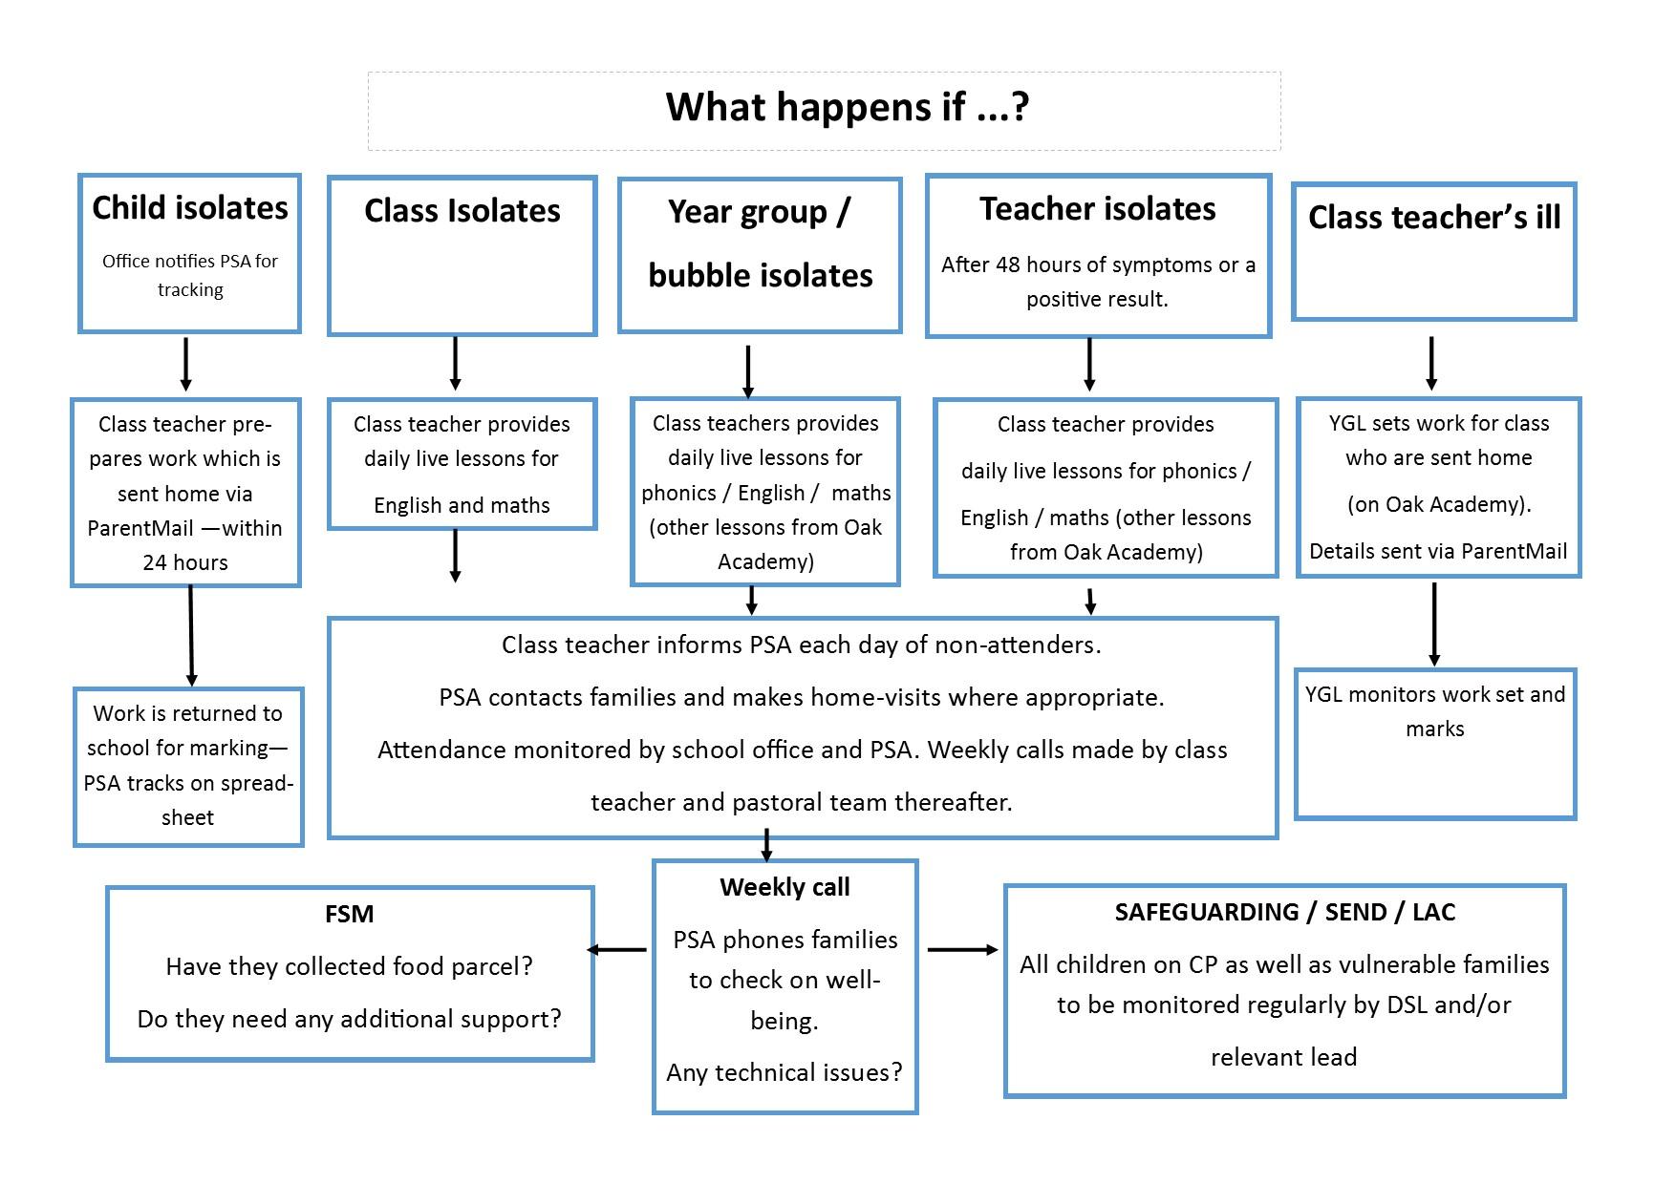

Review

This policy will be reviewed annually and amended as necessary.

Date of this policy: September 2020

Date of next review: January 2021

Reviewed by:

Signature of Headteacher:…………………………………..……Date:…………………..

Signature of Chair of Governors:…………………………………Date:…………………..

