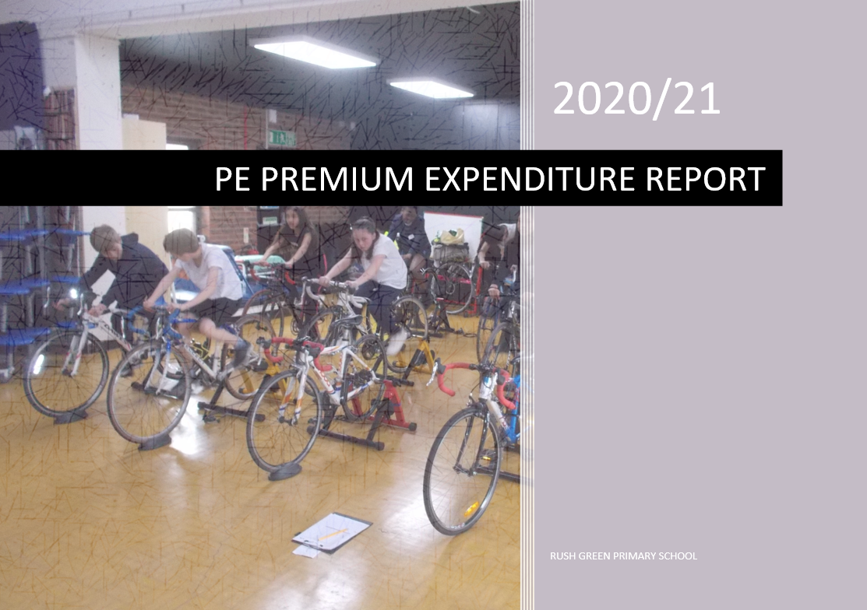

Review and Reflection of 2019/20

Develop or add to the PE activities that we already offer:
• Build capacity and capability within the school to ensure that improvements made now will benefit pupils joining the school in future years
and promote the DfE’s 5 Key Areas:
• The engagement of all pupils in regular physical activity – The Chief Medical Officer guidelines recommend that children aged 5-16 engage in at least 60 minutes of physical activity a day, of which 30 minutes should be in school (includes playtime and journeys to and from school)
• The profile of PE and sport being raised across the school as a tool for whole school improvement;
• Increased confidence, knowledge and skills of all staff in teaching PE and sport;
• Broader experience of a range of sports and activities offered to all pupils;
• Increased participation in competitive sport.

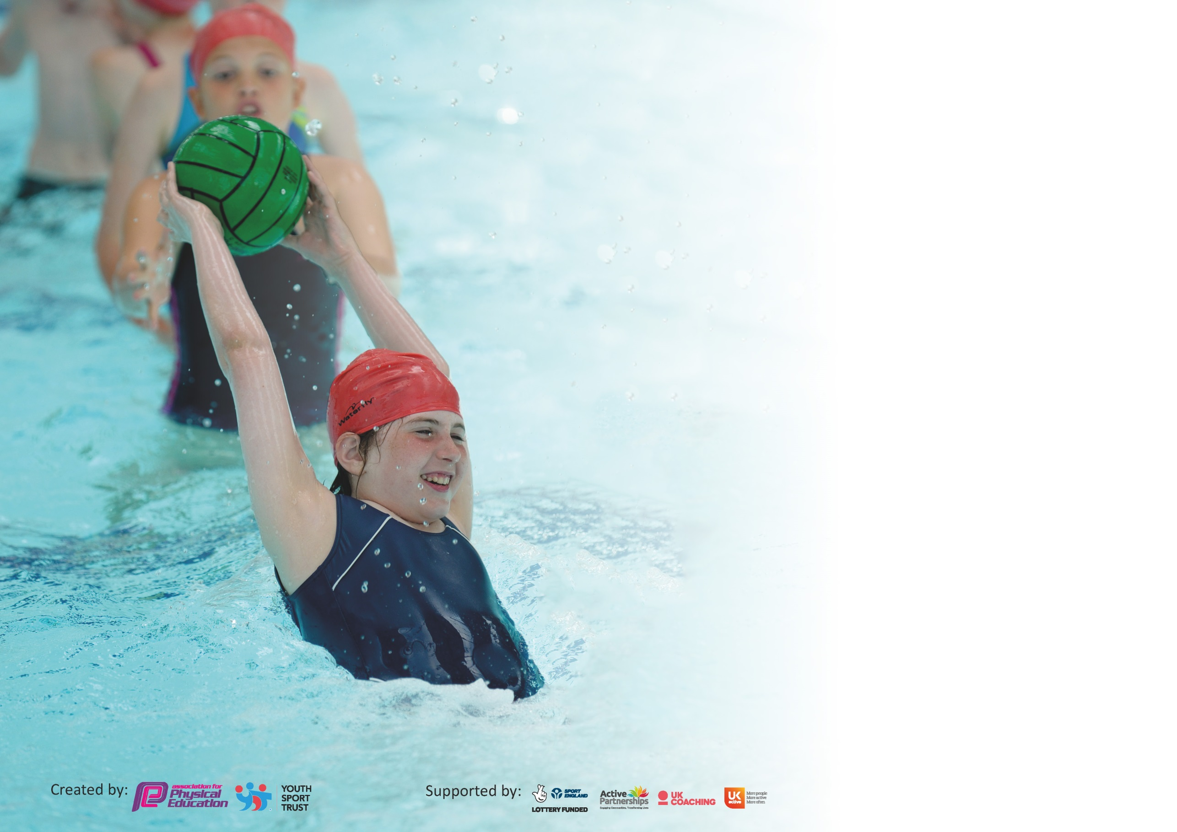

It is important that your grant is used effectively and based on school need. The Education Inspection Framework (Ofsted 2019 p64) makes clear there will be a focus on ‘whether leaders and those responsible for governors all understand their respective roles and perform these in a way that enhances the effectiveness of the school’.

Under the Quality of Education criteria (p41) inspectors consider the extent to which schools can articulate their curriculum (INTENT), construct their curriculum (IMPLEMENTATION) and demonstrate the outcomes which result (IMPACT).

To assist schools with common transferable language this template has been developed to utilise the same three headings which should make your plans easily transferable between working documents.

Schools must use the funding to make additional and sustainable improvements to the quality of Physical Education, School Sport and Physical Activity (PESSPA) they offer. This means that you should
use the Primary PE and Sport Premium to:

- Develop or add to the PESSPA activities that your school already offer
- Build capacity and capability within the school to ensure that improvements made now will benefit pupils joining the school in future years

Please visit gov.uk for the revised DfE guidance including the 5 key indicators across which schools should demonstrate an improvement. This document will help you to review your provision and to report your spend. DfE encourages schools to use this template as an effective way of meeting the reporting requirements of the Primary PE and Sport Premium.

We recommend you start by reflecting on the impact of current provision and reviewing the previous spend.

Schools are required to publish details of how they spend this funding as well as on the impact it has on pupils’ PE and sport participation and attainment by the end of the summer term or by 31st July 2020 at the latest.

We recommend regularly updating the table and publishing it on your website throughout the year. This evidences your ongoing self-evaluation of how you are using the funding to secure maximum, sustainable impact. Final copy must be posted on your website by the end of the academic year and no later than the 31st July 2020. To see an example of how to complete the table please click HE
RE.

Support for review and reflection - considering the 5 key indicators from DfE, what development needs are a priority for your setting and your pupils now and why? Use the space below to reflect on previous spend and key achievements and areas for development.

Key achievements to date until July 2019: | Areas for further improvement and baseline evidence of need:
- Develop or add to the PESSPA activities that your school already offer  - Build capacity and capability within the school to ensure that improvements made now will benefit pupils joining the school in future years  - Broadened extra-curricular clubs such as Kickboxing and Yoga to target specific groups of children (including least active, low self-esteem, behavioural groups)  - Increased capacity and attendance of Secret Sports Club (least active)  - Initiated girls football club and attended first competition  - Participated in boys football competitions for the first time outside of school  - Achieved gold medal in Borough Sitting Volleyball competition (SEND)  - Finished 9th out of 33 London Boroughs in the Virtual London Youth Games  - Installed permanent basketball posts in both KS1 and KS2 playground as a result of pupil voice  - Positive feedback from staff on tennis inset – as a result, increased uptake and improved quality of teaching  - Tracked % of children in extra- curricular clubs and %SEN, %PPM, % least active  - Participation in virtual competitions via YST for chn and families.  (Covid-19)  - Reduced levels of Obesity in both Reception and Year 6.  Reception levels: RG LBD National  2016/17 26.22 25.44 22.57  2018/19 23.33 24.84 22.59  Year 6 Levels:  2016/17 46.23 44.29 34.25  2018/19 33.01 44.85 34.29  - We held a second consecutive year of the School Games Gold Award  - 74 % children participated in extra-curricular sport clubs  - 45% children in inter competitions for the Borough  - 100% children participated in intra competitions in school in 2018/2019 | - Develop or add to the PESSPA activities that your school already offer  - Build capacity and capability within the school to ensure that improvements made now will benefit pupils joining the school in future years  - Continue to review and maintain the quality and variety of our extra -curricular provision (initiate cycling club and lunchtime clubs – pupil voice) as well as broadening the curriculum on offer (e.g. initiate orienteering activities and installing better provisions for existing sports – netball posts, gymnastics mats)  - Improve links with local competitive sporting clubs – invitation / assemblies / local sporting ‘heroes’  - Implement a Healthy Lifestyle PE Unit so children understand how they can access fitness outside of school – links to clubs and online resources (mental well-being – COVID)  - Continue identify keys groups, such as: G&T students and least active through initial baseline assessment and half termly runs  - Target the participation of disadvantaged and least active children in sport  - To continue to encourage active play during morning playtimes and lunchtimes by implementing trained play leaders, plus specific support training (video/inset) for staff and midday assistants  - Implement new PE assessments for each strand (in line with PE Spirals)  - Continue CPD/ staff training to improve PE teaching (including differentiation for SEND) and pupil outcomes  - Provide swim catch up for children unable to swim a length by the start of Year 6.

Meeting national curriculum requirements for swimming and water safety.
What percentage of your current Year 6 cohort swim competently, confidently and proficiently over a distance of at least 25 metres?  N.B. Even though your pupils may swim in another year please report on their attainment on leaving  primary school at the end of the summer term 2020. | %
What percentage of your current Year 6 cohort use a range of strokes effectively [for example, front crawl, backstroke and breaststroke]? | %
What percentage of your current Year 6 cohort perform safe self-rescue in different water-based situations? | %
Schools can choose to use the Primary PE and Sport Premium to provide additional provision for swimming but this must be for activity over and above the national curriculum requirements. Have you used it in this way? | Yes/No

Academic Year: 2020/21 | Total fund allocated: £25,000 | Date Updated:
Key indicator 1: The engagement of all pupils in regular physical activity – Chief Medical Officer guidelines recommend that primary school pupils undertake at least 30 minutes of physical activity a day in school |  |  |  | Percentage of total allocation:
 |  |  |  | %
Intent | Implementation |  | Impact
School focus with clarity on intended impact on pupils: | Make sure your actions to achieve are linked to your intentions: | Funding allocated: | Evidence of impact: what do pupils now know and what can they now do? What has changed?: | Sustainability and suggested next steps:
Headline Intended Impact on Pupils – All pupils will be active on average 60 minutes a day, 7 days a week.  To ensure all children can swim, particularly disadvantaged children.  To engage and ensure that all pupils are participating in a minimum of 30 minutes of physical activity every day.  COVID-19  Purchase additional resources so that all children have access to high quality resources when being taught.  COVID-19  Playtime and lunchtime resources are provided to support children’s active play.  Ensure all children participate in P.E.  To decrease obesity levels in Y6 pupils through physical activity  COVID-19 | Transport for Year 5 children to participate in swimming lessons every week.  Track number of pupils able to swim 25 metres.  Through staff inset and specific training (video and guidance set out in Primary PE in Sport Premium Webinar), accompanied by allocated year group equipment and resources. Allocate 30 minutes of daily curriculum time.  Cold Timetable  Links to yoga/mental well-being  Shared resources and information with Borough  PE INSET – mini golf  The correct resources are being used to support teaching and enhance skills.  Mats, benches, netball posts, balls (footballs, basketballs, netballs, dodgeballs), hoops, bean bags, vortexes, hockey equipment.  swingball  Active play is encouraged to help meet the demands of the CMO  MDAs and Sports Leaders are trained to support. PE team have provided support to middays for active lunch times.  Spare classroom kits reserved for pupils without PE uniform to enable them to take part.  Due to obesity levels being the highest in Barking and Dagenham and the highest in the country, the Y6 children will receive 2 hours 20 minutes of high-quality PE per week.  Continue to provide families and chn with support and ongoing access to virtual competitions though the YST. | £7350.00  £210.00 per week x 35 coach transport  £3000  £500.00  £150.00 | - Improved fitness (half termly runs)  - Improved physical competence (competition results)  - obesity rates – no data due to Summer 2020 Covid-19  - Improved confidence and mental-well being (pupil voice)  - Improved capacity for learning (quantity and depth – embedding mastery skills)  - Aspect of enjoyment (engagement)  Based on historical data  Reduced levels of Obesity in both Reception and Year 6.  Reception levels: RG LBD National  2016/17 26.22 25.44 22.57  2018/19 23.33 24.84 22.59  Year 6 Levels:  2016/17 46.23 44.29 34.25  2018/19 33.01 44.85 34.29  - obesity rates – no current data due to Summer 2020 Covid-19 | Continue to liaise with families and pupils to ascertain the clubs and activities that are pupils want to be attending and uptake of new initiatives e.g. Street Tag, Change4Life  Continue to provide high quality extra-curricular clubs that are parent paid e.g. after school clubs  PP funding and free places given where applicable to support families who need extra - help accessing these clubs e.g. yoga, kickboxing and cycling  Lunchtime activity facilitated by sports leaders and MDS so the provision is in house.  Prediction – due to cultural capital, it is looking imminent that obesity levels will stay the same (if not show a slight increase) – however, we have supported families with healthy and active life choices, as best as possible through continuous home communication, throughout the Lockdown period. This is also a main focus in school time, e.g. change in PE timetables – 30 minutes of activity each day.
Key indicator 2: The profile of PESSPA being raised across the school as a tool for whole school improvement |  |  |  | Percentage of total allocation:
 |  |  |  | %
Intent | Implementation |  | Impact
School focus with clarity on intended impact on pupils: | Actions to achieve: | Funding allocated: | Evidence and impact: | Sustainability and suggested next steps:
Headline Intended Impact on Pupils – All pupils’ personal development will be celebrated.  Supporting the target for all pupils to be active on average 60 minutes a day, 7 days a week.  Annual subscription to LA Sports partnership.  Pupils and staff have access to specialist teaching staff and borough led competitions.  Develop knowledge and pedagogy of the PE curriculum for all staff  Develop attainment levels and success of whole school PE  Children are motivated to improve their skills within different sports and attend club sessions.  Maintain links with West Ham  Maintain links with StreetTag  Raising the profile of PE, Physical Activity, School Sport and Mental Well-being.  Sport for All | Receive Gold School Games Award for the second year.  PE team attend AFPE training.  PE team to attend regular partnership meetings to enhance PE in school and make links to help improve outcomes/results in competitions.  PE Lead to attend Level 5 Certificate in Primary School Physical Education Course  Regular training of staff in Complete PE for supporting both lesson resources and as an assessment tool  Maintain club links with local sporting providers such as Muskateers Fencing, Premier, Cousins and Total Sportz  Specific PE skills INSET for YR 6 staff/CPD  Whole school display of PE curriculum ( as a working wall – Spirals) plus achievements  Achievements – communication and regular updates via Twitter and school website  Visiting other schools, direct contact and advice from Borough, collating resources/best practise.  Staff INSET  To provide all chn with equal opportunities – Club / Virtual competition | £100.00  £567.70  £1500  £500 (renewal fee) | We predict 90% of chn will be working at Expected level. | SLT has seen the benefits of the raised profile and is committed to funding these areas  100% of Pupils feel proud to be involved in assembles/photos on notice boards etc. which is impacting on confidence and self esteem – see pupil voice

Key indicator 3: Increased confidence, knowledge and skills of all staff in teaching PE and sport |  |  |  | Percentage of total allocation:
 |  |  |  | %
Intent | Implementation |  | Impact
School focus with clarity on intended  impact on pupils: | Actions to achieve: | Funding  allocated: | Evidence and impact: | Sustainability and suggested  next steps:
Headline Intended Impact on Pupils – All pupils’ will receive 2 hours high quality physical education every week.  100% of pupils will be developed in their physical, cognitive, social and emotional learning.  Supporting the target for all pupils to be active on average 60 minutes a day, 7 days a week.  Annual subscription to LA Sports partnership.  Pupils and staff have access to specialist teaching staff and borough led competitions.  Children are motivated to improve their skills within different sports and attend club sessions.  COVID-19  PE specialist to train staff on the job and therefore improve teaching of PE and ensuring high quality lessons are delivered. | PE team to attend regular partnership meetings to enhance PE in school and make links to help improve outcomes/results in competitions.  Virtual competitions run by Borough  Specialist PE staff – Primary PE, Total Sportz and Cousins staff to support with CPD for all teachers  PE Specialist Subject Training and supply cover costs Level 5 Primary PE specialist. This is through the local authority support package.  PE INSET  Annual subscription of interactive version of the SOW to allow for consistency and staff CPD to continue beyond the funding – Complete PE | £567.70  £6000  £2650  £315 | As a result of a bespoke CPD (Local authority support package and additional CPD), staff insets, courses, interactive SOW and updating equipment we expect to see significant impact:  Staff Confidence in September 2020 showed that 96% of teachers were confident in teaching all areas of PE.  We predict that by July 2021, 100% of staff will feel confident in teaching all areas of the curriculum. We plan to give support to NQTs.  During the last observations 80% of teaching for PE was good or outstanding. By July 2020 we predict that all teachers will have been trained and that 100% of all lessons being delivered will be good or better.  Pupil voice data in September 2020 showed that 100% of pupils felt that PE is always fun. By July 2021, we predict that this will be maintained at 100%.  Pupil attainment data in July 2020  showed that ??% of FS and ??% of KS1 achieving ARE. Which means as a whole school ??% are achieving ARE.  By July 2021, we predict that 90% of KS1 and 90% of KS2 will achieve ARE.  WIDER IMPACT AS A RESULT OF ABOVE  - Standards achieved in PE NC are improving with over 90% achieving end. of KS attainment target (ARE)  - See notes in Indicator 1 and 2 about attendance and attitudes to learning with better performance in SATs | PE Leader to complete the Level 5 certificate in Primary PE subject specialism and leadership. This allows sustainability going forwards as PE leader can then upskill staff in house if/when the funding stops  Staff will all be confident and delivering good or better PE lessons. Continued CPD can come from sharing good practice in school and working with other schools plus our Level 5 qualified PE Leader.  Interactive SOW includes over 6500 videos showing outcomes of learning. These videos linked to lessons provides continued CPD beyond the SSP funding.
Key indicator 4: Broader experience of a range of sports and activities offered to all pupils |  |  |  | Percentage of total allocation:
 |  |  |  | %
Intent | Implementation |  | Impact
School focus with clarity on intended  impact on pupils: | Actions to achieve: | Funding  allocated: | Evidence and impact: | Sustainability and suggested  next steps:
Headline Intended Impact on Pupils – All pupils’ will be exposed to new areas of activity.  Supporting the target for all pupils to be active on average 60 minutes a day, 7 days a week  Additional achievements:  To increase the number of children, particularly vulnerable children, who participate in PE.  Increase the diversity of physical activities  ON HOLD – COVID-19  Target year 4 children who do not enjoy physical activity to help reduce levels of obesity.  Bikeability Club and Bike Club run by Vandome Cycles  Raising the profile of PE through well known, successful sporting role models (GB athletes) – specific – BAME role models | Set up and run clubs. Use internal and external resources.  Introduction and set up of Mini Golf lessons  Trial of yoga club and kick-boxing club (ON HOLD COVID-19)  Focus particularly on those pupils who do not take up additional PE and Sport opportunities.  Set up a secret fit club  Children benefit by learning to ride a bike and being safe on the road.  Sports for Schools, GB athletes, changing stereotypes. | £3250 | - Dance opportunities to broaden the experience of dance for G&T pupils. We predict that this wil increase performance and encourage showcasing a performance  - Climbing wall, trapeze and rope ladder experience for EYFS. We predict that 100% of pupils will enjoy the experience and this will increase the number of pupils seeking active lifestyles outside of school. In addition, developing core strength and fine motor skills to improve the quality of handwriting.  - Permanent basketball posts installed in KS1 and KS2 playgrounds as a result of pupil voice. Development of skills to improve quality of lessons taught, practise of skills and performance at competition level  - Encourage and support uptake of teaching staff to become involved in extra- curricular activities and some teachers feel more confident teaching new activities.  WIDER IMPACT AS A RESULT OF ABOVE  100% of pupils say they enjoy PE and Sport and want to get involved in more activities  Expect an increase in motivation/uptake of sport in a range of diverse groups | Staff will work together and share good practice within the school and with Borough - which will lead to better confidence all round and more staff keen to get involved thus ensuring the extra activities will not only continue but there will also be an expansion.  The school is no longer dependent on 'experts' coming in to teach PE and Sport as staffs are more confident and keen.  Continue to liaise with families and pupils to ascertain the clubs and activities that are pupils want to be attending.  Continue to provide high quality extra-curricular clubs that are parent paid and therefore do not require any funding or teacher led and so free to attend (ON HOLD COVID-19)  PP funding and free places given where applicable to support families who need extra - help accessing these clubs – after school sports clubs, curriculum time and holiday clubs (ON HOLD COVID-19)

Key indicator 5: Increased participation in competitive sport |  |  |  | Percentage of total allocation:
 |  |  |  | %
Intent | Implementation |  | Impact
School focus with clarity on intended  impact on pupils: | Actions to achieve: | Funding  allocated: | Evidence and impact: | Sustainability and suggested  next steps:
Headline Intended Impact on Pupils – Increase the number of pupils participating in an increased range of competitive opportunities Supporting the target for all pupils to be active on average 60 minutes a day, 7 days a week  To increase the number of children, particularly vulnerable children, who participate in competitions (Level 1 and 2), offering opportunities across all Key stages. | Virtual competitions:  Panathlon (Autumn 1 and Autumn 2) – 16 chn per competition)  Cross Country Y1-6 (Autumn Term)  Sports Hall Athletics (Autumn Term) – focus G&T  Dance (Spring) 30 chn (Y5)  Awaiting virtual / Normal Competitions to be announced for the rest of the year.  Access borough competitions; compete against other schools.  Ensure children have opportunities to compete in borough competitions.  Attend competitions with 13, A teams, 6, B teams and 2, C teams.  Cross country Year 3 – 6 (virtual)  Basketball Year 6  Basketball 3V3 year 5-6  Sportshall athletics Year 6 (virtual)  Panathlon x 2 – all year groups(virtual)  Netball year 5/6  Dodgeball  Tennis year 3- 4  Gymnastics year 2  Quad kids – year 3-4 and 5-6  Tag rugby year 5-6  Transport for events  Supply cover so staff can attend events with children. Staff to support children and help improve techniques and tactics for each sport/competition.  - Implement an effective house system for engaging in competition in lesson time. This means there will be an in class level 1 competition for all classes at the end of each term (SOW supports this set up and guides teachers)  - Apply for school games mark to achieve Gold level Award for the third year running. | £200 x ? = £2600  £200 x ? = £2600 | Providing inclusive sporting opportunities at competition level (within Borough)  - increase confidence  - improve skill level (differentiated)  - increase motivation for physical activity  - sense of achievement (certificate)  - team building skills  Improve fitness, stamina and well-being (across the school) – target cultural capital – in addition, opportunity for mass participation – competition  Providing inclusive sporting opportunities at competition level (within Borough)  - increase confidence  - enhance skill level  - provide challenge  - increase motivation for physical activity  - sense of achievement (certificate)  - team building skills  Providing inclusive sporting opportunities at competition level (within Borough)  - increase confidence  - improve skill level (differentiated)  - increase motivation for physical activity  - sense of achievement (certificate)  - team building skills  Black lives Matter focus – multiple genres.  By July 2021 100% of children across all key stages will have competed in level 1 and level 2 virtual competitions.  B By July 2021, we predict that 100% of KS1 and 100% of KS2 will take part in a virtual level 2 competition.  - Schools own data / registers of teams  - Calendar of events / fixture lists  - School Games mark  WIDER IMPACT AS A RESULT OF ABOVE  - Improved standards in invasion games in curriculum time (95% of KS1 and KS2 achieve ARE)  - More girls are participating in Level 2 competition  - Better integration of pupils from minority ethnic backgrounds and parents also showing more interest in PE and sports.  Historical Data 2019- March2020  : Cross country A team 3-6 (32 chn)  Basketball A and B team (12chn)  Sportshall A team (20 chn)  Football boys 3 x comps (10 chn)  Football girls 1 comp (9chn)  Panathlon A team (10 chn)  Volleyball A team (6 chn)  Netball A and B team (14 total)  Tag Rugby A team (10)  11 A teams  2 B teams  28% Children in level 2 comps up until Easter.  70% children in extra curricular clubs  50% SEN in extra curricular clubs  41%Least Active in extra curricular clubs (secret sports club, girls football, yoga, kickboxing) Base on a third of each class being inactive.  Less in some areas than year before as school closed in March. Increase up until then in club participation compared to year before.  Corona virus  Virtual comps: VYG week 2, 3, 4. (9) competitions entered by yr 1, yr 6 and Key worker chn.  West Ham comp- 20 activities.  2018/19  74 %Children in extra curricular clubs  SEN 65% in clubs  45% children in Level 2 comps | Competition will be imbedded as a normal element of learning at level 1 stage through continued access to house competitions in class/lesson time. (SOW). This will bear no cost if the SSP funding stops  Access to level 2/ Virtual Borough/ YSG  PE team  PE team  PE team

Signed off by
Head Teacher:
Date:
Subject Leader:
Date:
Governor:
Date:

