The Law and how it applies to you as a parent or carer
UK law protects any child from cruel and abusive treatment by their parents or carers up to 18 years of age.
It is against the law for a parent to use physical punishment on their child that causes bruising, either by hitting or using an implement to inflict injury.
It is against the law for anyone other than the child’s parent to use ANY form of physical punishment.

Diversity
Many different ideas exist about how
to be a ‘good’ parent and these can often vary within families, ethnic groups and communities.
British society acknowledges and affirms
cultural diversity but children, whatever their
cultural background, always have a right to
be protected. Anything that causes harm to
a child, whether part of a cultural or faith
tradition, is never acceptable. Some practices
that may be culturally acceptable in some countries are banned by law in the United Kingdom, and indeed in many other countries.

For more information and support
In the first instance you can talk to your School’s Designated Safeguarding Lead (DSL) who will be able to give you advice and support regarding any questions you may have about the contents of this leaflet.
If you are worried that a child is at risk of significant harm you must contact our Multi-Agency Safeguarding Hub (MASH) on 020 8227 3811 or out of hours 020 8594 8356.
For details on early help and what support is available please contact 020 8227 5600 or visit www.lbbd.gov.uk/where-to-go-for-early-help-and-support-for-families
Please visit www.lbbd.gov.uk/holiday-activities
for details of children’s, activities, programmes and sport .This page also has a link to information on getting support and advice regarding money worries, accessing foodbanks, finding a childcare provider and details on the provision for children with disabilities and additional needs.
National resources
www.nspcc.org.uk/what-is-child-abuse/ www.nspcc.org.uk/keeping-children-safe/ https://afruca.org/manual/
Disciplining your Children
Alternatives to Physical Punishment
July 2021

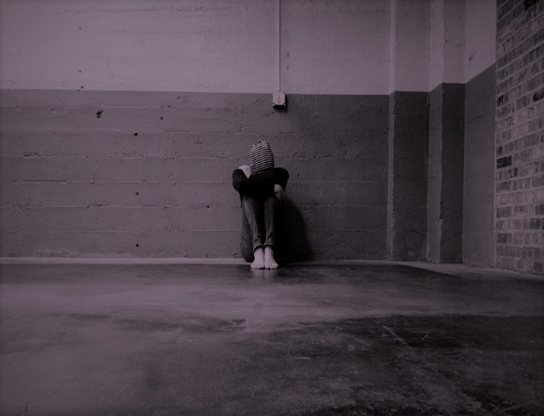

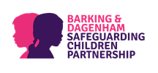
The aim of this leaflet is to support parents and carers to feel confident in managing their children’s behaviour and to seek advice if they are having difficulties.

What is Physical Punishment?
Physical punishment, physical chastisement or corporal punishment is using any physical force to punish a child for wrongdoing.
Effects of Physical Punishment on Children
Physical punishment may influence behaviour in the short-term. However, physical methods of discipline are associated with increased child aggression, antisocial behaviour, increased violent and criminal behaviour in adulthood, lower intellectual achievement, poorer quality of parent–child relationships, mental health problems (such as depression), and diminished moral internalisation.
Discipline
Discipline should not be seen the same
as punishment. It includes being a positive role model and setting good examples for your child.

It also includes negotiation and compromise, instruction, providing boundaries, guidance, advice, and helping your child set realistic goals. There are lots of different ways of disciplining a child and if you restrict yourself to simply reacting against behaviour you don’t like, you will be missing lots of opportunities to bring positive, loving discipline into their life.
Introducing sanctions or punishing your child is only a part of the process and should only be done in ways that are fair – never abusive.
Above everything else, children need to know they are loved unconditionally, even when they are behaving badly. This will help in developing a healthy self-esteem which is very important for your child’s emotional wellbeing.
Make sure you also praise your child's good behaviour. Praising a good behaviour is called positive reinforcement and leads to more of that behaviour.
Boundaries
We all know that children test limits at some time or another, pushing boundaries is an important part of growing up and becoming more independent, and one day, thinking for themselves and making good choices.
We set ‘boundaries’ about what we expect of our children and family. If these boundaries are
too loose then children have little direction and the balance of power shifts towards the child.
If they are too harsh then children do
not develop their own sense of responsibility.
Think about the rules in your house and
explain these to your children. Tell them
about why you think these are important.
Give them a chance to discuss the rules and
to know when things might be changeable.
For instance, during school days you expect a
fixed time for bedtime but at weekends this
could be later. Clear limit setting provides children with a sense of safety, stability, predictability, and security.
Consistency
It is important that children have routine
and predictability. They need to know that
there are consequences for how they behave.
Rewarding positive behaviour is, generally,
more effective than punishing challenging
behaviour. Praise and encouragement are
powerful tools for developing good habits.
However challenging your child’s behaviour is, it is important to be as consistent and fair as possible. Managing your child's behaviour works best when you let your child know in advance what you expect of them.

