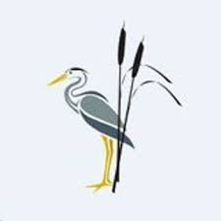
Rush Green Recommended Reading List EYFS

Classic Fiction | Contemporary Fiction | Non-fiction
The Tiger Who Came to Tea—Judith Kerr Owl Babies—Martin Waddell Each Peach Pear Plum—Allan Ahlberg The Very Hungry Caterpillar—Eric Clarke  Alfie Gets in First—Shirley Hughes  Elmer—David Mckee  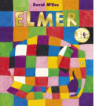  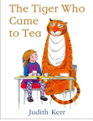 | Ten Terrible Dinosaurs—Paul Strickland  Orange , Pear, Apple, Bear—Emily Gravett  The Gruffalo—Julia Donaldson  Astro Girl—Ken Wilson  Max Bedtime for Monsters— Ed Vere  Emily Brown and the Thing—Cressida Cowell  Jabari Jumps—Gaia Cornwell Knuffle Bunny—Mo Willems  Lulu Loves the Library—Anna McQuinn On Sudden Hill—Linda Sarah  Otto the Book Bear—Katie Cleminson Ruby’s Worry—Tom Percival  The Leopard’s Drum—Jessica Souhami There’s a Tiger in the Garden—Lizzy Stewart  What the Ladybird Heard—Julia Donaldson  The Way Back Home—Oliver Jeffers  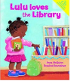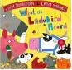  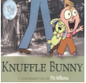 | Because of an Acorn—Lola M & Adam Schaefer Blackbird , Blackbird What Do You Do—Kate McLelland Colours—Patrick George Happy—Mies Van Hout Once Upon a Star—James Carter Rain—Manja Stojic Surprising Sharks—Nicola Davies Tad—Benji Davies Trees—Lemniscates When I Grow Up—Patrick George Yucky Worms—Vivian French  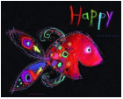  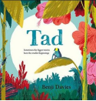
Poetry
A Great Big Cuddle—Michael Rosen Here’s a Little Poem—Various My Very First Mother Goose—Iona Opie Chomp Chomp Big Roars
Here Come the Dinosaurs—Kaye Umansky
Zim Zam Zoom! - James Carter
