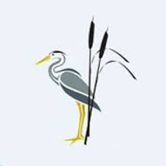
Rush Green Recommended Reading List Year 1

Classic Fiction | Contemporary Fiction | Non-fiction
Mog the Forgetful Cat—Judith Kerr  Peace at Last—Jill Murphy  Hairy MacLary from Donaldson’s Dairy—Lynley Dodd  The Jolly Postman—Allan Ahlberg  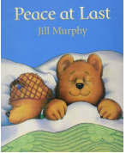 | Grandad’s Island—Benji Davies  Don’t Let the Pigeon Drive the Bus—Mo Willems  The Storm Whale—Benji Davies  Look Up—Nathan Byron  How to Find Gold—Viviane Schwarz  Farmer Duck—Martin Waddell  Bears Don’t Read—Emma Chichester Clarke  Aaaarrgghh Spider– Lydia Monks  I Love You Blue Kangaroo—Emily Chichester Clarke Giraffes Can’t Dance—Giles Andreae  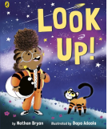  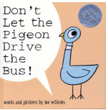 | A First Book of Nature—Nicola Davies  Actual Size—Steve Jenkins Caterpillar Butterfly—Vivian French  Fabulous Frogs—Martin Jenkins  It Starts With a Seed—Laura Knowles  The Big Book of Bugs—Yuval Zommer  The Emperor’s Egg—Martin Jenkins  What’s Under the Bed—Mick Manning  White Owl Barn Owl—Nicola Davies  What Are You Playing At? - Marie Sabine Roger  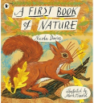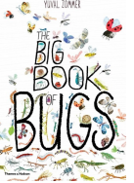
Poetry
The Puffin Book of Fantastic First Poems—June Crebbin All Around Me—Shirley Hughes
Out and About—Shirley Hughes
Poems Out Loud!: First Poems to Read and Perform
