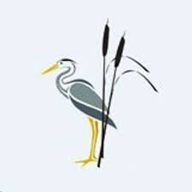
Rush Green Recommended Reading List Year 2

Classic Fiction | Contemporary Fiction | Non-fiction
Dogger—Shirley Hughes  Toys in Space—Mini Grey  The Hodgeheg—Dick King-Smith  The Owl Who was Afraid of the Dark—Jill Tomlinson  Amazing Grace—Mary Hoffman  Mrs Pepperpot—Alf Proysen  The Magic Faraway Tree – Enid Blyton  Classic Fairy Tales: The Illustrated Collection – Berlie Doherty  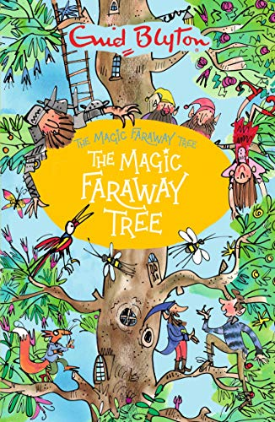  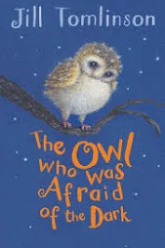 | Charlie Cook’s Favourite Book—Julia Donaldson  Meerkat Mail—Emily Gravett Olga da Polga—Michael Bond  Rabbit and Bear—Julian Gough Anna Hibiscus– Atinuke  Man on the Moon—Simon Bartram  Goldilocks and Just The One Bear—Leigh Hodgkinson  Inside The Villains – Clotilde Perrin  I Was A Rat!: Or, the Scarlet Slippers – Phillip Pullman  The Dragonsitter – Josh Lacey  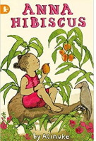  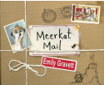 | A First Book of Animals—Nicola Davies  10 Things I Can Do to Help My World—Melanie Walsh  Little People Big Dreams—Maria Isabel Sanchez Vegera  Counting Lions—Katie Cotton Growing Frogs—Vivian French  Here We Are—Oliver Jeffers  Moth—An Evolution Story—Isabel Thomas  One Day on Our Blue Planet—Ella Bailey  Professor Astro Cat’s Solar System—Dominic Walliam  River Story—Meredith Hooper Shadow—Robie H Harris  Stone Age Bone Age—Mick Manning  Tiny: The Invisible World of Microbes—Nicola Davies  We Travel So Far—Laura Knowles The Big Book of Beasts—Yuval Zommer  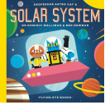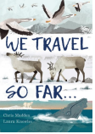
Poetry
Fruits—Valerie Bloom
Please Mrs Butler—Allan Ahlberg
Poems to Perform—Julia Donaldson
Don’t Put Mustard in the Custard—Michael Rosen
Revolting Rhymes—Roald Dahl
A Poem for Every Day of the Year—Allie Esiri
I Am The Seed That Grew The Tree—Fiona Waters
