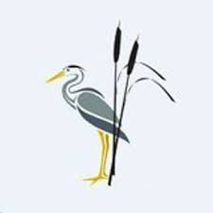
Rush Green Recommended Reading List Year 3

Classic Fiction | Contemporary Fiction | Non-fiction
The Iron Man—Ted Hughes  Flat Stanley—Jeff Brown  Fattypuffs and Thinifers—Andre Maurois  A Bear Called Paddington—Michael Bond  The Owl Who was Afraid of the Dark—Jill Tomlinson Mrs Pepperpot—Alf Proysen  Clever Polly and the Stupid Wolf— Catherine Storr Finn Family Moomintroll—Tove Jansson  The Sheep Pig—Dick King Smith  Fantastic Mr Fox—Roald Dahl  George’s Marvellous Medicine—Roald Dahl  My Naughty Little Sister—Dorothy Edwards  The Worst Witch—Jill Murphy  Carbonel—Barbara Sleigh  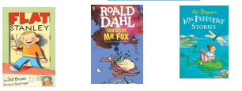 | My Funny Family—Chris Higgins  Sam Wu—Katie Tsang  One Christmas Wish—Katherine Rundell  Royal Rabbits of London—Santa Montefiore  Cookie—Konnie Huq  My Parents Cancelled My Birthday—Jo Simmons  The Dragon in the Library—Louie Stowell  You’re a Bad Man Mr Gum— Andy Stanton  The Midnight Gang—David Walliams  Planet Omar—Zanib Mian  Super Cats—Gwyneth Rees  Mister Cleghorn’s Seal—Judith Kerr  Amelia Fang—Laura Ellen  Anderson The Dragonsitter—Josh Lacey  Woof!- Allan Ahlberg  The Nothing to See Here Hotel—Steven Butler  The Explorer—Katherine Rundell  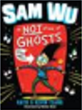  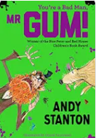 | The Big Blue Book of the Blue – Yuval Zommer  The Skies Above My Eyes – Charlotte Guillain  Africa Amazing Africa – Antinuke  Atlas of Adventures – Rachel Williams  Beautiful Birds – Jean Roussen  Fantastically Great Women Who Changed the World – Kate Pankhurst  Mad about Monkeys – Owen Davey  Stone Girl Bone Girl – Laurence Anholt  The Pebble in my Pocket – Merdith Hooper  Wild Animals of the North – Dieter Braun  So you think you’ve got it bad – Chae Strathie  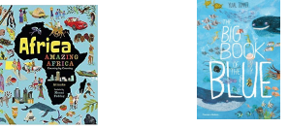
Poetry | Picture Books and Graphic Novels | Myths and Legends
100 Brilliant Poems for Children—Paul Cookson  The Owl and the Pussycat—Edward Lear  Now We Are Six—A.A. Milne  Please Mrs Butler—Allan Ahlberg  A Year of Nature Poems—Joseph Coelho  Jelly Boots Smelly Boots—Michael Rosen  A Poem for Every Day of the Year—Allie Esiri  I am the Seed That Grew the Tree—Fiona Waters  My Life as a Goldfish—Rachel Rooney  Bananas in my Ears—Michael Rosen  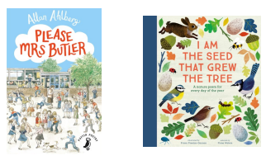 | Asterix the Gaul—Rene Goscinny  Tintin—Herge  Where’s Wally—Martin Handford  The Lion and the Unicorn—Shirley Hughes  Ella’s Big Chance—Shirley Hughes  The Missing Bookshop—Katie Clapham  Once Upon a Wild Wood—Chris Riddell  Artemis Fowl—Eoin Colfer  Fungus the Bogeyman—Raymond Briggs  Snow White in New York—Fiona French Stormbreaker (The Graphic Novel) - Anthony Horowitz  Vern and Lettuce—Sarah McIntyre  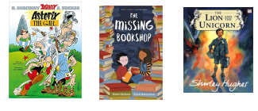 | Robin Hood and the Silver Arrow– Tony Bradman  Brer Rabbit—John Agard  Grandma Chickenlegs—Geraldine McCaughrean  Mrs McCool and the Giant Cuchulainn– Jessica Souhami  Rainbow Bird—Eric Maddern  The Iliad and the Odyssey—Marcia Williams  The Stone Age—Marcia Williams  