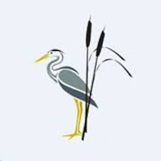
Rush Green Recommended Reading List Year 4

Classic Fiction | Contemporary Fiction | Non-fiction
Finn Family Moomintroll—Tove Jansson  The Incredible Adventures of Professor Branestawm—Norman Hunter  Pippi Longstocking—Astrid Lindgren  Adventures of the Little Wooden Horse— Ursula Moray Williams  Charlotte’s Web—E.B. White  The Miraculous Journey of Edward Tulane—Kate DiCamillo  The Velveteen Rabbit—Margery Williams  Charlie and the Chocolate Factory -Roald Dahl  The BFG—Roald Dahl  The Borrowers—Mary Norton  Emil and the Detectives—Erich Kastner  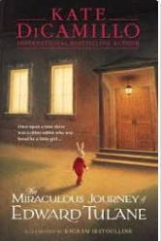 | Bill’s New Frock—Anne Fine  Akimbo and the Elephants—Alexander McCall Smith Rooftoppers—Katherine Rundell  How to Eat Fried Worms—Thomas Rockwell  The Owl Tree—Jenny Nimmo  Fortunately, the Milk…- Neil Gaiman  Goth Girl—Chris Riddell  Ice Palace—Robert Swindells  Kindlekrax—Philip Ridley  Lob—Linda Newbery  Noah Barleywater Runs Away—John Boyne  One Dog and his Boy—Eva Ibbotsom  Small Change for Stuart—Lissa Evans  The Accidental Prime Minister—Tom McLaughlin  Pages and Co—Anna James  The Highland Falcon Thief—M.G. Leonard  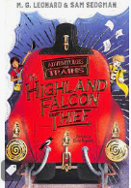  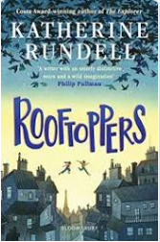 | A Beetle is Shy—Dianna Hutts Ashton  A Little Guide to Wild Flowers—Charlotte Voake  Barefoot Books World Atlas—Nick Crane  Can We Save the Tiger—Martin Jenkins  City Atlas—Georgia Cherry  Creaturepedia—Adrienne Barman  Fantastically Great Women Who Saved the Planet—Kate Pankhurst  Little Leaders– Vashti Harrison  Mama Miti—Donna Jo Napoli  One Plastic Bag—Miranda Paul  The Great Fire of London—Emma Adams  The Tudors—Marcia Williams  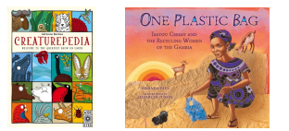
Poetry | Picture Books and Graphic Novels | Myths and Legends
If You Could See Laughter—Mandy Coe Monster Slayer—Brian Patten  Moon Juice—Kate Wakeling  Poetry Pie—Roger McGough  The Puffin Book of Utterly Brilliant Poetry– Brian Patten  The Rainmaker Danced—John Agard  Things You Find in a Poet’s Beard—A.F. Harrold  Under the Moon and Over the Sea—John Agard Where Zebras Go—Sue Hardy– Dawson  I am the Seed That Grew the Tree—Fiona Waters  A Year of Nature Poems—Joseph Coelho  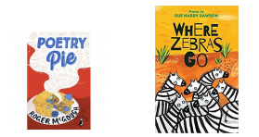 | Gorilla—Anthony Browne  Gregory Cool—Caroline Binch  Leon and the Place Between—Graham Baker-Smith Mouse Bird Snake Wolf—David Almond  The Day War Came—Nicola Davies  The Lost Happy Endings—Carol Anne Duffy  The Mousehole Cat—Antonia Barber  The True Story of the Three Little Pigs— Jon Scieszka Traction Man—Mini Grey  Ug—Raymond Briggs  Window—Jeannie Baker  Cloudland—John Burningham  The Last Alchemist—Colin Thompson  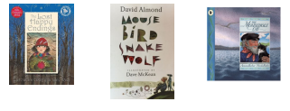 | African Tales—Gcina Mhlophe  King Arthur—Marcia Williams  Anancy and Mr Dry Bone—Fiona French  The Happy Prince—Oscar Wilde  How Rabbit Stole the Fire—Joanna Troughton  The Adventures of Robin Hood—Roger Lancelyn  Green Ancient Egypt—Marcia Williams  The Elephant’s Friend—Marcia Williams  A Collection of Just So Stories— Rudyard Kipling  