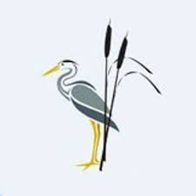
Rush Green Recommended Reading List Year 5

Classic Fiction | Contemporary Fiction | Non-fiction
Stig of the Dump—Clive King  Tom’s Midnight Garden—Philippa Pearce  Heidi—Joanna Spry  The Call of the Wild—Jack London  Harry Potter—J.K. Rowling  James and the Giant Peach—Roald Dahl  Danny The Champion of the World— Roald Dahl When Hitler Stole Pink Rabbit—Judith Kerr  Inkheart—Cornelia Funke  Eragon—Christopher Paolini  Alice’s Adventures in Wonderland—Lewis Carroll  The Wind in the Willows—Kenneth Grahame  The House at Pooh Corner—A.A. Milne  Street Child—Berlie Doherty  The Hobbit—J.R.R. Tolkein | A Boy and a Bear in a Boat—Dave Shelton  The Boy at the Back of the Class—Onjali Rauf  The Wolf Wilder—Katherine Rundell  Evie’s Ghost—Helen Peters  Letters from the Lighthouse—Emma Carroll  The Wizards of Once—Cressida Cowell  A Place Called Perfect—Helena Duggan  Cogheart—Peter Bunzl  Shadowsmith—Ross MacKenzie  Beetle Boy—M.G. Leonard  The Mystery of the Colour Thief—Ewa Jozefkowicz Bronze and Sunflower—Cao Wenxuan  Goggle Eyes—Anne Fine  The Last Wild—Piers Torday  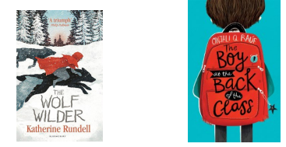 | Long Walk to Freedom—Nelson Mandela  Lesser Spotted Animals—Martin Brown  Maps—Daniel Mizielinski  Archie’s War—Marcia Williams  Shackleton’s Journey—William Grill  Skyward—Sally Deng  The Egyptian Echo—Paul Dowswell  The Savage Stone Age—Terry Deary  What Mr Darwin Saw—Mick Manning  The Colours of History—Clive Gifford  Women in Science—Rachel Ignotofsky  Greta and the Giants—Zoe Tucker  Prisoners of Geography (Our World Explained) - Tim Marshall  What’s Where in the World—DK  An Anthology of Intriguing Animals— Ben Hoare  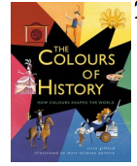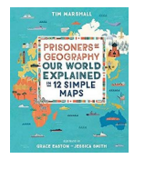
Poetry | Picture Books and Graphic Novels | Myths and Legends
Rhythm and Poetry—Karl Nova  Classic Poetry—Michael Rosen  Jabberwocky—Lewis Carroll  Poems from a Green and Blue Planet— Sabina Mahfouz  Cosmic Disco—Grace Nichols  Falling Out of the Sky—Rachel Piercey  Love that Dog—Sharon Creech  Michael Rosen’s Big Book of Bad Things— Michael Rosen  A Poem for Every Night of the Year— Allie Esiri  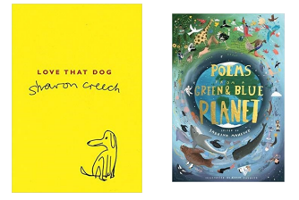 | Artemis Fowl—Eoin Colfer  Count Karlstein—Philip Pullman  Danger is Everywhere—David O’Doherty  Snow White in New York—Fiona French  Stormbreaker—Anthony Horowitz  Tom’s Midnight Garden—Philippa Pearce  The Journey—Francesca Simon  The Rabbits—John Marsden  The Wolves in the Wall—Neil Gaiman  Thirteen Unpredictable Tales—Paul Jennings  Fox—Margaret Wild  Goldilocks on CCTV—John Agard  Hilda and the Troll—Luke Pearson  Rose Blanche—Roberto Innocenti  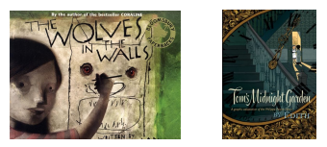 | Arthur, High King of Britain—Michael Morpurgo  Arthur the Seeing Stone—Kevin Crossley Holland Chaucer’s Canterbury Tales—Marcia Williams  How the World Became—Ted Hughes  Seasons of Splendour—Madhur Jaffrey  Once Upon a Starry Night—Jacqueline Mitton  The Moon in Swampland—M.P. Robertson  Tales of the Greek Heroes—Roger Lancelyn Green  The Tale of Troy—Roger Lancelyn Green  