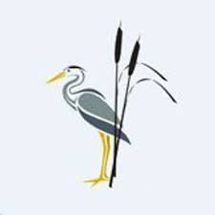
Rush Green Recommended Reading List Year 6

Classic Fiction | Contemporary Fiction | Non-fiction
Swallows and Amazons—Arthur Ransome  Five Children and It—E. Nesbit  The Phoenix and the Carpet—E. Nesbit  Charlotte Sometimes—Penelope Farmer  A Traveller in Time—Alison Uttley  The Secret Garden –Frances Hodgson Burnett  The Wolves of Willoughby Chase—Joan Aitken Carrie’s War—Nina Bawden  Goodnight Mister Tom—Michelle Magorina  The Letter for the King—Tonke Dragt  Black Beauty—Anna Sewell  A Wrinkle in Time—Madeleine L’Engle  The Magician’s Nephew—C.S. Lewis  The Adventures of Tom Sawyer—Mark Twain  The Midnight Fox—Betsy Byars | Wonder—R.J.Palacio  The Boy in the Striped Pyjamas—John Boyne  Anna at War—Helen Peters  The Good Thieves—Katherine Rundell  The Girl Savage—Katherine Rundell  Frost Hollow Hall—Emma Carroll  The Nowhere Emporium—Ross McKenzie  Wolf Brother—Michelle Paver  The Girl of Ink and Stars—Kiran Millwood  Hargrave Holes—Louis Sachar  Fuzzy Mud—Louis Sachar  Skellig—David Almond  The London Eye Mystery—Siobhan Dows  High– Rise Mystery—Sharna Jackson  Boy Underwater—Adam Baron  Floodland—Marcus Sedgwick  Phoenix—S.F. Said  Pig Heart Boy—Malorie Blackman  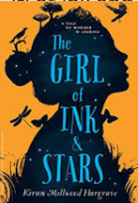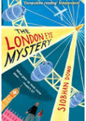 | A Really Short History of Nearly Everything—Bill Bryson Coming to England—Floella Benjamin  My Name is Book—John Agard  Rebel Voices—Louise Kay Stewart  Suffragette—David Roberts  The Missing—Michael Rosen  Who Are Refugees and Migrants—Michael Rosen  River Stories—Timothy Knapman  Three Cheers for Women—Marcia Williams  Amazing Evolution—Anna Claybourne  Timelines of Everything—Dorling Kindersley  What Happened When in the World—DK  What’s Where on Earth—DK  The Wonders of Nature—Ben Hoare  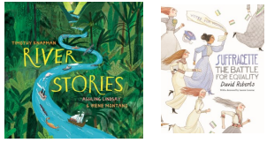
Poetry | Picture Books and Graphic Novels | Myths and Legends
Shakespeare for Every Day of the Year—Allie Esiri Talking Turkeys—Benjamin Zephaniah  Dark Sky Park—Philip Gross  Michael Rosen’s A to Z – Michael Rosen  New and Collected Poems for Children—Carol Ann Duffy  Off Road to Everywhere—Philip Gross  Overheard in the Tower Block—Joseph Coelho Sensational!- Roger McGough  The Highwayman—Alfred Noyes  The Lady of Shallot—Lord Tennyson  You Tell Me—Michael Rosen  Wonderland. Alice in Poetry—Michaela Morgan  Let in the Stars—Mandy Coe  Where Zebras Go– Sue Hardy Dawson  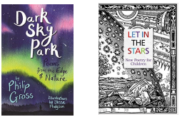 | A Story Like the Wind—Gill Lewis  Chaucer’s Canterbury Tales—Marcia Williams  Rose Blanche—Roberto Innocenti  The Arrival—Shaun Tan  The Mysteries of Harris Burdick—Chris Van Allsburg  The Chronicles of Harris Burdick—Chris Van Allsburg  The Kingdom Revealed—Rob Ryan  The Viewer—Gary Crew  Varmints—Helen Ward  Hilda and the Bird Parade—Luke Pearson  King of the Sky—Nicola Davies  Sulwe—Lupita Nyong’o  Arthur and the Golden Rope—Joe Todd Stanton  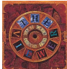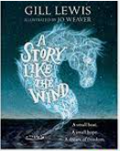 | African Tales- Gcina Mhlophe  Faery Tales—Carol Ann Duffy  How the World Became—Ted Hughes  Norse Mythology—Neil Gaiman  Tales of Ancient Egypt—Roger Lancelyn  Green Tales of the Greek Heroes—Roger Lancelyn  Green Seasons of Splendour—Madhur Jaffrey  Between Worlds—Kevin Crossley  Holland Falling Out of the Sky—Rachel Piercey  One Thousand and One Arabian Nights— Geraldine McCaughrean  Tales from the Caribbean– Trish Cooke  The Adventures of Odysseus—Hugh Lupton  Myths and Legends of the World—Lonely Planet  Kids Mythologica—Stephen P. Kershaw  A World Full of Animal Stories—Angela McAllister  