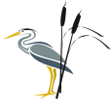
Phonics Journal

Rush Green Primary School
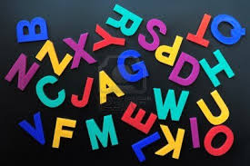

Year 1 – Summer 1

Phonics Teacher: Miss Ellis
Child’s Name: _____________________________

Dear Parents/Carers,
Phonics is a way of teaching children to read quickly and fluently. The children are taught how to:
- Recognise the sounds that individual letters or groups of letters make
- Identify the sounds that different combinations of letters make such as ‘sh’ in ship and ‘oa’ in goat
- Blend these sounds together from left to right to make words.

How do we teach Phonics?
At Rush Green Primary School we teach Phonics using the Jolly Phonics Programme. This journal contains a weekly breakdown of what your child will be learning in their Phonics lessons.

How can you help at home?
Use this journal as a tool to support your child’s learning at home. There are examples of words which your child can ‘segment and blend’ using their ‘phoneme fingers’.

How do we use this journal in school?
The children have a spelling challenge every Friday during their phonics lesson. Please practise the weekly spellings in this journal. You can also help your child write sentences containing the weekly challenge words so that they understand their meaning. The journal must be in school every Friday so the children can do their spelling test in it.

If you have any queries about this journal please speak to your child’s class teacher.
Thank you for your continued support.

Summer 1
Week | Grapheme | Example Words
1  15.04.24 | or  aw  au  al | for, born, ordinary  paw, fawn, awkward  haul, launch, August  metal, talk, small
2  22.04.24 | ph | phone, elephant, phonics
3  29.04.24 | c  (when a c is followed by an i, e or y it makes a ‘s’ sound) | ice, pencil, circus
4  07.05.24 | g  (when a g is followed by an i, e or y it makes a ‘j’ sound) | gem, magic, energy
5  13.05.24 | ai  a-e  ay | aim, tail, snail, brain  same, cake, bake, shave  day, stay, spray
6  20.05.24 | ie  i-e  y  igh | pie, tie, cried  bike, kite, slide  dry, cry, fry  high, right, fright,

W/b 15.04.24
form | paw | August
fork | prawn | talk
Include each of these words in a sentence:

Read each word and then draw a picture to match.

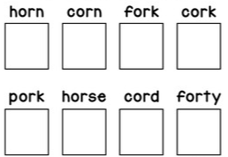

Write the missing digraph on the lines then write the whole word out again on the line below.

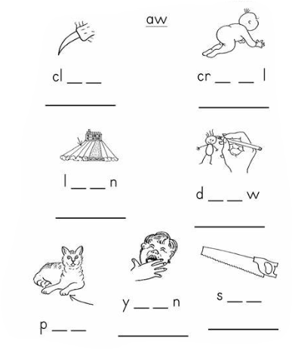

or / aw
Write the correct digraph in the spaces and then read each word.
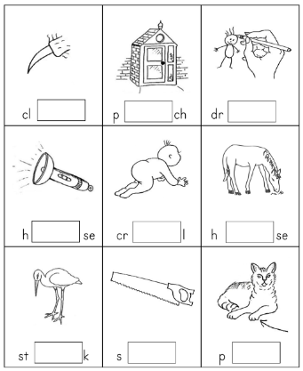

Read each word and then sort them into the table below.
al | all

chalk | mall | talk | call
small | malt | fall | salt
stalk | tall | ball | wall

Practise Test (at home)
W/b 15.04.24
1
2
3
4
5
6

W/b 22.04.24
phone | dolphin | sphinx
more | before | elephant

Include each of these words in a sentence:

Match the word to the corresponding picture by copying the spelling from the word bank below.

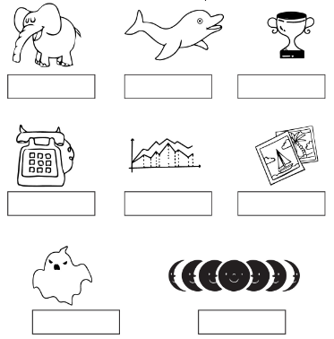

elephant | telephone | graphic | photo
trophy | moon phase | phantom | dolphin

Say the name of the picture in the boxes below. Identify if the word has ph or f and then colour the circle to record your answer.
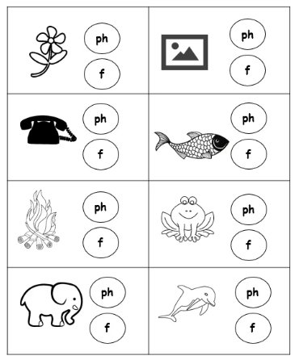
Practise Test (at home)
W/b 22.04.24
1
2
3
4
5
6
7
8

W/b 29.04.24
other | city | pencil
were | circus | fancy

Include each of these words in a sentence:

Hard and Soft C
The soft /c/ sound is made when the letter c is next to e, i or y (for example, cell and city).
The hard /c/ sound is made when the letter c is next to a, o or u (for example, cat and corn).

Copy the words below into the correct column in the table.

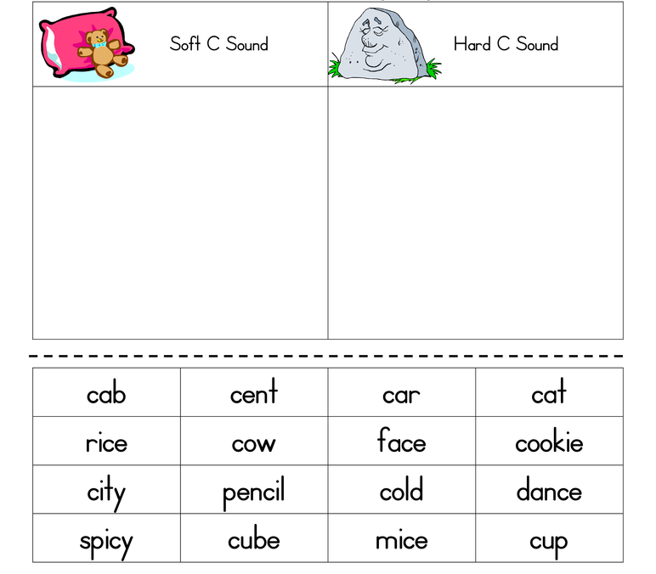

Read the words below, one at a time. Then, circle hard c /k/ or soft c /s/ to show which sound c is making in each word.

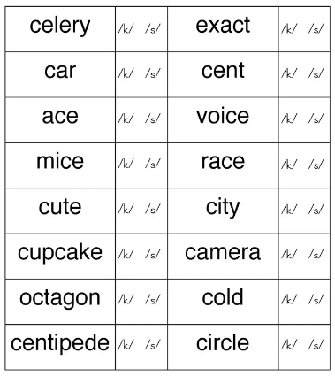

Practise Test (at home)
W/b 29.04.24
1
2
3
4
5
6

W/b 07.05.24
because | margin | germ
giant | magic | page

Include each of these words in a sentence:

Hard and Soft G
The soft /g/ sound is made when the letter g is next to e, i or y (for example, change, gentle).
The hard /g/ sound is made when the letter g is next to a, o or u (for example, girl, go).

Copy the words below into the correct column in the table.

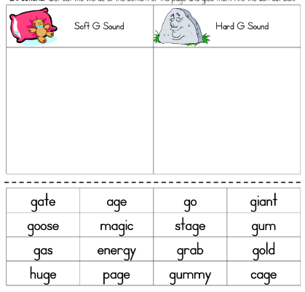

Practise Test (at home)
W/b 07.05.24
1
2
3
4
5
6

W/b 13.05.24
want | tail | stay
aim | name | daylight

Include each of these words in a sentence:

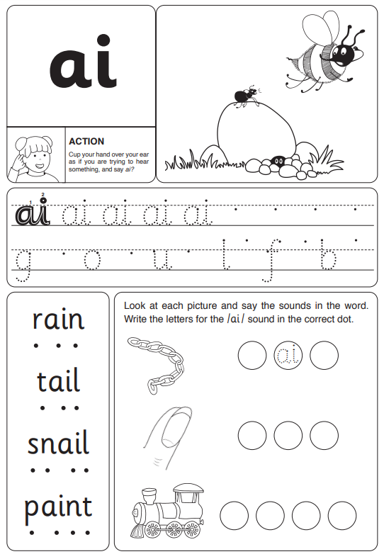
Copy the split digraph a-e words into the correct table below.

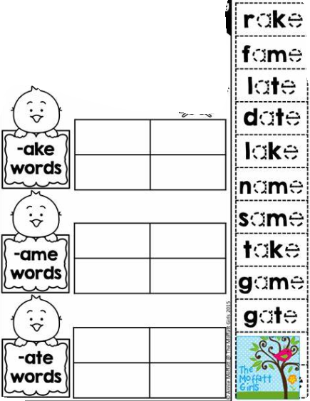

Write a word to match each picture.

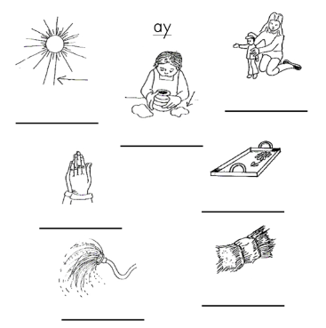

Practise Test (at home)
W/b 13.05.24
1
2
3
4
5
6
7
8

W/b 20.05.24
saw | high | tie
put | my | tile

Include each of these words in a sentence:

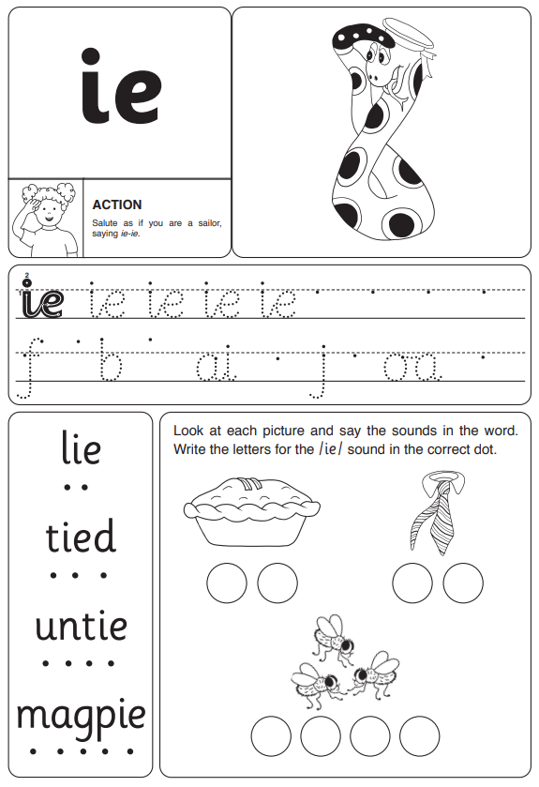

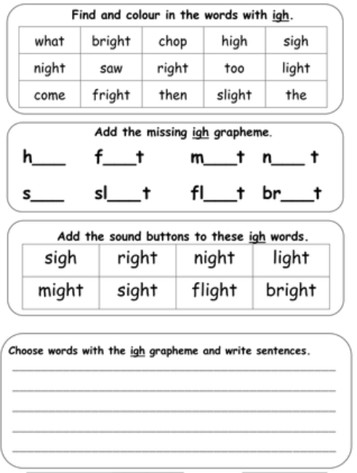

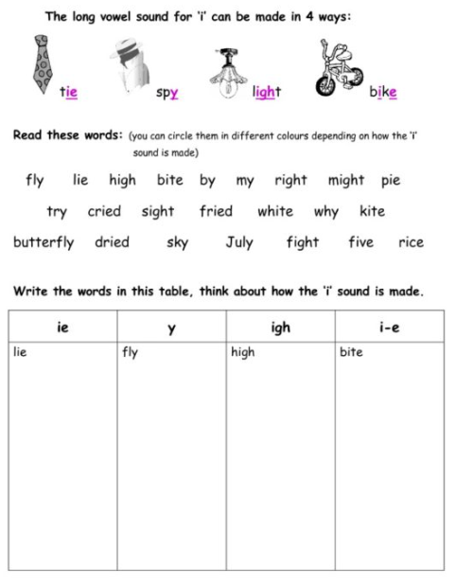

Practise Test (at home)
W/b 20.05.24
1
2
3
4
5
6

W/b 15.04.24
SPELLING TEST

W/b 22.04.24
SPELLING TEST

W/b 29.04.24
SPELLING TEST

W/b 07.05.24
SPELLING TEST

W/b 13.05.24
SPELLING TEST

W/b 20.05.24
SPELLING TEST

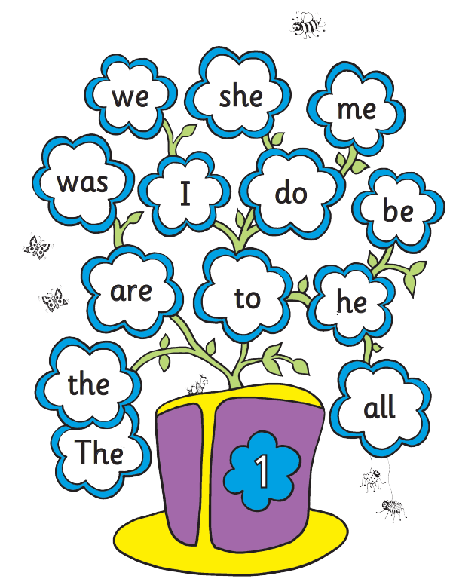

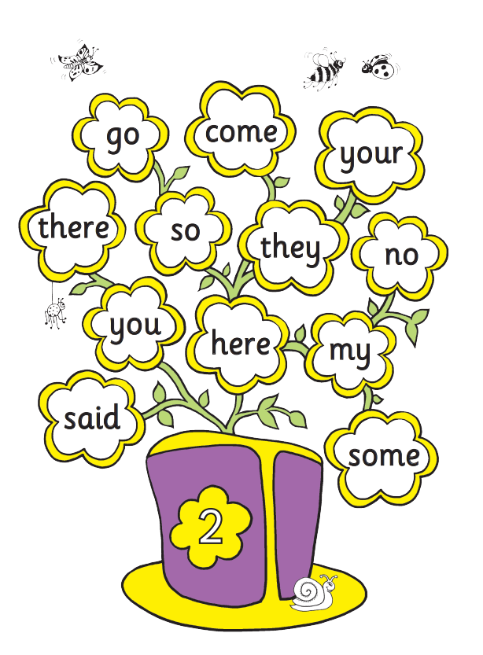
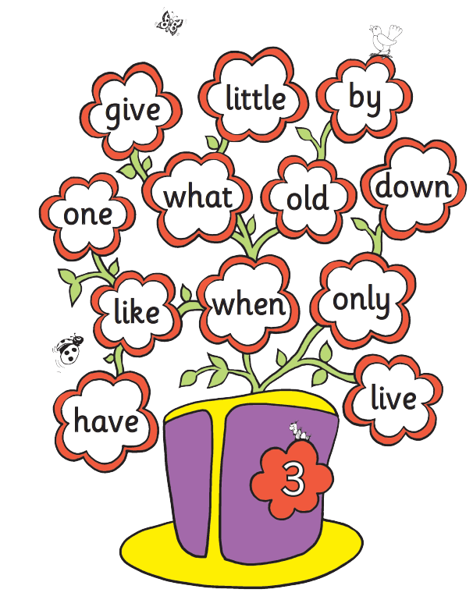

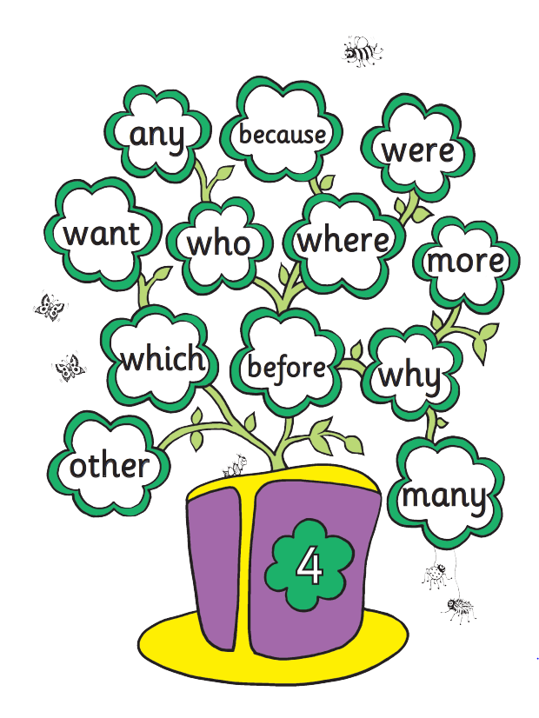

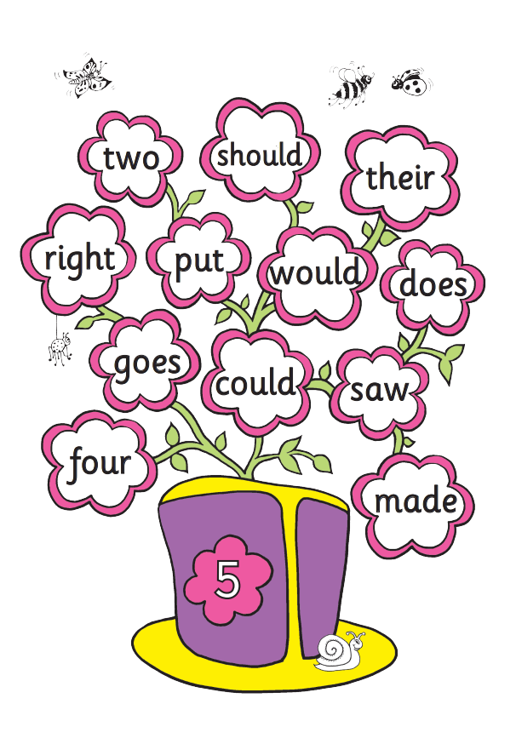
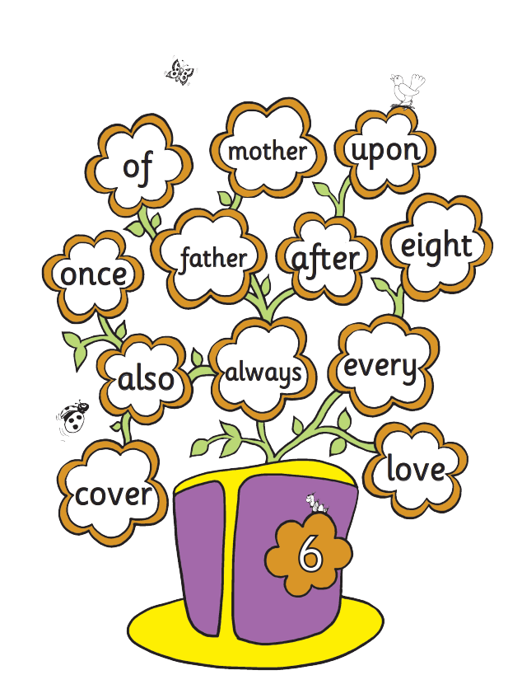

Zero Tolerance Words:
Year 1
Your child must know how to spell the following words
all
come
you
want
what
they
are
out
here
once
some
there
asked
when
little

