Phonics Journal

Rush Green Primary School

Year 1 – Summer 1

Phonics Teacher: Miss McCorkell
Child’s Name: _____________________________

Dear Parents/Carers,
Phonics is a way of teaching children to read quickly and fluently. The children are taught how to:
- Recognise the sounds that individual letters or groups of letters make
- Identify the sounds that different combinations of letters make such as ‘sh’ in ship and ‘oa’ in goat
- Blend these sounds together from left to right to make words.

How do we teach Phonics?
At Rush Green Primary School we teach Phonics using the Jolly Phonics Programme. This journal contains a weekly breakdown of what your child will be learning in their Phonics lessons.

How can you help at home?
Use this journal as a tool to support your child’s learning at home. There are examples of words which your child can ‘segment and blend’ using their ‘phoneme fingers’.

How do we use this journal in school?
The children have a spelling challenge every Friday during their phonics lesson. Please practise the weekly spellings in this journal. You can also help your child write sentences containing the weekly challenge words so that they understand their meaning. The journal must be in school every Friday so the children can do their spelling test in it.

If you have any queries about this journal please speak to your child’s class teacher.
Thank you for your continued support.

Summer 1
Week beginning | Weekly Focus | Examples
W/b 15.04.24 | er  ir  ur | verb, singer, order, herb, better,  whirl, twirl, thirst, shirt, stir  burn, surf, turnip, curl, surf, burger
W/b 22.04.24 | aw  au  al | paw, squawk, draw, awkward  August, haunt, haul, launch  walk, chalk
W/b 29.04.24 | air  ear as air  are as air | air, hair, fair, fairy  bear, pear, tear  care, beware, square, spare
W/b 07.05.24 | ph as /f/  soft c  (when c is followed by an i, e or y, it makes a ‘s’ sound)  soft g  (when g is followed by an i, e or y, it makes a ‘j’ sound) | phonics, phone, dolphin  ice, twice, nice  pencil, city  cylinder, cycle  giant, digit  large, gem, change  gym, gymnastics
W/b 13.05.24 | ai  a-e  ay | snail, train, explain, aim  spade, mate, grape  play, day, may
W/b 20.05.24 | ee  e-e  ea  y | tree, see, three  eve, Pete, athlete  tea, scream, east  body, stormy, jellyfish

W/b 15.04.24
jumper | tower | third
girl | church | burn
Include each of these words in a sentence:

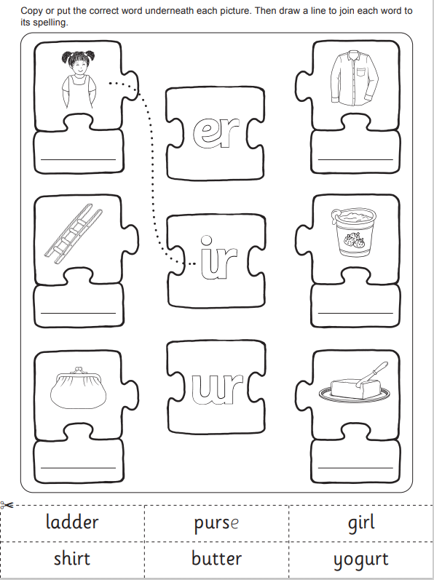

Practise Test (at home)
W/b 15.03.24
1
2
3
4
5
6

W/b 22.04.24

launch | straw | chalk
jigsaw | always | fault

Include each of these words in a sentence:

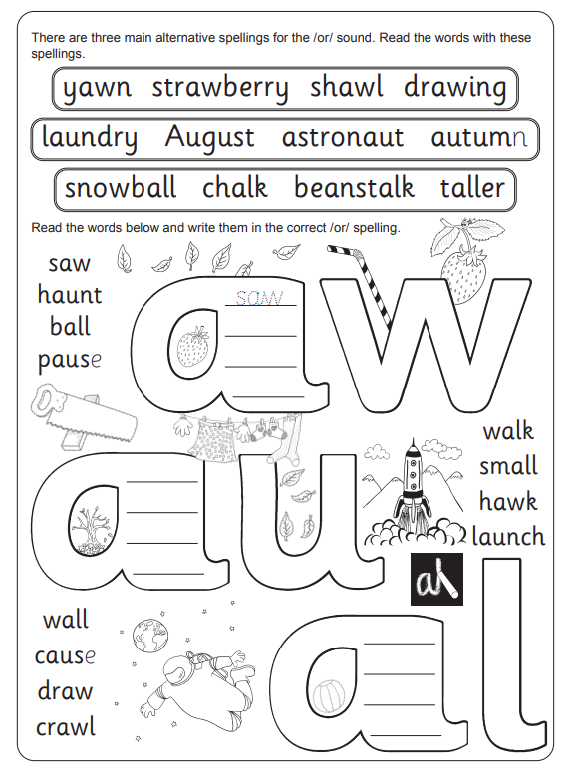

Practise Test (at home)
W/b 22.04.24
1
2
3
4
5
6
7
8

W/b 29.04.24
scare | share | pair
chair | wears | bear

Include each of these words in a sentence:

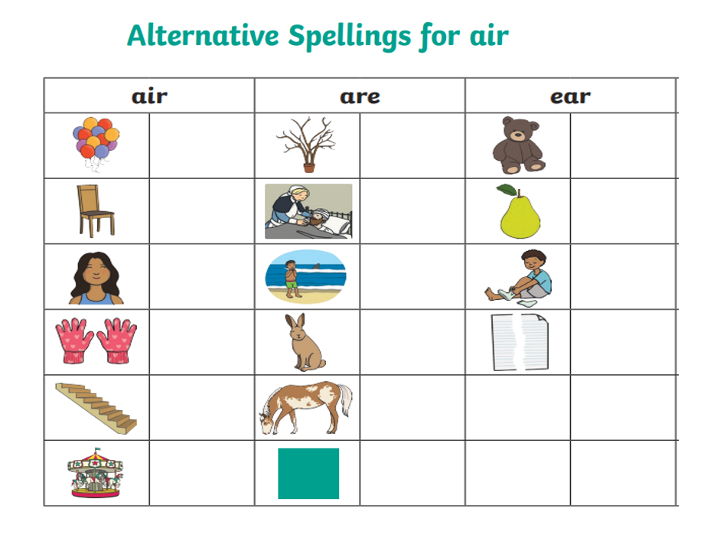

Practise Test (at home)
W/b 29.04.24
1
2
3
4
5
6

W/b 07.05.24
elephant | photo | pencil
page | twice | orange

Include each of these words in a sentence:

Circle the sound you can hear in each picture.

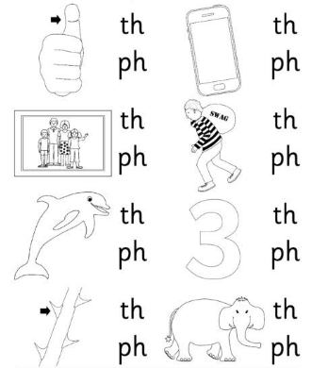

Draw a line to match the picture to the word.

bouncy
pencil
dice
fence
mice

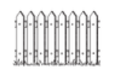

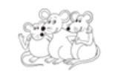

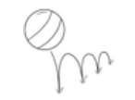

Practise Test (at home)
W/b 07.05.24
1
2
3
4
5
6

W/b 13.05.24
complain | display | daydream
train | plate | flame

Include each of these words in a sentence:

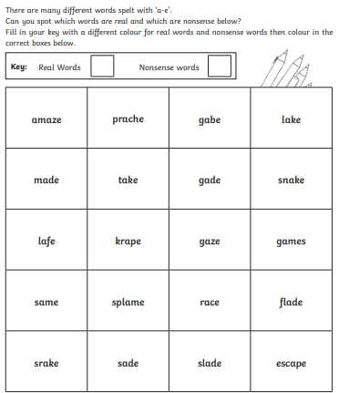

Practise Test (at home)
W/b 13.05.24
1
2
3
4
5
6
7
8

W/b 20.05.24
these | very | even
peel | teach | leaf

Include each of these words in a sentence:

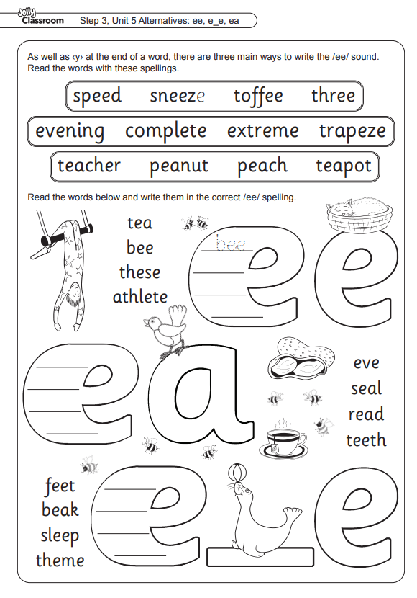

Practise Test (at home)
W/b 20.05.24
1
2
3
4
5
6

W/b 15.04.24
SPELLING TEST

W/b 22.04.24
SPELLING TEST

W/b 29.04.24
SPELLING TEST

W/b 07.05.24
SPELLING TEST

W/b 13.05.24
SPELLING TEST

W/b 20.05.24
SPELLING TEST

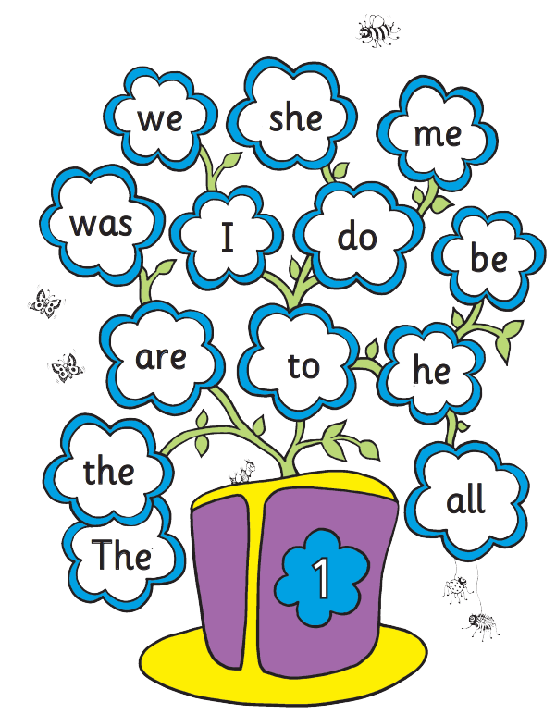

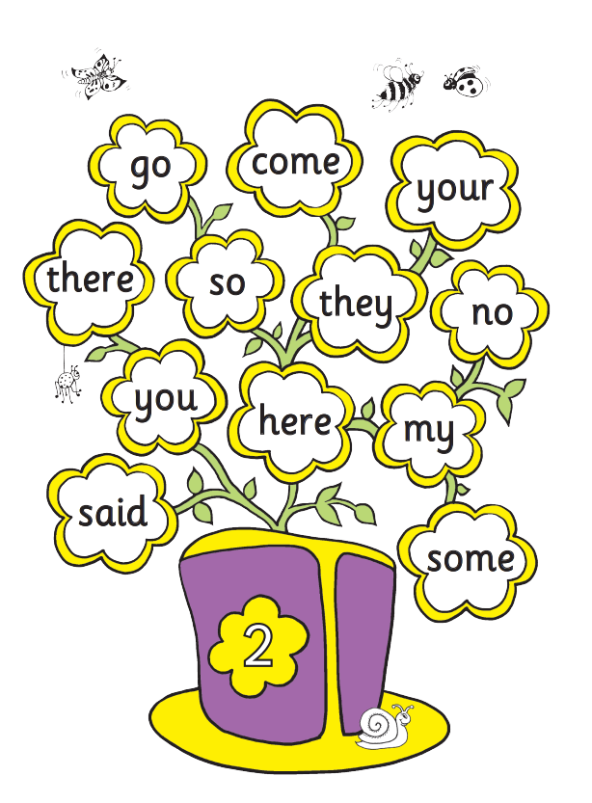
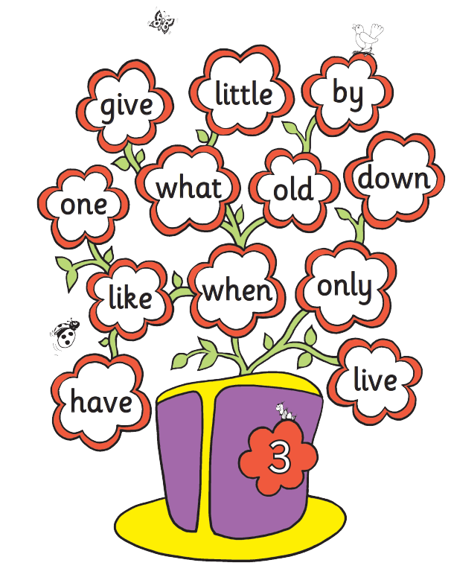

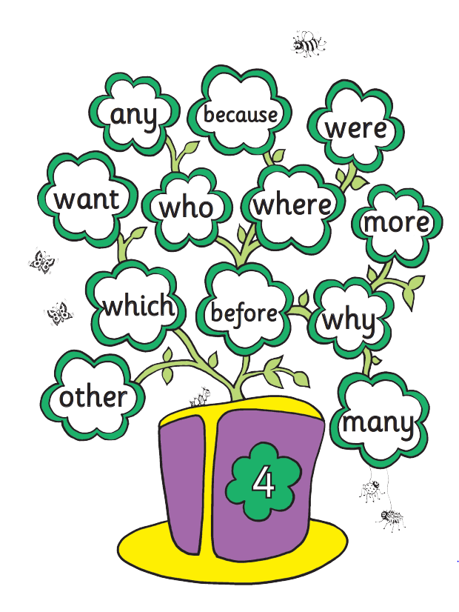

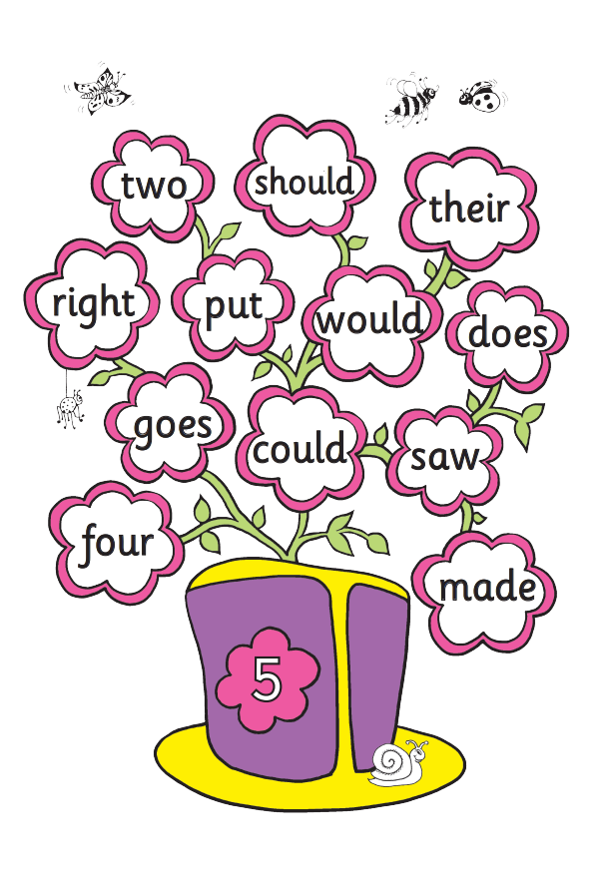
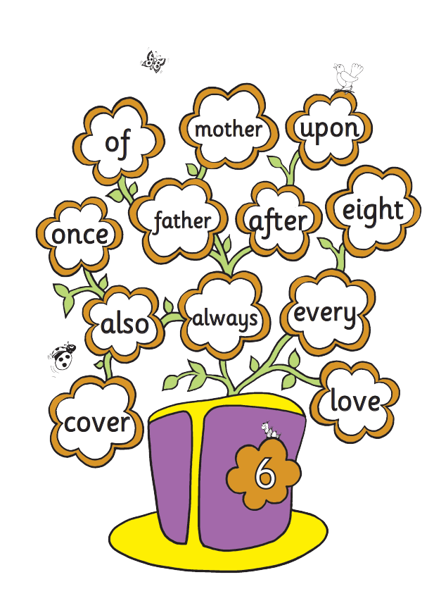

Zero Tolerance Words:
Year 1
Your child must know how to spell the following words
all
come
you
want
what
they
are
out
here
once
some
there
asked
when
little

