Phonics Journal

Rush Green Primary School

Year 1 – Summer 1

Phonics Teacher: Mrs Osborne
Child’s Name: _____________________________

Dear Parents/Carers,
Phonics is a way of teaching children to read quickly and fluently. The children are taught how to:
- Recognise the sounds that individual letters or groups of letters make
- Identify the sounds that different combinations of letters make such as ‘sh’ in ship and ‘oa’ in goat
- Blend these sounds together from left to right to make words.

How do we teach Phonics?
At Rush Green Primary School we teach Phonics using the Jolly Phonics Programme. This journal contains a weekly breakdown of what your child will be learning in their Phonics lessons.

How can you help at home?
Use this journal as a tool to support your child’s learning at home. There are examples of words which your child can ‘segment and blend’ using their ‘phoneme fingers’.

How do we use this journal in school?
The children have a spelling challenge every Friday during their phonics lesson. Please practise the weekly spellings in this journal. You can also help your child write sentences containing the weekly challenge words so that they understand their meaning. The journal must be in school every Friday so the children can do their spelling test in it.

If you have any queries about this journal please speak to your child’s class teacher.
Thank you for your continued support.

Summer 1
Week beginning | Weekly Focus | Examples
W/b 15.04.24 | y as ee | happy, sleepy, lucky
W/b 22.04.24 | Short vowels – a, e, i, o, u | pick, dog, pat, igloo, on
W/b 29.04.24 | Short vowels and ck | click, twig, cluck, check
W/b 07.05.24 | Short vowels and double letters | egg, bell, button
W/b 13.05.24 | Long vowels and split digraphs  Long vowel sounds are where a vowel makes the same sound as the way its name is pronounced. For instance, the ‘ee’ in the word ‘three’.  A split digraph also contains two letters that makes one sound (a-e, e-e, i-e, o-e and u-e) but they are split between a consonant, for example; make, bike and home | three, bee, coat, oak, aim, rain, tie.  cake, like, ape, eve.
W/b 20.05.24 | Long Vowels and split digraphs  Long vowel sounds are where a vowel makes the same sound as the way its name is pronounced. For instance, the ‘oa’ in the word ‘goat’.  A split digraph also contains two letters that makes one sound (a-e, e-e, i-e, o-e and u-e) but they are split between a consonant, for example; lake, smile and rose | float, glue, oats.  bake, shade, tube, time, these.
W/b 15.04.24
very | happy | party
windy | story | shiny
Include each of these words in a sentence:

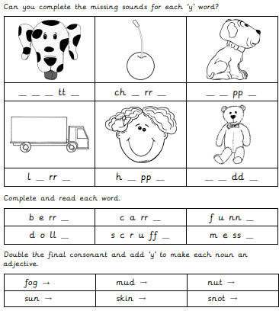

Practise Test (at home)
W/b 15.04.24
1
2
3
4
5
6

W/b 22.04.24

sit | shop | sun
and | went | wish

Include each of these words in a sentence:

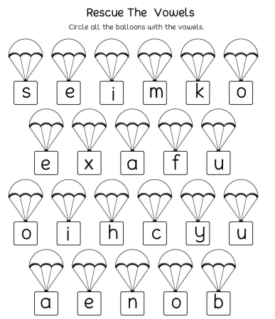

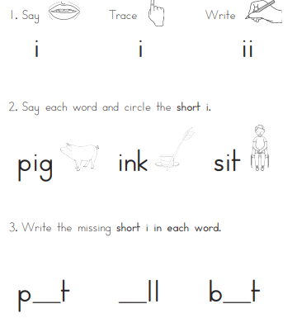
Practise Test (at home)
W/b 22.04.24
1
2
3
4
5
6
7
8

W/b 29.04.24
back | duck | pick
neck | sock | quick

Include each of these words in a sentence:

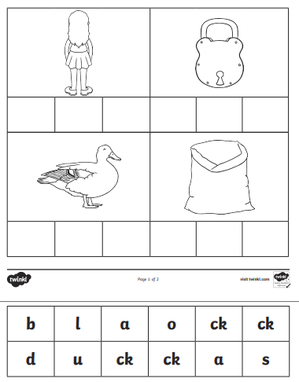

Practise Test (at home)
W/b 29.04.24
1
2
3
4
5
6

W/b 07.05.24
mass | off | tell
buzz | miss | egg

Include each of these words in a sentence:

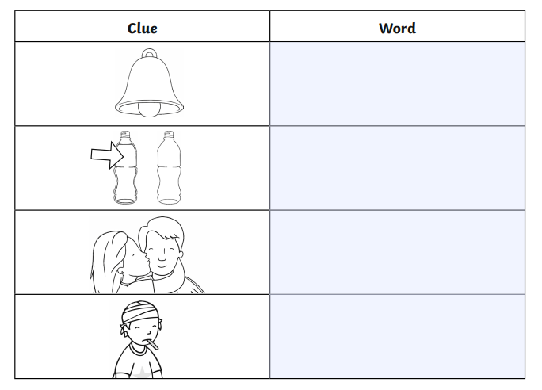

Practise Test (at home)
W/b 07.05.24
1
2
3
4
5
6

W/b 13.05.24
these | made | home
cube | game | mine

Include each of these words in a sentence:

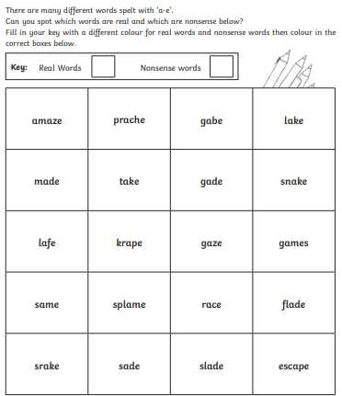

Practise Test (at home)
W/b 13.05.24
1
2
3
4
5
6
7
8

W/b 20.05.24
hope | use | make
five | even | kite

Include each of these words in a sentence:

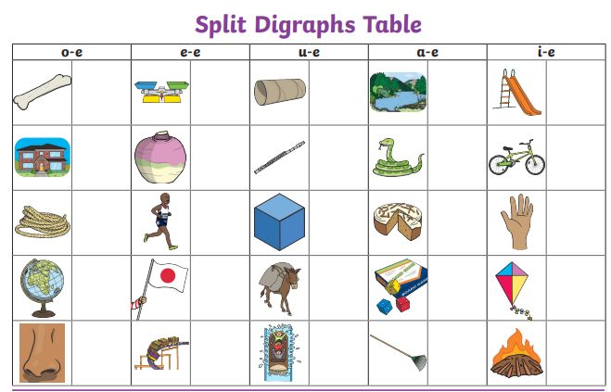

Look at the picture clue and write the word in the box that matches.
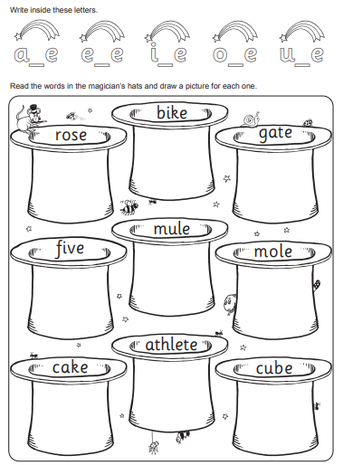

Practise Test (at home)
W/b 20.05.24
1
2
3
4
5
6

W/b 15.04.24
SPELLING TEST

W/b 22.04.24
SPELLING TEST

W/b 29.04.24
SPELLING TEST

W/b 07.05.24
SPELLING TEST

W/b 13.05.24
SPELLING TEST

W/b 20.05.24
SPELLING TEST

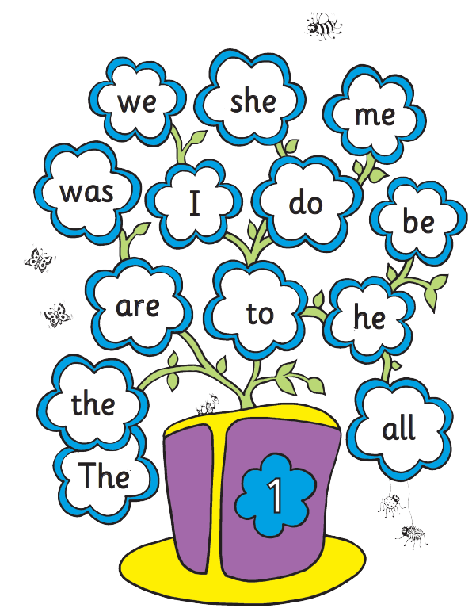

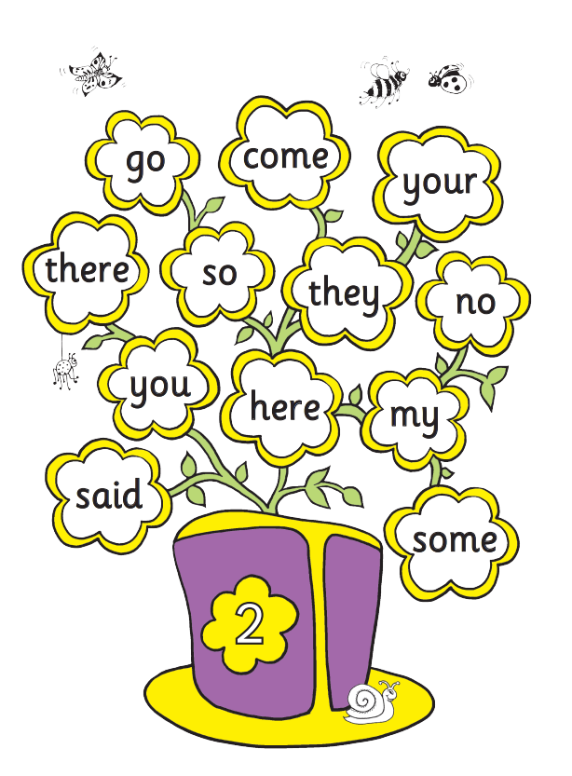
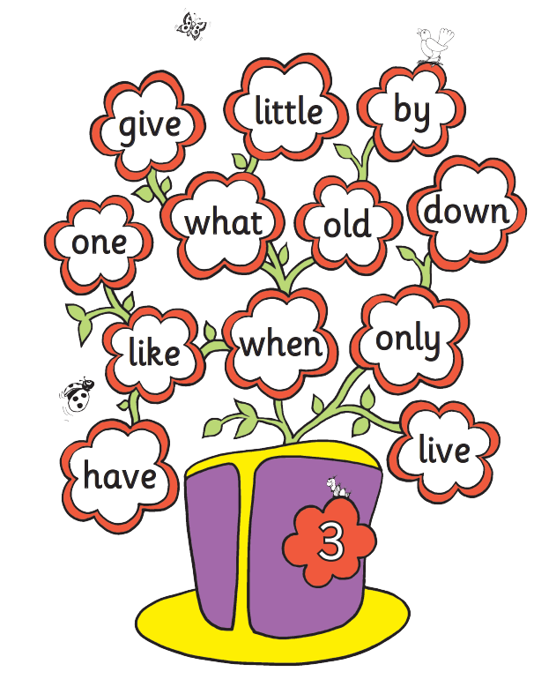

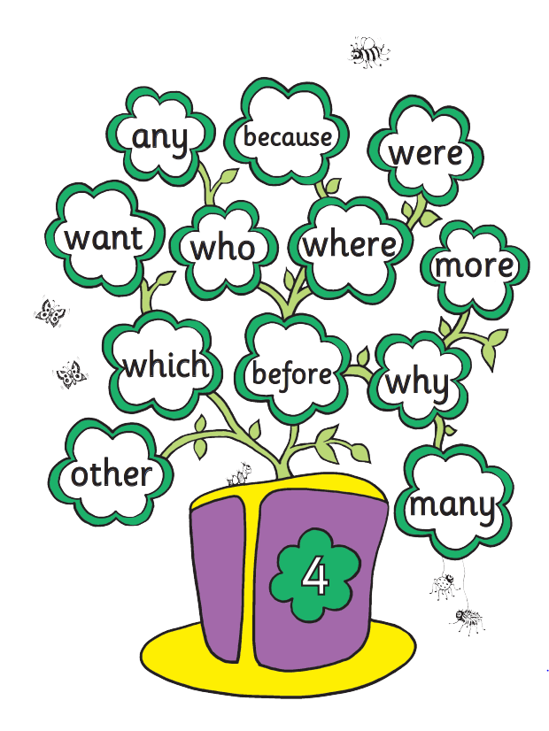

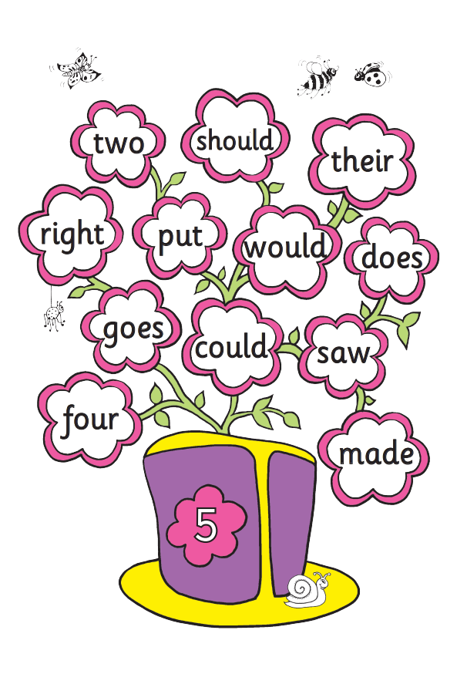
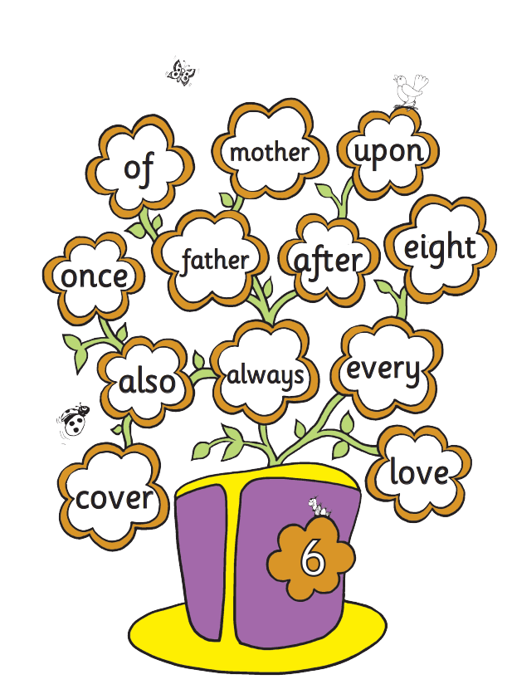

Zero Tolerance Words:
Year 1
Your child must know how to spell the following words
all
come
you
want
what
they
are
out
here
once
some
there
asked
when
little

