Phonics Journal

Rush Green Primary School
Year 1 – Summer 1

Phonics Teacher: Mrs Tracey

Child’s Name: _____________________________

Dear Parents/Carers,

Phonics is a way of teaching children to read quickly and fluently. The children are taught how to:
- Recognise the sounds that individual letters or groups of letters make
- Identify the sounds that different combinations of letters make such as ‘sh’ in ship and ‘oa’ in goat
- Blend these sounds together from left to right to make words.

How do we teach Phonics?
At Rush Green Primary School, we teach Phonics using the Jolly Phonics Programme. This journal contains a weekly breakdown of what your child will be learning in their Phonics lessons.

How can you help at home?
Use this journal as a tool to support your child’s learning at home. There are examples of words which your child can ‘segment and blend’ using their ‘phoneme fingers’.

How do we use this journal in school?
The children have a spelling challenge every Friday during their phonics lesson. Please practise the weekly spellings in this journal. You can also help your child write sentences containing the weekly challenge words so that they understand their meaning. The journal must be in school every Friday so the children can do their spelling test in it.

If you have any queries about this journal please speak to your child’s class teacher.

Thank you for your continued support.

Summer 1
Week | Grapheme | Example Words
1  15.04.24 | air  ear as air  are as air | fair, chair, staircase  bear, tearing, wear  mare, shared, stare
2  22.04.24 | soft c as ce, ci, cy  soft g as gi, ge, gy | nice, ice, slice  city, pencil  cycle, cylinder  giant, gigantic, ginger  large, change, orange  gym, gymnastics
3  29.04.24 | ue  u_e  ew as long oo | blue, glue, true  cube, tube, June, cute  pew, jewel, few
4  06.05.24 | ou  ow | ground, pounding, cloud  snowman, grown, flows, own
5  13.05.24 | er  ir  ur | father, computer, brother  bird, girl, twirl  fur, curl, turn
6  20.05.24 | aw  au  al | paw, saw, draw  Autumn, author, launching  also, always, walk

Week Beginning 15.04.24
every | staircase | father
carefully | mother | wearing

Include each of these words in a sentence:

Practise Test (at home)
Week Beginning 15.04.24
1
2
3
4
5
6

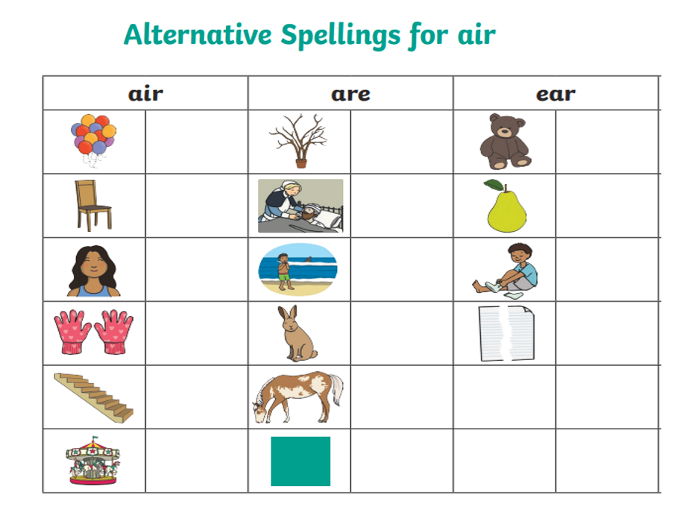

Week Beginning 22.04.24
voice | recycle | pencil
large | giraffe | apology

Include each of these words in a sentence:

Practise Test (at home)
Week Beginning 22.04.24
1
2
3
4
5
6

Read the following and fill in the missing words from the box below:
Fudge
My friend ______________ is a happy ____________. He always
has a smile on his _____________. At his party, we
_____________ in a _______________. Then we each ate a _________________ of ______________ cake. We had a great
time.
face Fudge orange
piece gent circle
danced

Week Beginning 29.04.24
goes | fewer | untrue
argue | does | excuse

Include each of these words in a sentence:

Practise Test (at home)
Week Beginning 29.04.24
1
2
3
4
5
6

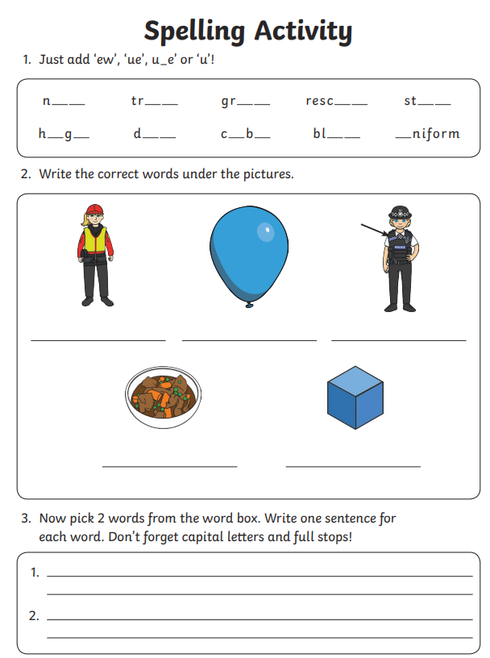
Week Beginning 06.05.24
could | downhill | sound
house | should | crowd

Include each of these words in a sentence:

Practise Test (at home)
Week Beginning 06.05.24
1
2
3
4
5
6

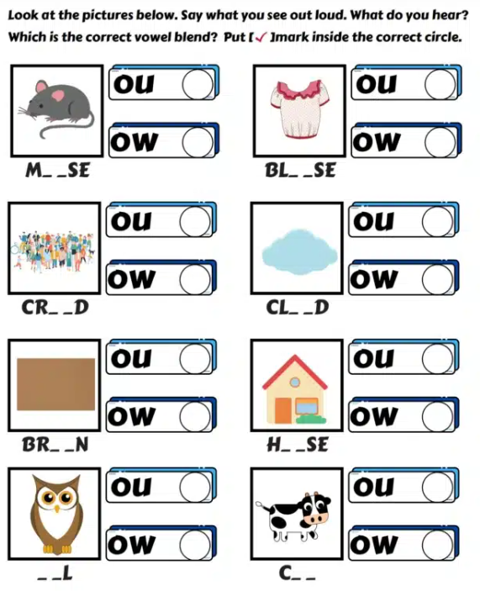

Week Beginning 13.05.24
also | helicopter | eight
curly | of | twirled

Include each of these words in a sentence:

Practise Test (at home)
Week Beginning 13.05.24
1
2
3
4
5
6

Spelling: sound er – er, ur, ir
The words below are missing the ‘er’ sound. Choose the correct spelling using er, ur or ir to complete the words.

wint_______ p______ple th_______sty
st_______ fing_____ laught_________
th_______d c______cle t______n
n_______se ch_______ch bak_________

Week Beginning 20.05.24
love | walked | after
squawk | cover | August

Include each of these words in a sentence:

Practise Test (at home)
Week Beginning 20.05.24
1
2
3
4
5
6

Use the pictures and write the words in the boxes using the correct spelling.
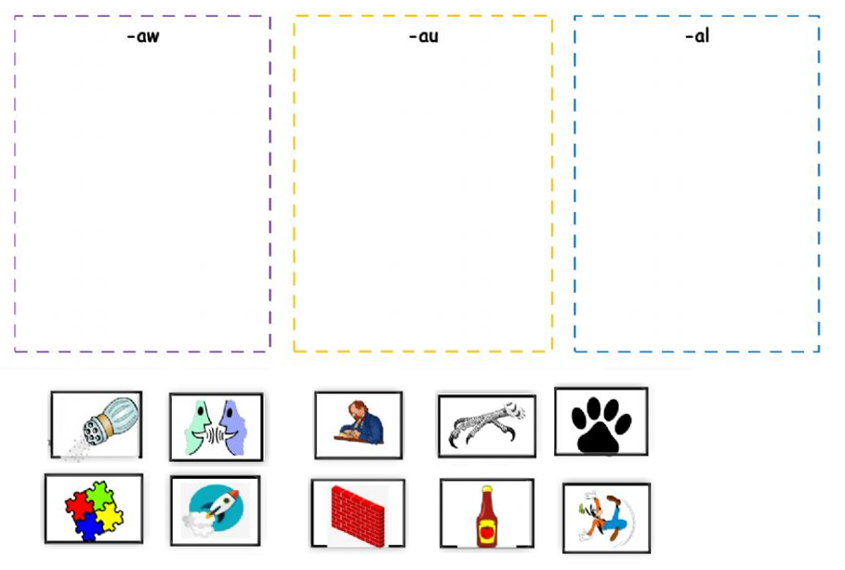

Week Beginning 15.04.24
SPELLING TEST

Week Beginning 22.04.24
SPELLING TEST

Week Beginning 29.04.24
SPELLING TEST

Week Beginning 06.05.24
SPELLING TEST

Week Beginning 13.05.24
SPELLING TEST

Week Beginning 20.05.24
SPELLING TEST

Phonics Terminology
Phonics | The relationships between the sounds of a language and the letters those sounds make.
Phoneme | The smallest unit of sound.
Grapheme | Letter/s that represent phonemes.
Digraph | A grapheme containing two letters that make just one sound (phoneme) i.e. sh in fish and ch in chip.
Trigraph | A grapheme containing three letters that make just one sound (phoneme) i.e air in hair and igh in night.
Segmenting | Splitting a spoken word into its phonemes in the order in which they are heard.
Blending | Taking given phonemes and combining them to make a word, the opposite of segmenting.
Phoneme Fingers | A method in which we use our fingers to segment a word i.e. c-a-t would be represented by three fingers and f-i-sh would also be represent by three fingers as it also contains three sounds even though it is made up of four letters.
It is very important that your child practises articulating each sound correctly and does not add extra sounds to the end of a phoneme i.e s should be pronounced as ssss and not sss-a
Useful links
Articulation of Phonemes | http://www.youtube.com/watch?v=BqhXUW_v-1s  Search for ‘articulation of phonemes’ on YouTube
Jolly Phonics Songs | http://www.youtube.com/watch?v=eCjJYB07aSU  Search for ‘Jolly Phonics in order’ on YouTube
Phonics Play | www.phonicsplay.co.uk

Jolly Phonics Tricky Words
Below are all of the tricky words that the children have learnt so far and will be learning throughout Spring 2. Please practise reading and spelling these words with your child.
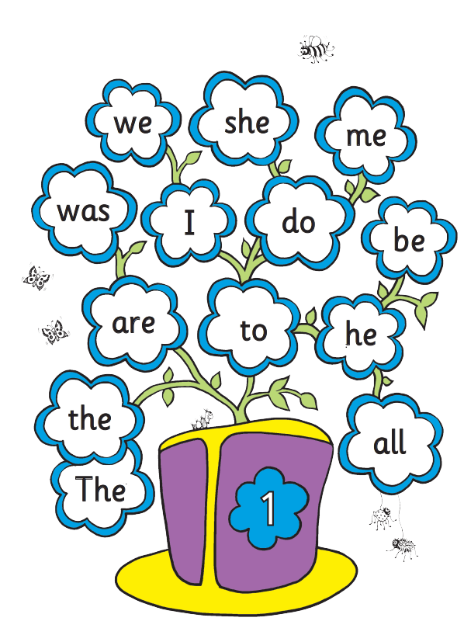

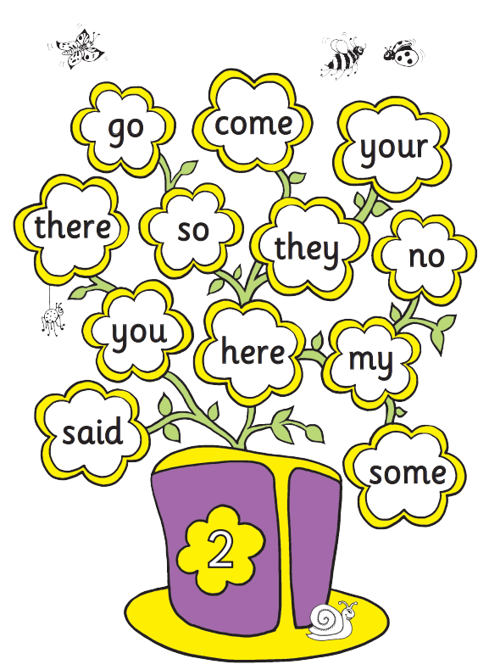

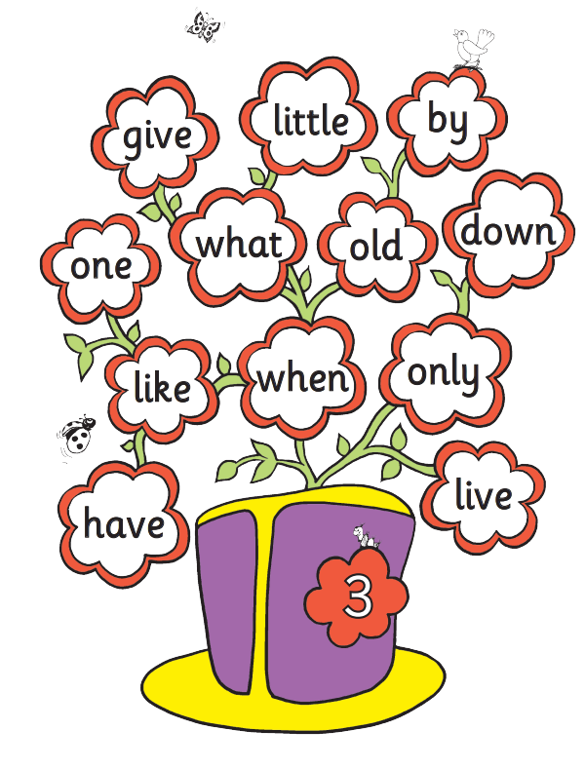

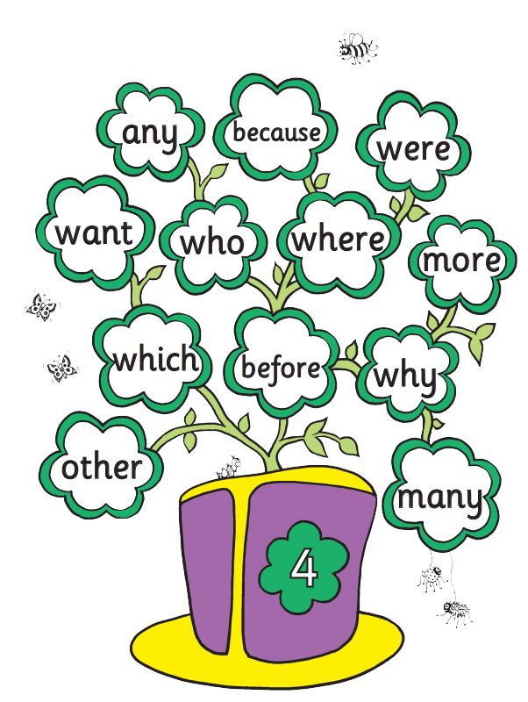

Zero Tolerance Words: Year 1
Your child must know how to spell the following words
all
come
you
want
what
they
are
out
here
once
some
there
asked
when
little

Zero Tolerance Words: Year 2
Your child must know how to spell the following words
very
about
after
because
should
great
really
could
where
called
people
fast
poor
every
any

