Dear Parents/Carers,

Please work with your child to help them become good spellers.
Use their spelling journal to practise spellings that are set for them each week. Help them learn the spelling rule and apply it and talk about exceptions to each rule. Help your child with the tricky part of words and also discuss how word patterns, endings, etc., can help them remember how to spell certain words. Put each word into a sentence so they can see the word in context. This often makes it easier for a child to remember.

At Rush Green Primary School we have high expectations of learners at all times. Included in this journal is a list of ‘Zero Tolerance’ words that children are expected to spell correctly at all times in their work. Please practise these words with your child regularly too. Spelling rules and patterns have been taught on a weekly basis and are based on what children may be learning in class during phonic lessons, spelling lessons or words they may need to know for a particular topic. There may be additional spellings sent home should the need arise during the term.

The ability to spell confidently enables an individual to become a more effective and fluent writer. Learning to spell should not be just learning lists of words (although this is a necessary first phase in establishing later automatic use) but a means of applying strategies appropriately, and building on known facts. This spelling journal will help support your child in these aims.

Thank you for your continued support.

Strategy - Roots

“To learn my word I can find the word root. I can see whether the root has been changed when the new letters are added, e.g. for a prefix, suffix, or a tense change”, for example
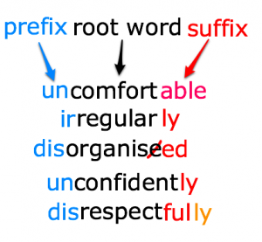

Strategy – Mnemonics

“To learn my word I can make up a sentence to help me remember it, or use sayings to help with tricky letters.
.” E.g. could – o u lucky duck;
people – people eat orange peel like elephants.
because – big elephants can’t always use small exits
"It's necessary to have 1 collar and 2 sleeves."



Strategy – Analogy


“To learn my word I can use words that I already know to help me.”
e.g. could, would, should.
ght- light, bright, tight, might, flight, fight, uptight, lighter, sightseeing...
pl- play, plan, plastic, plenty, plain, plonk...
spr- spring, sprung, spritz, sprat, spray, sprinkle...
Good spellers know letter patterns and use them to help recall spellings or guess the spelling. Knowing common letter patterns is a fantastic strategy to help you improve your spelling and to spell well.

Strategy – Word Families
Learn word families that are linked by meaning and pattern. This is a very interesting strategy and can help spelling by helping you love words and taking in interest in them.
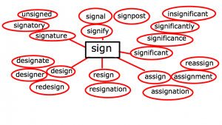
ject- (from Latin- throw) reject (throw away!), rejection, projection, (to throw light on something), projectile, dejection, objection, adjective (to throw light on nouns!), injection
rupt (from Latin for broken) rupture, interrupt, disruption, eruption, bankrupt, corrupt, abrupt...
Strategy – Handwriting



“To learn my word I can remember and practise the direction and movement of my pencil when I am writing it.”

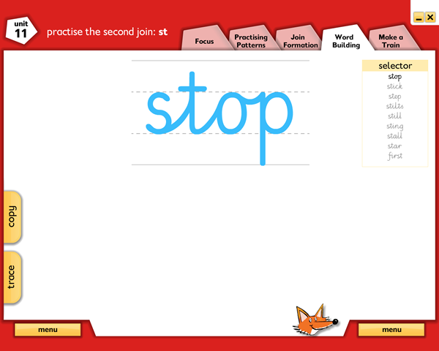

Strategy – Syllables and Phonemes

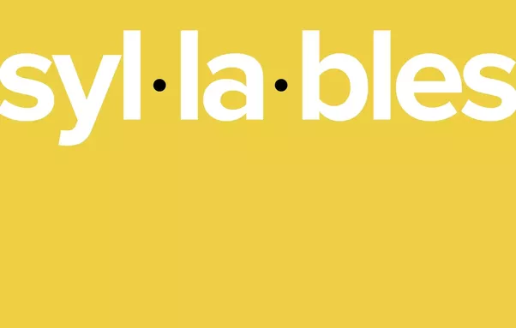
Use syllable breakdown “To learn my word I can listen to how many syllables there are so I can break it into smaller bits to remember. Then I can identify the phonemes in each syllable.” E.g. Sep-tem-ber. 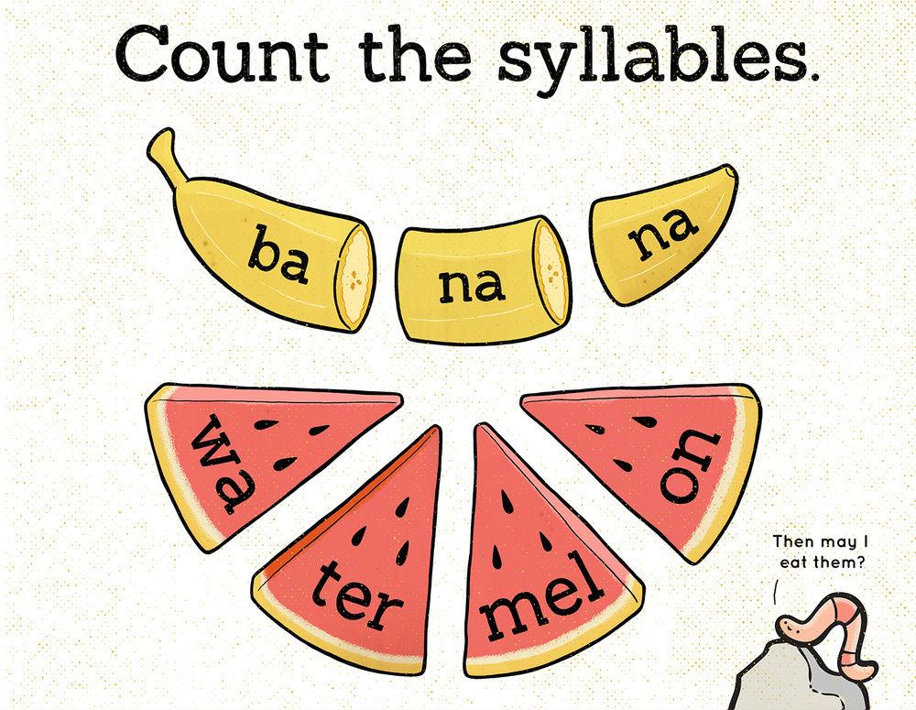
-   Study the word and practise spelling it out loud. |  |  | 2.  Use a piece of paper to cover your word.
3.  Write the word you covered. |  |  | 4.  Check to see if you spell your word correctly.
5. Learn the rule |  |  |   6. Apply the rule (remember that there may be exceptions to this rule)
Week 1
Group | A | B |  | C
Spelling Rule: | prefixes un (meaning not) and dis (meaning apart or away) | suffixes ify (meaning to become) and en (meaning to become or increase) |  | Words containing prefix tele- (meaning far or or at a distance) and trans- (meaning across, beyond or changing)
Example words
1 | unkind | beautify |  | television
2 | unhappy | purify |  | teleport
3 | unclean | glorify |  | telescopic
4 | disown | shorten |  | transportation
5 | disappear | deaden |  | transmission
6 | dislike | lengthen |  | translate
Write 6 of your own words, applying the spelling rule you have learnt.
Remember, you can use a dictionary to help you.
1.
2.
3.
4.
5.
6.
Explain the spelling rule in your own words:
Write 3 words that are exceptions to the rule:
Explain why these words do not follow the rule:
Include each of your own words in a sentence:
Remember – you will be tested on your ability to apply the rule, not on a set list of words.

Spelling Test
1.
2.
3.
4.
5.
6.
7.
8.
9.
10.
11.
12.
13.
14.
15.
16.
17.
18.
19.
20.

Study the word and practise spelling it out loud. |  |  | 2. Use a piece of paper to cover your word.
3. Write the word you covered. |  |  | 4. Check to see if you spell your word correctly.
5. Learn the rule |  |  | 6. Apply the rule (remember that there may be exceptions to this rule)
Week 2
Group | A | B |  | C
Spelling Rule: | Prefixes mis- (meaning mistaken or wrong) and difference between to, too and two | Prefixes Mis- (meaning mistaken or wrong) Ex (meaning out of or without) |  | Prefixes mini- (meaning small) and micro- (meaning tiny)
Example words
1 | mistake | misplace |  | minibus
2 | misplace | mistake |  | miniscule
3 | mischief | misread |  | miniature
4 | too | exhibit |  | microphone
5 | two | export |  | microwave
6 | to | explore |  | microscope
Write 6 of your own words, applying the spelling rule you have learnt.
Remember, you can use a dictionary to help you.
1.
2.
3.
4.
5.
6.
Explain the spelling rule in your own words:
Write 3 words that are exceptions to the rule:
Explain why these words do not follow the rule:
Include each of your own words in a sentence:
Remember – you will be tested on your ability to apply the rule, not on a set list of words.

Spelling Test
1.
2.
3.
4.
5.
6.
7.
8.
9.
10.
11.
12.
13.
14.
15.
16.
17.
18.
19.
20.

Study the word and practise spelling it out loud. |  |  | 2. Use a piece of paper to cover your word.
3. Write the word you covered. |  |  | 4. Check to see if you spell your word correctly.
5. Learn the rule |  |  | 6. Apply the rule (remember that there may be exceptions to this rule)
Week 3
Group | A | B |  | C
Spelling Rule: | Homophones – words that sound the same but have different spellings and meanings | Adding suffixes to nouns –tion (meaning action – changing a noun to a verb) and -ity (meaning to have a quality or be in a condition) |  | words containing prefixes denoting number such as tri (meaning 3) and quad (meaning 4)
Example words
1 | pear | caution |  | tripod
2 | pair | education |  | triangular
3 | see | creation |  | triple
4 | sea | curiosity |  | quadrilateral
5 | hear | creativity |  | quad-bike
6 | here | responsibility |  | quadruple
Write 6 of your own words, applying the spelling rule you have learnt.
Remember, you can use a dictionary to help you.
1.
2.
3.
4.
5.
6.
Explain the spelling rule in your own words:
Write 3 words that are exceptions to the rule:
Explain why these words do not follow the rule:
Include each of your own words in a sentence:
Remember – you will be tested on your ability to apply the rule, not on a set list of words.

Spelling Test
1.
2.
3.
4.
5.
6.
7.
8.
9.
10.
11.
12.
13.
14.
15.
16.
17.
18.
19.
20.

Study the word and practise spelling it out loud. |  |  | 2. Use a piece of paper to cover your word.
3. Write the word you covered. |  |  | 4. Check to see if you spell your word correctly.
5. Learn the rule |  |  | 6. Apply the rule (remember that there may be exceptions to this rule)
Week 4
Group | A | B |  | C
Spelling Rule: | Homophones – words that sound the same but have different spellings and meanings | Words with silent letters (letters that are not pronounced when the word is said aloud) |  | Words containing prefix aqua- (meaning linked to water) and multi- (meaning many)
Example words
1 | are | know |  | aquamarine
2 | our | write |  | aquarium
3 | wear | knit |  | aquaplane
4 | where | sign |  | multicultural
5 | hear | knight |  | multiply
6 | here | Wednesday |  | multimillionaire
Write 6 of your own words, applying the spelling rule you have learnt.
Remember, you can use a dictionary to help you.
1.
2.
3.
4.
5.
6.
Explain the spelling rule in your own words:
Write 3 words that are exceptions to the rule:
Explain why these words do not follow the rule:
Include each of your own words in a sentence:
Remember – you will be tested on your ability to apply the rule, not on a set list of words.

Spelling Test
1.
2.
3.
4.
5.
6.
7.
8.
9.
10.
11.
12.
13.
14.
15.
16.
17.
18.
19.
20.

Study the word and practise spelling it out loud. |  |  | 2. Use a piece of paper to cover your word.
3. Write the word you covered. |  |  | 4. Check to see if you spell your word correctly.
5. Learn the rule |  |  | 6. Apply the rule (remember that there may be exceptions to this rule)
Week 5
Group | A | B |  | C
Spelling Rule: | Contractions are short words made by putting two words together. Letters are omitted in the contraction and replaced by an apostrophe. The apostrophe shows where the letters would be if the words were written in full. E.g. do not -> don’t | Words with the same letter string but different pronunciations |  | Words containing prefix audi- (meaning to hear or linked to sound) and anti- (meaning against or opposite)
Example words
1 | don’t | mood |  | audience
2 | we’ll | book |  | audiobook
3 | we’re | height |  | audiologist
4 | they’ve | neighbour |  | antifreeze
5 | can’t | enough |  | antisocial
6 | shouldn’t | cough |  | antiseptic
Write 6 of your own words, applying the spelling rule you have learnt.
Remember, you can use a dictionary to help you.
1.
2.
3.
4.
5.
6.
Explain the spelling rule in your own words:
Write 3 words that are exceptions to the rule:
Explain why these words do not follow the rule:
Include each of your own words in a sentence:
Remember – you will be tested on your ability to apply the rule, not on a set list of words.

Spelling Test
1.
2.
3.
4.
5.
6.
7.
8.
9.
10.
11.
12.
13.
14.
15.
16.
17.
18.
19.
20.

Study the word and practise spelling it out loud. |  |  | 2. Use a piece of paper to cover your word.
3. Write the word you covered. |  |  | 4. Check to see if you spell your word correctly.
5. Learn the rule |  |  | 6. Apply the rule (remember that there may be exceptions to this rule)
Week 6
Group | A | B |  | C
Spelling Rule: | Prefix de- (meaning remove or separate) and re- (meaning over again) | Irregular plurals – when words end in f or fe, drop the f and replace it with ves |  | Irregular plurals – when words end in f or fe, drop the f and replace it with ves
Example words
1 | replay | wife |  | wife
2 | reread | wives |  | wives
3 | reapply | leaf |  | leaf
4 | deactivate | leaves |  | leaves
5 | devalue | thief |  | thief
6 | decide | thieves |  | thieves
Write 6 of your own words, applying the spelling rule you have learnt.
Remember, you can use a dictionary to help you.
1.
2.
3.
4.
5.
6.
Explain the spelling rule in your own words:
Write 3 words that are exceptions to the rule:
Explain why these words do not follow the rule:
Include each of your own words in a sentence:
Remember – you will be tested on your ability to apply the rule, not on a set list of words.

Spelling Test
1.
2.
3.
4.
5.
6.
7.
8.
9.
10.
11.
12.
13.
14.
15.
16.
17.
18.
19.
20.

Study the word and practise spelling it out loud. |  |  | 2. Use a piece of paper to cover your word.
3. Write the word you covered. |  |  | 4. Check to see if you spell your word correctly.
5. Learn the rule |  |  | 6. Apply the rule (remember that there may be exceptions to this rule)
Spellings that follow the rule. |  |  | Week 7
Group | A | B |  | C
Spelling Rule: | Words ending in –le  With a single consonant before the ending, words make a long vowel sound (the vowel sounds like its letter).  With a double consonant before the ending, words make a short vowel sound (the vowel sounds like it’s phonic sound). | Homophones – words that sound the same but are spelt differently |  | Contractions are short words made by putting two words together. Letters are omitted in the contraction and replaced by an apostrophe. The apostrophe shows where the letters would be if the words were written in full. E.g. do not -> don’t
Example words
1 | little | pear |  | hadn’t
2 | middle | pair |  | haven’t
3 | settle | see |  | won’t
4 | title | sea |  | you’re
5 | purple | hear |  | they’re
6 | cradle | here |  | you’ll
Write 6 of your own words, applying the spelling rule you have learnt.
Remember, you can use a dictionary to help you.
1.
2.
3.
4.
5.
6.
Explain the spelling rule in your own words:
Write 3 words that are exceptions to the rule:
Explain why these words do not follow the rule:
Include each of your own words in a sentence:
Remember – you will be tested on your ability to apply the rule, not on a set list of words.

Spelling Test
1.
2.
3.
4.
5.
6.
7.
8.
9.
10.
11.
12.
13.
14.
15.
16.
17.
18.
19.
20.

Study the word and practise spelling it out loud. |  |  | 2. Use a piece of paper to cover your word.
3. Write the word you covered. |  |  | 4. Check to see if you spell your word correctly.
5. Learn the rule |  |  | 6. Apply the rule (remember that there may be exceptions to this rule)
Spellings that follow the rule. |  |  | Week 8
Group | A | B |  | C
Spelling Rule: | Words ending in cle, ible, ple  With a single consonant before the ending, words make a long vowel sound (the vowel sounds like its letter).  With a double consonant before the ending, words make a short vowel sound (the vowel sounds like it’s phonic sound). | Letter string igh – to make an ‘i’ sound |  | Contractions are short words made by putting two words together. Letters are omitted in the contraction and replaced by an apostrophe. The apostrophe shows where the letters would be if the words were written in full. E.g. she is -> she’s
Example words
1 | incredible | sigh |  | who’s
2 | horrible | high |  | who’ll
3 | terrible | fright |  | mightn’t
4 | example | delight |  | mustn’t
5 | icicle | flight |  | would’ve
6 | circle | bright |  | could’ve
Write 6 of your own words, applying the spelling rule you have learnt.
Remember, you can use a dictionary to help you.
1.
2.
3.
4.
5.
6.
Explain the spelling rule in your own words:
Write 3 words that are exceptions to the rule:
Explain why these words do not follow the rule:
Include each of your own words in a sentence:
Remember – you will be tested on your ability to apply the rule, not on a set list of words.

Spelling Test
1.
2.
3.
4.
5.
6.
7.
8.
9.
10.
11.
12.
13.
14.
15.
16.
17.
18.
19.
20.

Study the word and practise spelling it out loud. |  |  | 2. Use a piece of paper to cover your word.
3. Write the word you covered. |  |  | 4. Check to see if you spell your word correctly.
5. Learn the rule |  |  | 6. Apply the rule (remember that there may be exceptions to this rule)
Spellings that follow the rule. |  |  | Week 9
Group | A | B |  | C
Spelling Rule: | suffixes –ly (to change an adjective to an adverb) and ful (to change a noun to an adjective) | Contractions are short words made by putting two words together. Letters are omitted in the contraction and replaced by an apostrophe. The apostrophe shows where the letters would be if the words were written in full. |  | Words containing prefixes mis- (meaning wrongly), ex- (meaning out of or not) and re- (meaning again)
Example words
1 | joyful | we’ll |  | misread
2 | careful | we’re |  | misfortune
3 | playful | they’ve |  | export
4 | helpful | couldn’t |  | explode
5 | lovely | won ‘t |  | realise
6 | luckily | can’t |  | replay
Write 6 of your own words, applying the spelling rule you have learnt.
Remember, you can use a dictionary to help you.
1.
2.
3.
4.
5.
6.
Explain the spelling rule in your own words:
Write 3 words that are exceptions to the rule:
Explain why these words do not follow the rule:
Include each of your own words in a sentence:
Remember – you will be tested on your ability to apply the rule, not on a set list of words.

Spelling Test
1.
2.
3.
4.
5.
6.
7.
8.
9.
10.
11.
12.
13.
14.
15.
16.
17.
18.
19.
20.

Study the word and practise spelling it out loud. |  |  | 2. Use a piece of paper to cover your word.
3. Write the word you covered. |  |  | 4. Check to see if you spell your word correctly.
5. Learn the rule |  |  | 6. Apply the rule (remember that there may be exceptions to this rule)
Spellings that follow the rule. |  |  | Week 10
Group | A | B |  | C
Spelling Rule: | Verbs that do not add –ed to the end when changing them to the past tense | Adverbs – adding –ly to the root word to change it from an adjective to an adverb |  | Words containing prefixes mis- (meaning wrongly), ex- (meaning out of or not) and re- (meaning again)
Example words
1 | ran | bravely |  | mischief
2 | swam | slowly |  | mischievous
3 | cried | kindly |  | exaggerate
4 | chose | gracefully |  | examine
5 | drank | cunningly |  | readmit
6 | thought | anxiously |  | reappear
Write 6 of your own words, applying the spelling rule you have learnt.
Remember, you can use a dictionary to help you.
1.
2.
3.
4.
5.
6.
Explain the spelling rule in your own words:
Write 3 words that are exceptions to the rule:
Explain why these words do not follow the rule:
Include each of your own words in a sentence:
Remember – you will be tested on your ability to apply the rule, not on a set list of words.

Spelling Test
1.
2.
3.
4.
5.
6.
7.
8.
9.
10.
11.
12.
13.
14.
15.
16.
17.
18.
19.
20.

Study the word and practise spelling it out loud. |  |  | 2. Use a piece of paper to cover your word.
3. Write the word you covered. |  |  | 4. Check to see if you spell your word correctly.
5. Learn the rule |  |  | 6. Apply the rule (remember that there may be exceptions to this rule)
Spellings that follow the rule. |  |  | Week 11
Group | A | B |  | C
Spelling Rule: | Adding er and est  If the word ends in a consonant, just add er or est  If the word ends in a vowel or a y, drop the last letter and add ier or iest | words containing prefix auto- (meaning self), circ- (meaning around) and bi- (meaning two) |  | words containing prefix auto- (meaning self), circ- (meaning around) and bi- (meaning two)
Example words
1 | smaller | autobiography |  | autobiography
2 | smallest | automatic |  | automatic
3 | greedier | circus |  | circus
4 | greediest | circulate |  | circulate
5 | happier | bisect |  | bisect
6 | happiest | bicycle |  | bicycle
Write 6 of your own words, applying the spelling rule you have learnt.
Remember, you can use a dictionary to help you.
1.
2.
3.
4.
5.
6.
Explain the spelling rule in your own words:
Write 3 words that are exceptions to the rule:
Explain why these words do not follow the rule:
Include each of your own words in a sentence:
Remember – you will be tested on your ability to apply the rule, not on a set list of words.

Spelling Test
1.
2.
3.
4.
5.
6.
7.
8.
9.
10.
11.
12.
13.
14.
15.
16.
17.
18.
19.
20.

Study the word and practise spelling it out loud. |  |  | 2. Use a piece of paper to cover your word.
3. Write the word you covered. |  |  | 4. Check to see if you spell your word correctly.
5. Learn the rule |  |  | 6. Apply the rule (remember that there may be exceptions to this rule)
Spellings that follow the rule. |  |  | Week 12
Group | A | B |  | C
Spelling Rule: | Irregular past tense verbs - Verbs that do not add –ed to the end when changing them to the past tense | Suffix –ment (to change a verb to a noun) and –ness (changing an adjective to a noun) |  | words containing prefix auto- (meaning self), circ- (meaning around) and bi- (meaning two)
Example words
1 | go | improvement |  | autopsies
2 | went | arrangement |  | automated
3 | have | settlement |  | circled
4 | had | shyness |  | circumstances
5 | do | laziness |  | binoculars
6 | did | happiness |  | bilingual
Write 6 of your own words, applying the spelling rule you have learnt.
Remember, you can use a dictionary to help you.
1.
2.
3.
4.
5.
6.
Explain the spelling rule in your own words:
Write 3 words that are exceptions to the rule:
Explain why these words do not follow the rule:
Include each of your own words in a sentence:
Remember – you will be tested on your ability to apply the rule, not on a set list of words.

Spelling Test
1.
2.
3.
4.
5.
6.
7.
8.
9.
10.
11.
12.
13.
14.
15.
16.
17.
18.
19.
20.

Spelling Rules
The Rule: | Examples:
The Rule: | Examples:
The Rule: | Examples:

Vibrant Vocabulary

Good writers use the best words for the job! Never use a boring word just because you know how to spell it – HAVE A GO at using the best word. If you’re not sure how to spell it – DON’T PANIC! Put a wiggly line underneath and look it up when you’ve finished writing.
Copy it below to use again another time.
AMAZING ADJECTIVES | POWERFUL  VERBS | ASTOUNDING  ADVERBS



