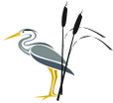
Phonics Journal

Rush Green Primary School
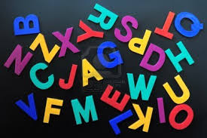
Year 1 – Spring 2

Phonics Teacher: Miss Ellis

Child’s Name: _____________________________



Dear Parents/Carers,
Phonics is a way of teaching children to read quickly and fluently. The children are taught how to:
- Recognise the sounds that individual letters or groups of letters make
- Identify the sounds that different combinations of letters make such as ‘sh’ in ship and ‘oa’ in goat
- Blend these sounds together from left to right to make words.

How do we teach Phonics?
At Rush Green Primary School we teach Phonics using the Jolly Phonics Programme. This journal contains a weekly breakdown of what your child will be learning in their Phonics lessons.

How can you help at home?
Use this journal as a tool to support your child’s learning at home. There are examples of words which your child can ‘segment and blend’ using their ‘phoneme fingers’.

How do we use this journal in school?
The children have a spelling challenge every Friday during their phonics lesson. Please practise the weekly spellings in this journal. You can also help your child write sentences containing the weekly challenge words so that they understand their meaning. The journal must be in school every Friday so the children can do their spelling test in it.

If you have any queries about this journal please speak to your child’s class teacher.
Thank you for your continued support.

Spring 2
Week | Grapheme | Example Words
1  24.02.25 | ee  ea | tree, queen, cheek  sea, meat, eat, easy
2  03.03.25 | igh  y (ie) | night, fight, light  my, shy, cry, sky, python
3  10.03.25 | ow (oa)  ow (ou) | own, bow, snow, blow,  owl, cow, brown, town, powder
4  17.03.25 | ir  ur  er | girl, skirt, stir, third  burn, hurt, turnip  otter, number, verb
5  24.03.25 | ue  ew | rescue, cue, fuel  few, ewe, pew
6  31.03.25 | Revision Week, Split Digraphs  a-e  e-e  i-e  o-e | make, name, snake  eve, Pete, theme  like, ride, spine  bone, home, stone

Week Beginning 24.02.25
read | tree | eat
queen | easy | eel

Include each of these words in a sentence:

Finish each word on the right by adding the ee digraph. Then match each word to the corresponding picture.

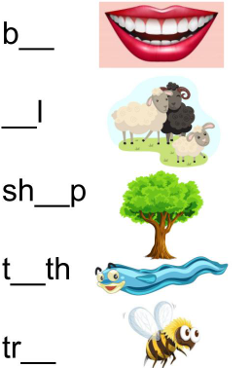
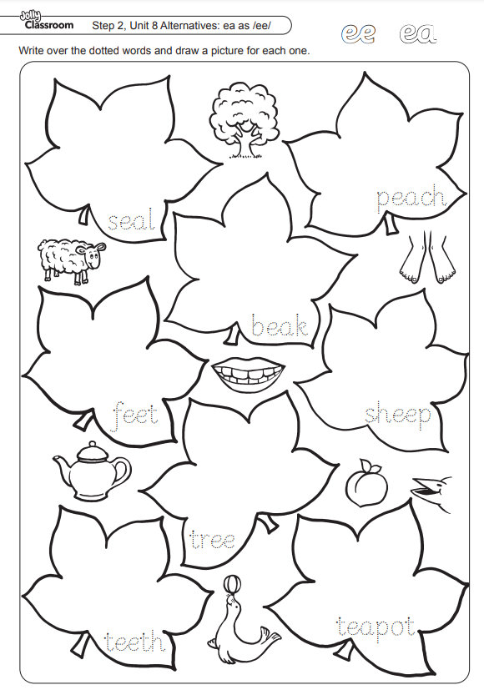

Practise Test (at home)
Week Beginning 24.02.25
1
2
3
4
5
6
Week Beginning 03.03.25
night | light | python
my | flying | sigh

Include each of these words in a sentence:

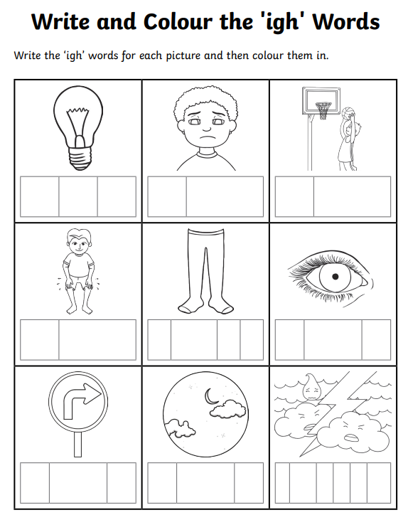

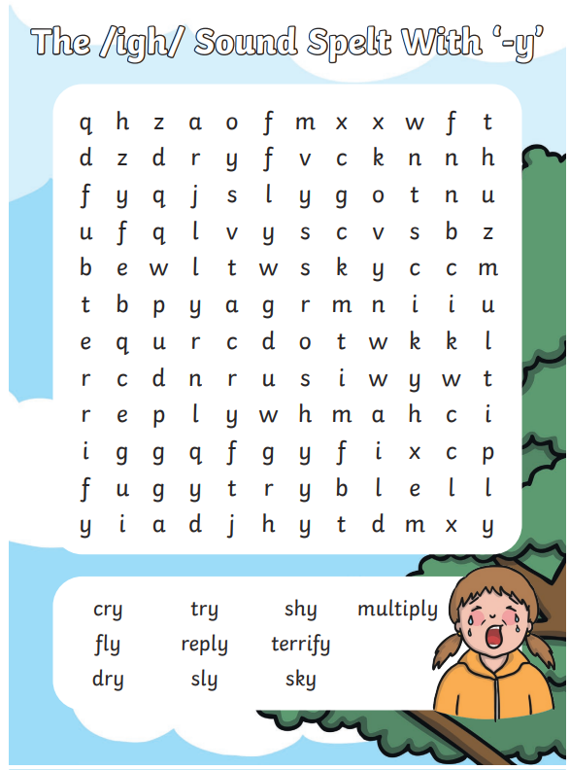

Practise Test (at home)
Week Beginning 03.03.25
1
2
3
4
5
6

Week Beginning 10.03.25
bow | owl | brown
own | snowy | allow

Include each of these words in a sentence:

Read each word. Then, cut along the dotted lines and decide if the /ow/ is making an /oa/ or /ou/ sound. Sort them into two piles.
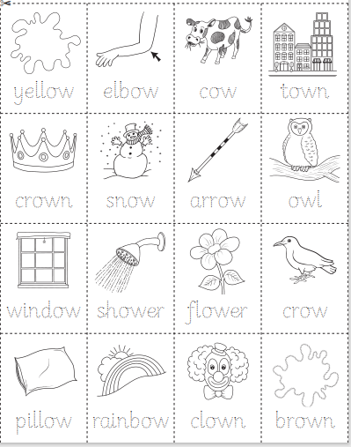

Write each word into the table using the /ou/ and /ow/ heading to help you.

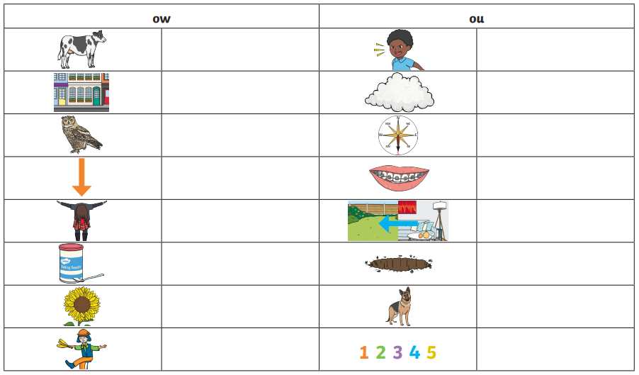

Practise Test (at home)
Week Beginning 10.03.25
1
2
3
4
5
6

Week Beginning 17.03.25
girl | burn | verb
stir | turnip | number

Include each of these words in a sentence:

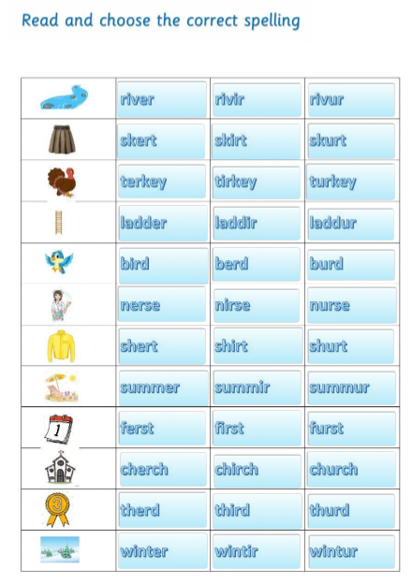


Practise Test (at home)
Week Beginning 17.03.25
1
2
3
4
5
6

Week Beginning 24.03.25
value | few | due
ewe | venue | new

Include each of these words in a sentence:

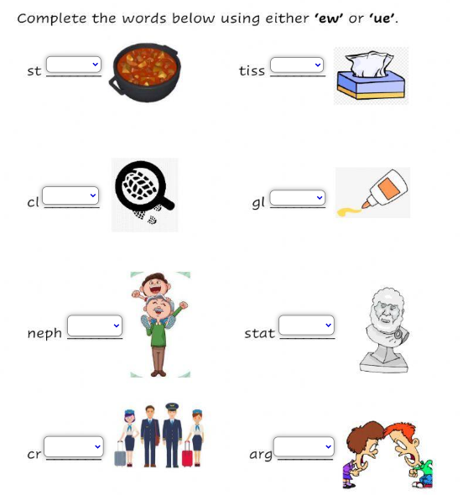

Practise Test (at home)
Week Beginning 24.03.25
1
2
3
4
5
6

Week Beginning 31.03.25
like | these | home
eve | name | time

Include each of these words in a sentence:

Write a word to match each picture below. Remember to use the a-e split digraph.
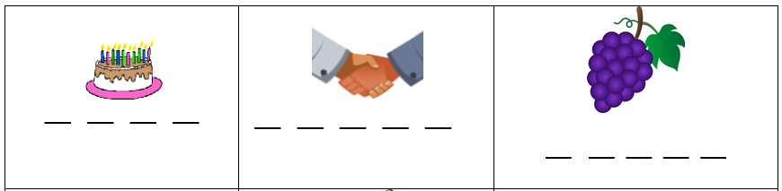

Write a word to match each picture below. Remember to use the o-e split digraph.
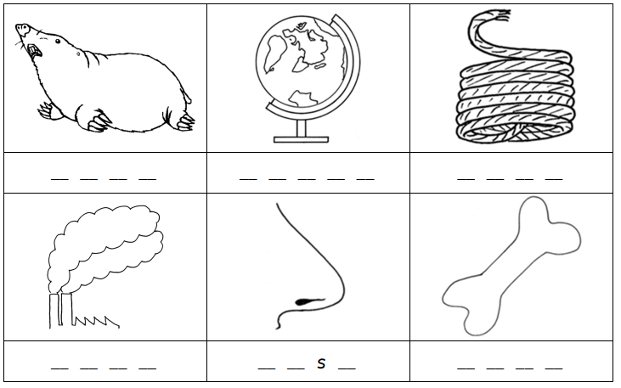

Write a word to match each picture below. Remember to use the i-e split digraph.
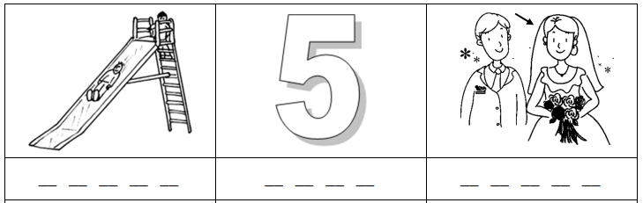
Practise Test (at home)
Week Beginning 31.03.25
1
2
3
4
5
6

Week Beginning 24.02.25
SPELLING TEST

Week Beginning 03.03.25
SPELLING TEST

Week Beginning 10.03.25
SPELLING TEST

Week Beginning 17.03.25
SPELLING TEST

Week Beginning 24.03.25
SPELLING TEST

Week Beginning 31.03.25
SPELLING TEST

Zero Tolerance Words: Reception
Your child must know how to spell the following words
the
to
no
go
and
look
me
my
was
went
he
with

Zero Tolerance Words: Year 1
Your child must know how to spell the following words
all
come
you
want
what
they
are
out
here
once
some
there
asked
when
little

Phonics Terminology
Phonics | The relationships between the sounds of a language and the letters those sounds make.
Phoneme | The smallest unit of sound.
Grapheme | Letter/s that represent phonemes.
Digraph | A grapheme containing two letters that make just one sound (phoneme) i.e. sh in fish and ch in chip.
Trigraph | A grapheme containing three letters that make just one sound (phoneme) i.e air in hair and igh in night.
Segmenting | Splitting a spoken word into its phonemes in the order in which they are heard.
Blending | Taking given phonemes and combining them to make a word, the opposite of segmenting.
Phoneme Fingers | A method in which we use our fingers to segment a word i.e. c-a-t would be represented by three fingers and f-i-sh would also be represent by three fingers as it also contains three sounds even though it is made up of four letters.

It is very important that your child practises articulating each sound correctly and does not add extra sounds to the end of a phoneme i.e s should be pronounced as ssss and not sss-a
Useful links
Articulation of Phonemes | http://www.youtube.com/watch?v=BqhXUW_v-1s  Search for ‘articulation of phonemes’ on YouTube
Jolly Phonics Songs | http://www.youtube.com/watch?v=eCjJYB07aSU  Search for ‘Jolly Phonics in order’ on YouTube
Phonics Play | www.phonicsplay.co.uk

