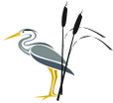
Spelling Journal

Rush Green Primary School
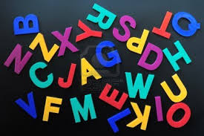
Year 2 – Summer

Miss Lee
Child’s Name: _____________________________

Dear Parents/Carers,

Please work with your child to help them become good spellers.
Use their spelling journal to practise spellings that are set for them each week. Help them learn the spelling rule and apply it and talk about exceptions to each rule. Help your child with the tricky part of words and also discuss how word patterns, endings, etc., can help them remember how to spell certain words. Put each word into a sentence so they can see the word in context. This often makes it easier for a child to remember.

At Rush Green Primary School we have high expectations of learners at all times. Included in this journal is a list of ‘Zero Tolerance’ words that children are expected to spell correctly at all times in their work. Please practise these words with your child regularly too. Spelling rules and patterns have been taught on a weekly basis and are based on what children may be learning in class during phonic lessons, spelling lessons or words they may need to know for a particular topic. There may be additional spellings sent home should the need arise during the term.

The ability to spell confidently enables an individual to become a more effective and fluent writer. Learning to spell should not be just learning lists of words (although this is a necessary first phase in establishing later automatic use) but a means of applying strategies appropriately, and building on known facts. This spelling journal will help support your child in these aims.

Thank you for your continued support.

Strategy - Roots

“To learn my word I can find the word root. I can see whether the root has been changed when the new letters are added, e.g. for a prefix, suffix, or a tense change”, for example
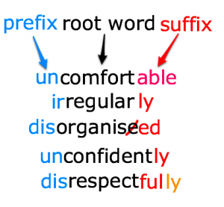

Strategy – Mnemonics

“To learn my word I can make up a sentence to help me remember it, or use sayings to help with tricky letters.
.” E.g. could – o u lucky duck;
people – people eat orange peel like elephants.
because – big elephants can’t always use small exits
"It's necessary to have 1 collar and 2 sleeves."

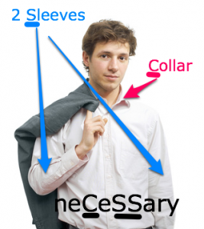

Strategy – Analogy


“To learn my word I can use words that I already know to help me.”
e.g. could, would, should.
ght- light, bright, tight, might, flight, fight, uptight, lighter, sightseeing...
pl- play, plan, plastic, plenty, plain, plonk...
spr- spring, sprung, spritz, sprat, spray, sprinkle...
Good spellers know letter patterns and use them to help recall spellings or guess the spelling. Knowing common letter patterns is a fantastic strategy to help you improve your spelling and to spell well.

Strategy – Word Families
Learn word families that are linked by meaning and pattern. This is a very interesting strategy and can help spelling by helping you love words and taking in interest in them.
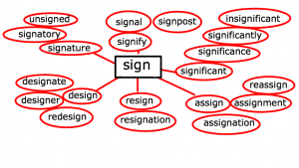
ject- (from Latin- throw) reject (throw away!), rejection, projection, (to throw light on something), projectile, dejection, objection, adjective (to throw light on nouns!), injection
rupt (from Latin for broken) rupture, interrupt, disruption, eruption, bankrupt, corrupt, abrupt...

Strategy – Handwriting

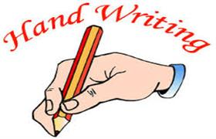

“To learn my word I can remember and practise the direction and movement of my pencil when I am writing it.”

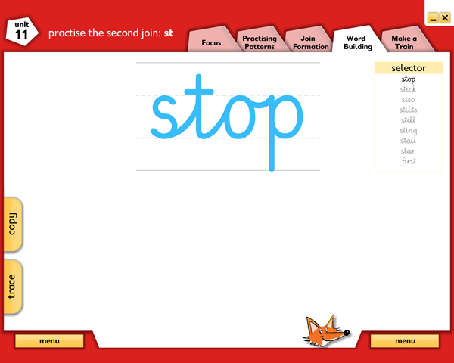

Strategy – Syllables and Phonemes

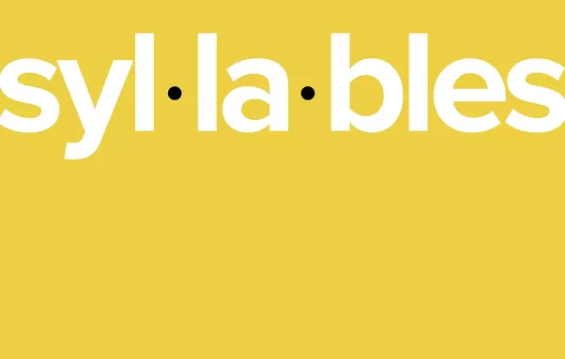
Use syllable breakdown “To learn my word I can listen to how many syllables there are so I can break it into smaller bits to remember. Then I can identify the phonemes in each syllable.” E.g. Sep-tem-ber. 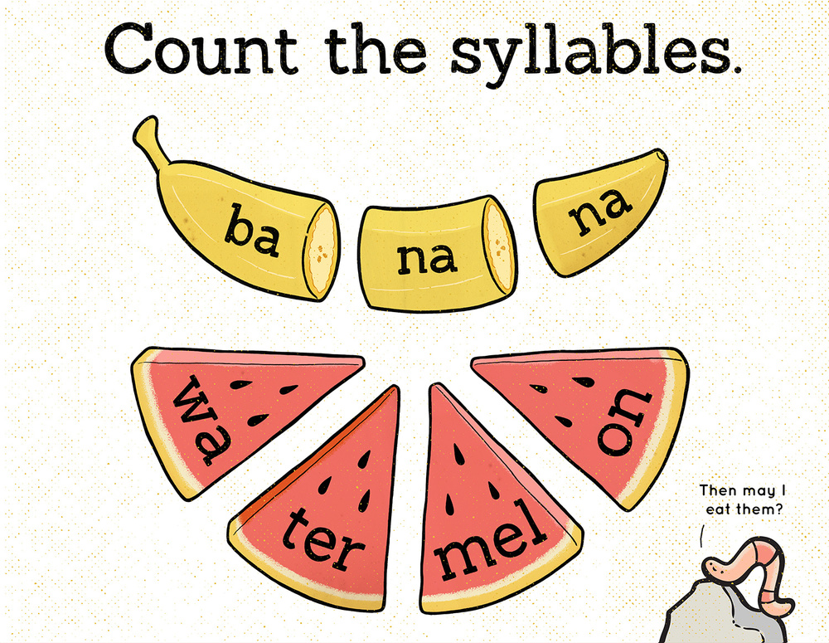
-   Study the word and practise spelling it out loud. |  | 2.  Use a piece of paper to cover your word.
3. 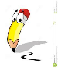 Write the word you covered. |  | 4.  Check to see if you spell your word correctly.
5. Learn the rule |  |   6. Apply the rule (remember that there may be exceptions to this rule)
Spellings that follow the rule. |  | W/b 21/04/25
Teacher | Miss Lee
Spelling Rules: | The /n/ sound spelt kn and (less often) gn at the beginning of words – these are silent letters that do not need sounding out.
Example words
1 | knock
2 | know
3 | knee
4 | gnat
5 | gnaw
6 | gnome
Write 6 of your own words, applying the spelling rule you have learnt.
Remember, you can use a dictionary to help you.
1.
2.
3.
4.
5.
6.
Explain the spelling rule in your own words:
Write 3 words that are exceptions to the rule;
Explain why these words do not follow the rule:
Include each of your own words in a sentence:
Remember – you will be tested on your ability to apply the rule, not on a set list of words.

W/b 21.04.25
SPELLING TEST

Study the word and practise spelling it out loud. |  | 2. Use a piece of paper to cover your word.
3. Write the word you covered. |  | 4. Check to see if you spell your word correctly.
5. Learn the rule |  | 6. Apply the rule (remember that there may be exceptions to this rule)
Spellings that follow the rule. |  | W/b 28.04.25
Teacher | Miss Lee
Spelling Rules: | A prefix is a letter or group of letters added to the beginning of a word.  Most prefixes are added to the beginning of root words without any changes in spelling.  The prefix ‘dis’ means ‘not’.
Example words
1 | disagree
2 | dislike
3 | disown
4 | distrust
5 | disappear
6 | dishonest
Write 6 of your own words, applying the spelling rule you have learnt.
Remember, you can use a dictionary to help you.
1.
2.
3.
4.
5.
6.
Explain the spelling rule in your own words:
Write 3 words that are exceptions to the rule;
Explain why these words do not follow the rule:
Include each of your own words in a sentence:
Remember – you will be tested on your ability to apply the rule, not on a set list of words.

W/b 28.04.25
SPELLING TEST

Study the word and practise spelling it out loud. |  | 2. Use a piece of paper to cover your word.
3. Write the word you covered. |  | 4. Check to see if you spell your word correctly.
5. Learn the rule |  | 6. Apply the rule (remember that there may be exceptions to this rule)
Spellings that follow the rule. |  | W/b 05.05.25
Teacher | Miss Lee
Spelling Rules: | Suffixes: A letetr or group of letters added to the end of a word, – ed, er and est  When the root word ends in a –y that has a consonant before it, the y is changed to i before –ed, –er and –est are added.
Example words
1 | copied
2 | copier
3 | happier
4 | happiest
5 | cried
6 | replied
1.
2.
3.
4.
5.
6.
Explain the spelling rule in your own words:
Write 3 words that are exceptions to the rule;
Explain why these words do not follow the rule:
Include each of your own words in a sentence:
Remember – you will be tested on your ability to apply the rule, not on a set list of words.

W/b 05.05.25
SPELLING TEST

Study the word and practise spelling it out loud. |  | 2. Use a piece of paper to cover your word.
3. Write the word you covered. |  | 4. Check to see if you spell your word correctly.
5. Learn the rule |  | 6. Apply the rule (remember that there may be exceptions to this rule)
Spellings that follow the rule. |  | W/b 12.05.25
Teacher | Miss Lee
Spelling Rules: | Adding the suffixes -ing, -ed, -er, -est and -y  When adding the suffixes –ing, –ed, –er, –est and –y to words ending in –e with a consonant before it,  the –e at the end of the root word is dropped before –ing, –ed, –er, –est, –y or any other suffix beginning with a vowel letter is added.
Example words
1 | hiking
2 | hike
3 | hiker
4 | nicer
5 | nicest
6 | shine
7 | shining
Write 6 of your own words, applying the spelling rule you have learnt.
Remember, you can use a dictionary to help you.
1.
2.
3.
4.
5.
6.
Explain the spelling rule in your own words:
Write 3 words that are exceptions to the rule;
Explain why these words do not follow the rule:
Include each of your own words in a sentence:
Remember – you will be tested on your ability to apply the rule, not on a set list of words.

W/b 12.05.25
SPELLING TEST

Study the word and practise spelling it out loud. |  | 2. Use a piece of paper to cover your word.
3. Write the word you covered. |  | 4. Check to see if you spell your word correctly.
5. Learn the rule |  | 6. Apply the rule (remember that there may be exceptions to this rule)
Spellings that follow the rule. |  | W/b 19.05.25
Teacher | Miss Lee
Spelling Rules: | Adding the suffixes -ing, -ed, -er, -est and -y  When adding –ing, –ed, –er, –est and –y to words of one syllable ending in a single consonant letter after a single vowel letter, the last consonant letter of the root word is doubled.
Example words
1 | patting
2 | patted
3 | humming
4 | hummed
5 | saddest
6 | runner
7 | runny
Write 6 of your own words, applying the spelling rule you have learnt.
Remember, you can use a dictionary to help you.
1.
2.
3.
4.
5.
6.
7.
Explain the spelling rule in your own words:
Write 3 words that are exceptions to the rule;
Explain why these words do not follow the rule:
Include each of your own words in a sentence:
Remember – you will be tested on your ability to apply the rule, not on a set list of words.

W/b 19.05.25
SPELLING TEST
1.
2.
3.
4.
5.
6.

Study the word and practise spelling it out loud. |  | 2. Use a piece of paper to cover your word.
3. Write the word you covered. |  | 4. Check to see if you spell your word correctly.
5. Learn the rule |  | 6. Apply the rule (remember that there may be exceptions to this rule)
Spellings that follow the rule. |  | W/b 02.06.25
Teacher | Miss Lee
Spelling Rules: | The suffixes –ment, –ness, –ful , –less and –ly  If a suffix starts with a consonant letter, it is added straight on to most root words without any change to the last letter of those words.
Example words
1 | enjoyment
2 | sadness
3 | careful
4 | playful
5 | badly
6 | hopeless
Write 6 of your own words, applying the spelling rule you have learnt.
Remember, you can use a dictionary to help you.
1.
2.
3.
4.
5.
6.
Explain the spelling rule in your own words:
Write 3 words that are exceptions to the rule;
Explain why these words do not follow the rule:
Include each of your own words in a sentence:
Remember – you will be tested on your ability to apply the rule, not on a set list of words.

W/b 06.02.25
SPELLING TEST
1.
2.
3.
4.
5.
6.

Study the word and practise spelling it out loud. |  | 2. Use a piece of paper to cover your word.
3. Write the word you covered. |  | 4. Check to see if you spell your word correctly.
5. Learn the rule |  | 6. Apply the rule (remember that there may be exceptions to this rule)
Spellings that follow the rule. |  | W/b 09.06.25
Teacher | Miss Lee
Spelling Rules: | Contractions  A contraction is a word made by shortening and combining two words. Letters are omitted and replaced by an apostrophe. The apostrophe shows where the letters would be if the words were written in full.
Example words
1 | He will – he’ll
2 | She will – she’ll
3 | I would – I’d
4 | will not – won’t
5 | they are – they’re
6 | I have – I’ve
Write 6 of your own words, applying the spelling rule you have learnt.
Remember, you can use a dictionary to help you.
1.
2.
3.
4.
5.
6.
Explain the spelling rule in your own words:
Write 3 words that are exceptions to the rule;
Explain why these words do not follow the rule:
Include each of your own words in a sentence:
Remember – you will be tested on your ability to apply the rule, not on a set list of words.

W/b 09.06.25
SPELLING TEST

Study the word and practise spelling it out loud. |  | 2. Use a piece of paper to cover your word.
3. Write the word you covered. |  | 4. Check to see if you spell your word correctly.
5. Learn the rule |  | 6. Apply the rule (remember that there may be exceptions to this rule)
Spellings that follow the rule. |  | W/b 16.06.25
Teacher | Miss Lee
Spelling Rules: | Homophones  Homophones are groups of words which sound the same when you say them but have different spellings and meanings.
Example words
1 | they’re their there
2 | buy by
3 | flower flour
4 | deer dear
5 | whole hole
6 | know no
7 | knew new
Write 6 of your own words, applying the spelling rule you have learnt.
Remember, you can use a dictionary to help you.
1.
2.
3.
4.
5.
6.
Explain the spelling rule in your own words:
Write 3 words that are exceptions to the rule;
Explain why these words do not follow the rule:
Include each of your own words in a sentence:
Remember – you will be tested on your ability to apply the rule, not on a set list of words.

W/b 16.06.25
SPELLING TEST

Study the word and practise spelling it out loud. |  | 2. Use a piece of paper to cover your word.
3. Write the word you covered. |  | 4. Check to see if you spell your word correctly.
5. Learn the rule |  | 6. Apply the rule (remember that there may be exceptions to this rule)
Spellings that follow the rule. |  | W/b 23.06.25
Teacher | Miss Lee
Spelling Rules: | Adding the prefix ‘un’ meaning ‘opposite’ to root words  Most prefixes are added to the beginning of root words without any changes in spelling.
Example words
1 | unhappy
2 | unpack
3 | unwell
4 | uncertain
5 | untidy
6 | untrue
7. | unfortunate
1.
2.
3.
4.
5.
6.
Explain the spelling rule in your own words:
Write 3 words that are exceptions to the rule;
Explain why these words do not follow the rule:
Include each of your own words in a sentence:
Remember – you will be tested on your ability to apply the rule, not on a set list of words.

W/b 23.06.25
SPELLING TEST

Study the word and practise spelling it out loud. |  | 2. Use a piece of paper to cover your word.
3. Write the word you covered. |  | 4. Check to see if you spell your word correctly.
5. Learn the rule |  | 6. Apply the rule (remember that there may be exceptions to this rule)
Spellings that follow the rule. |  | W/b 30.06.25
Teacher | Miss Lee
Spelling Rules: | The suffix ‘ly’ can be used to change adjectives into adverbs  Rule 1  Just add -ly to words ending in a consonant.  Rule 2  Add -ly to words ending in -l, Simply add -ly so word will end in ‘lly’
Example words | slow + ly → slowly  quick + ly → quickly |  | accidental + ly = accidentally
1 | generally
2 | quickly
3 | gratefully
4 | kindly
5 | finally
6 | eventually
Write 6 of your own words, applying the spelling rule you have learnt.
Remember, you can use a dictionary to help you.
1.
2.
3.
4.
5.
6.
Explain the spelling rule in your own words:
Write 3 words that are exceptions to the rule;
Explain why these words do not follow the rule:
Include each of your own words in a sentence:
Remember – you will be tested on your ability to apply the rule, not on a set list of words.

W/b 30.06.25
SPELLING TEST

Study the word and practise spelling it out loud. |  | 2. Use a piece of paper to cover your word.
3. Write the word you covered. |  | 4. Check to see if you spell your word correctly.
5. Learn the rule |  | 6. Apply the rule (remember that there may be exceptions to this rule)
Spellings that follow the rule. |  | W/b 07.07.25
Teacher | Miss Lee
Spelling Rules: | The suffix ‘ly’ can be used to change adjectives into adverbs  Rule 3  Verbs that end in an e. Keep the ‘e’ and add ‘ly’.  Rule 4  Words ending with patterns (-ble, -ple, -tle, -gle, -dle, -kle). Change the 'e' to 'y'
Example words | Love + ly = lovely |  | Crumble + ly = crumbly
1 | lonely
2 | rarely
3 | bearably
4 | giggly
5 | wriggly
6 | bravely
7 | Bristly
Write 6 of your own words, applying the spelling rule you have learnt.
Remember, you can use a dictionary to help you.
1.
2.
3.
4.
5.
6.
7.
Explain the spelling rule in your own words:
Write 3 words that are exceptions to the rule;
Explain why these words do not follow the rule:
Include each of your own words in a sentence:
Remember – you will be tested on your ability to apply the rule, not on a set list of words.

W/b 07.07.25
SPELLING TEST
1.
2.
3.
4.
5.
6.

Study the word and practise spelling it out loud. |  | 2. Use a piece of paper to cover your word.
3. Write the word you covered. |  | 4. Check to see if you spell your word correctly.
5. Learn the rule |  | 6. Apply the rule (remember that there may be exceptions to this rule)
Spellings that follow the rule. |  | W/b 14.07.25
Teacher | Miss Lee
Spelling Rules: | Adding the suffixes -ing, -ed, -er, -est and -y  When adding –ing, –ed, –er, –est and –y to words of one syllable ending in a single consonant letter after a single vowel letter, the last consonant letter of the root word is doubled.
Example words
1 | fuller
2 | hopping
3 | regretted
4 | tipping
5 | maddest
6 | winner
Write 6 of your own words, applying the spelling rule you have learnt.  Remember, you can use a dictionary to help you. |  |  | runny
1.
2.
3.
4.
5.
6.
Explain the spelling rule in your own words:
Write 3 words that are exceptions to the rule;
Explain why these words do not follow the rule:
Include each of your own words in a sentence:
Remember – you will be tested on your ability to apply the rule, not on a set list of words.

W/b 14.07.25
SPELLING TEST
1.
2.
3.
4.
5.
6.

Spelling Rules
The Rule: | Examples:
The Rule: | Examples:
The Rule: | Examples:

Vibrant Vocabulary

Good writers use the best words for the job! Never use a boring word just because you know how to spell it – HAVE A GO at using the best word. If you’re not sure how to spell it – DON’T PANIC! Put a wiggly line underneath and look it up when you’ve finished writing.
Copy it below to use again another time.
AMAZING ADJECTIVES | POWERFUL  VERBS | ASTOUNDING  ADVERBS

Zero Tolerance Words: Year 2
Your child must know how to spell the following words
very
about
after
because
should
great
really
could
where
called
people
fast
poor
every
any

Subject Vocabulary for Summer Term
Here is a list of all the vocabulary that you will come across in your lessons, along with a pictorial representation and their definition. You will come across these words over the course of the Summer term.
PSHE – Relationships
family |  | A family is a group of two or more persons related by birth, marriage, or adoption who live together.
cooperate |  | Doing something together or working together with others towards a shared aim.
relationship |  | A connection or involvement between two or more people.
conflict | 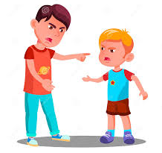 | An active disagreement between people with different opinions or ideas.
appreciation |    | The feeling of being, and showing, you are grateful for something.
boundaries |  | Unofficial rules about what should not be done; limits that define acceptable behaviour.
secrets |  | Something that is kept or meant to be kept unknown or hidden to others.
trust |  | To believe that someone is good and honest and will not harm you, or that something is safe and reliable.

Design Technology – Preparing Fruit and Vegetables
fruit | 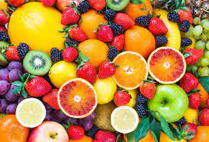 | The sweet and fleshy product of a tree or other plant that contains seed and can be eaten as food.
vegetable | 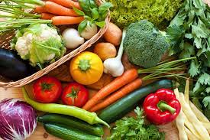 | Vegetables are parts of plants that are consumed by humans or other animals as food.
sugar | 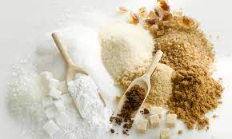 | Sugar is a sweet substance that comes from plants, mostly sugar cane and sugar beets
healthy | 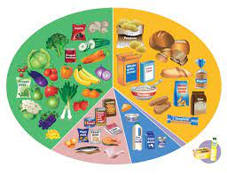 | To be healthy means to not be sick. Generally, a person can maintain a healthy lifestyle by eating a healthy diet and exercising. In order for the body to function properly, it needs nutrients.
ingredient |  | An ingredient is one part of a mixture. For example, if you're making chocolate chip cookies, flour is just one ingredient you'll need
peel | 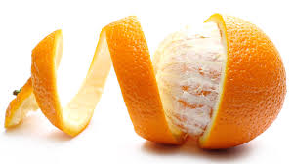 | Remove the outer covering or skin from (a fruit or vegetable).
grate | 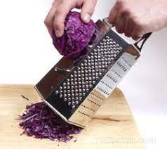 | Reduce (food) to small shreds by rubbing it on a grater.
chop | 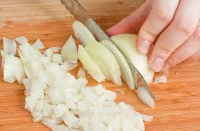 | To cut (something) into pieces with repeated sharp blows of an axe or knife
slice | 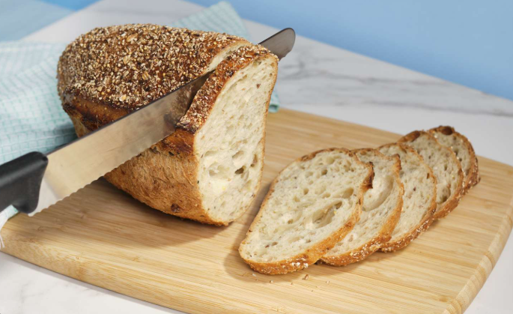 | a thin, broad piece of food, such as bread, meat, or cake, cut from a larger portion.

History – Local History
past |  | Something that happened or was done in the past.
Neanderthals |  | A species of very early human that lived in Europe and parts of Asia from about 300,000 to 30,000 years ago.
Archaeologists |  | Someone who studies the buildings, graves tools and other objects of people who lived in the past.
Abbey |  | Abbeys provide a complex of buildings and land for religious activities, work, and housing of Christian monks and nuns.
Abbess |  | A woman who is the head of an abbey of nuns.
Saint |  | A saint is a person who is believed to be especially close to God.
moat |  | The moat was a deep trench that was dug around the entire castle, outside of the castle walls.
census |  | Census is a count of the people who live in a country.
local |  | A particular place such as a neighbourhood or town.
market |  | A place where goods are sold.

RE – Fasting
fasting |  | Fasting is the abstaining from food or drink, particularly for a religious observance.
Lent | 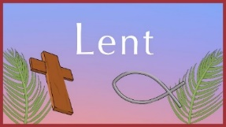 | Lent is a Christian observance which takes place in Spring.
Ramadan |  | Ramadan is the ninth month of the Islamic calendar. It is observed by Muslims worldwide and includes fasting, prayer, reflection and community.
Eid Ul Fitr |  | A religious holiday celebrated by Muslims worldwide that marks the end of Ramadan.
Shrove Tuesday | 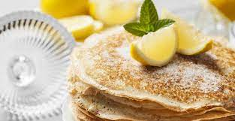 | Shrove Tuesday is a Christian festival celebrated in many countries across the globe. It falls on the Tuesday before the beginning of Lent.
Ash Wednesday |  | Ash Wednesday is a holy day of prayer and fasting in many Western Christian denominations. It is preceded by Shrove Tuesday and marks the first day of Lent.

Science – Plants
bulb | 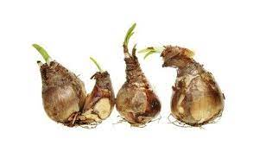 | A bulb is the part of some plants, mostly under the soil, that stores food while the plant is resting from growing.
sunlight |  | Light energy comes from the sun.
water |  | Water is a liquid that plants and animals need to survive.
temperature | 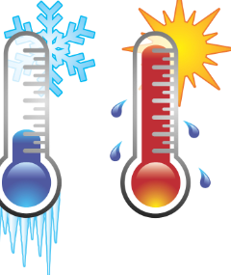 | Temperature is the measure of the warmth or coldness of an object or material.
nutrition | 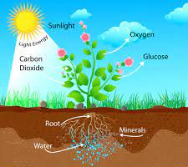 | The study of how to be healthy.
germination | 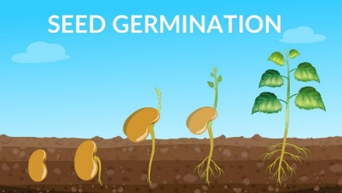 | The growth of a seed into a young plant or seedling.
shoot |  | After the seed germinates, the shoot begins to appear above the soil.
seed dispersal | 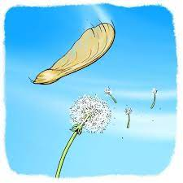 | Seeds are spread or scattered which then enables new plants to grow.

Geography – Life in the City
city |  | A city is a human settlement of a notable size. It can be defined as a permanent and densely settled place with administratively defined boundaries whose members work primarily on non-agricultural tasks.
symbol | 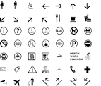 | A symbol is a mark, sign, or a word that indicates, signifies, or it is understood as representing an idea, object, or relationship.
village | 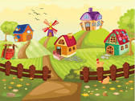 | A village is a clustered human settlement or community, larger than a hamlet but smaller than a town, with a population typically ranging from a few hundred to a few thousand.
Tropic of Cancer | 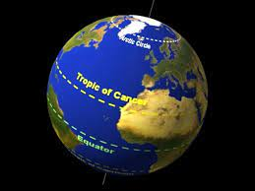 | The Tropic of Cancer, which is also referred to as the Northern Tropic, is the most northerly circle of latitude on Earth at which the Sun can be directly overhead.
key | 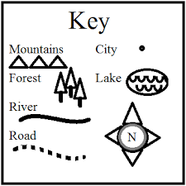 | A key is a list of symbols that appear on the map. For example, a church on the map may appear as a cross, a cross attached to a circle, a cross attached to a square. A church symbol with a square means that the church has a tower, while a circle means the church has a spire.
compass | 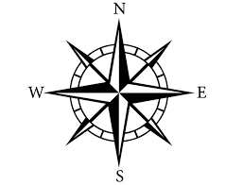 | A compass is a device that shows the cardinal directions used for navigation and geographic orientation. It commonly consists of a magnetized needle or other element, such as a compass card or compass rose, which can pivot to align itself with magnetic north.
town |  | A town is a human settlement. Towns are generally larger than villages and smaller than cities, though the criteria to distinguish between them vary considerably in different parts of the world.
Tropic of Capricorn | 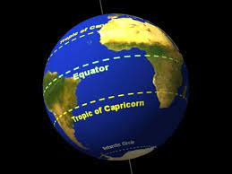 | The Tropic of Capricorn is the circle of latitude that contains the subsolar point at the December solstice.

RE- Creation
Creation |  | The universe or the creatures in it.
Adam | 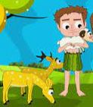 | According to the Old Testament, Adam is the name of the first man who was created by God from dust.
Eve | 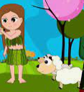 | According to the Old Testament, Eve is the name of the first woman who was created by God from a rib of Adam.
Garden of Eden |  | According to the Old Testament, the garden is where Adam and Eve, the first humans, lived in a state of perfection.
Paradise |  | A state or place of extreme beauty, delight or joy.
Lord Vishnu |  | The second member of the Hindu trinity. Known as ‘The Preserver’ and believed to have been incarnated in Krishna.
Lord Brahma |  | The principle member of the Hindu trinity, considered the creator of the universe.
Soma |  | Hindu God of the moon.

Art- Yayoi Kusuma

artist |  | A person who creates paintings or drawings as a profession or hobby.
vivid |  | Intensely deep or bright.
stippling |  | The art or process of drawing, painting, or engraving using numerous small dots or specks.
style |  | A distinctive appearance, typically determined by the principles according to which something is designed.
evaluate |  | The task of evaluating a work of art, such as a painting or a sculpture, requires a combination of objective information and subjective opinion.
sculpting | 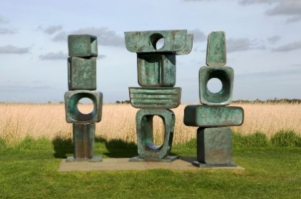 | An artistic form in which hard or plastic materials are worked into three-dimensional art objects.

