**Spelling Journal**

**Rush Green Primary School**



Year 2 – Summer Term

Phonics Teacher: Miss Mc Donagh & Mrs Bligh

Child’s Name: ___________________________­­__

Dear Parents/Carers,

Please work with your child to help them become good spellers.

Use their spelling journal to practise spellings that are set for them each week. Help them learn the spelling rule and apply it and talk about exceptions to each rule. Help your child with the tricky part of words and also discuss how word patterns, endings, etc., can help them remember how to spell certain words. Put each word into a sentence so they can see the word in context. This often makes it easier for a child to remember.

At Rush Green Primary School we have high expectations of learners at all times. Included in this journal is a list of ‘Zero Tolerance’ words that children are expected to spell correctly at all times in their work. Please practise these words with your child regularly too. Spelling rules and patterns have been taught on a weekly basis and are based on what children may be learning in class during phonic lessons, spelling lessons or words they may need to know for a particular topic. There may be additional spellings sent home should the need arise during the term.

The ability to spell confidently enables an individual to become a more effective and fluent writer. Learning to spell should not be just learning lists of words (although this is a necessary first phase in establishing later automatic use) but a means of applying strategies appropriately, and building on known facts. This spelling journal will help support your child in these aims.

Thank you for your continued support.

**Summer 1 Overview**

|  |  |  |  |
| --- | --- | --- | --- |
| Week beginning | Tricky Words | Spelling rule | Spellings |
| Week 1 | great  really | Contractions are shortened forms of words made by putting two words together. Letters are omitted and replaced by an apostrophe. The apostrophe shows where the letters would be if the words were written in full. | would not -> wouldn’t  should not -> shouldn’t  do not -> don’t  cannot -> can’t  could not -> couldn’t |
| Week 2 | where  who  what | Contractions are shortened forms of words made by putting two words together. Letters are omitted and replaced by an apostrophe. The apostrophe shows where the letters would be if the words were written in full. | I will -> I’ll  they will -> they’ll  he will -> he’ll  she will -> she’ll  you have -> you’ve  you are -> you’re |
| Week 3 | fast  poor | Adding the suffix ‘ful’ meaning ‘full of’ to form adjectives. | delightful, colourful, respectful, helpful, wishful, dreadful |
| Week 4 | like  live  give | Adding the suffix ‘ful’ meaning ‘full of’ to form adjectives. | beautiful, dutiful, plentiful, merciful, bountiful |
| Week 5 | wrong  said | Adding the suffix ‘ness’ changes an adjective to a noun. | happiness, loveliness, tidiness, silliness, nastiness, loneliness |

**Summer 2 Overview**

|  |  |  |  |
| --- | --- | --- | --- |
| Week 1 | February  January  August | Adding the suffix ‘ness’ changes an adjective to a noun. | fitness, greatness, kindness, childishness, carefulness, selfishness |
| Week 2 | Mr  Mrs | The /n/ sound spelt kn and (less often) gn at the beginning of words. Silent K and g. | knock, know, knee, gnat, gnaw, gnome |
| Week 3 | goes  does | Homophones are words that have the same pronunciation but different meanings, origins or spelling. | knight, night, there, their, they’re, which, witch |
| Week 4 | have  after | Homophones are words that have the same pronunciation but different meanings, origins or spelling. | hole, whole, sun, son, sea, see |
| Week 5 | found  ground | The suffix ‘ly’ can be used to change adjectives into adverbs. Rule 1  Just add -ly to words ending in a consonant. | slowly, quickly, deeply, gladly, quietly, sadly |
| Week 6 | with  again | The suffix ‘ly’  Rule 2  Add -ly to words ending in -l, Simply add -ly so word will end in ‘lly’ | accidentally, occasionally, generally, helpfully, gratefully, carefully |

Summer 1 Week 1

|  |  |  |  |
| --- | --- | --- | --- |
| **Study the word and practise spelling it out loud.** | | 2.  **Use a piece of paper to cover your word.** | |
| **3.  Write the word you covered.** | | **4.  Check to see if you spell your word correctly.** | |
| **5.** Image result for rules**Learn the rule** | | Image result for apply  **6. Apply the rule (remember that there may be exceptions to this rule)** | |
| Tricky words: great, really | |  | |
|  |  | | |
| Spelling Rules: | Contractions are shortened forms of words made by putting two words together. Letters are omitted and replaced by an apostrophe. The apostrophe shows where the letters would be if the words were written in full. | | |
| Example words | Learn | | Practise |
| 1 | would not -> wouldn’t | |  |
| 2 | should not -> shouldn’t | |  |
| 3 | do not -> don’t | |  |
| 4 | cannot -> can’t | |  |
| 5 | could not -> couldn’t | |  |
| Write 5 of your own words, applying the spelling rule you have learnt.  Remember, you can use a dictionary to help you. | | | |
| 1. | | | |
| 2. | | | |
| 3. | | | |
| 4. | | | |
| 5. | | | |
| Explain the spelling rule in your own words: | | | |
|  | | | |
|  | | | |
|  | | | |
| Include each of your own words in a sentence: | | | |
|  | | | |
|  | | | |
|  | | | |
|  | | | |
|  | | | |
|  | | | |
|  | | | |
|  | | | |
|  | | | |

Summer 1 Week 2

|  |  |  |  |
| --- | --- | --- | --- |
| **Study the word and practise spelling it out loud.** | | 2.  **Use a piece of paper to cover your word.** | |
| **3.  Write the word you covered.** | | **4.  Check to see if you spell your word correctly.** | |
| **5.** Image result for rules**Learn the rule** | | Image result for apply  **6. Apply the rule (remember that there may be exceptions to this rule)** | |
| Tricky words: where, who, what | |  | |
|  |  | | |
| Spelling Rules: | Contractions are shortened forms of words made by putting two words together. Letters are omitted and replaced by an apostrophe. The apostrophe shows where the letters would be if the words were written in full. | | |
| Example words | Learn | | Practise |
| 1 | I will -> I’ll | |  |
| 2 | they will -> they’ll | |  |
| 3 | he will -> he’ll | |  |
| 4 | she will -> she’ll | |  |
| 5 | you have -> you’ve | |  |
| 6 | you are -> you’re | |  |
| Write 6 of your own words, applying the spelling rule you have learnt.  Remember, you can use a dictionary to help you. | | | |
| 1. | | | |
| 2. | | | |
| 3. | | | |
| 4. | | | |
| 5. | | | |
| 6. | | | |
| Explain the spelling rule in your own words: | | | |
|  | | | |
|  | | | |
|  | | | |
|  | | | |
|  | | | |
| Include each of your own words in a sentence: | | | |
|  | | | |
|  | | | |
|  | | | |
|  | | | |
|  | | | |
|  | | | |
|  | | | |
|  | | | |
|  | | | |

Summer 1 Week 3

|  |  |  |  |
| --- | --- | --- | --- |
| **Study the word and practise spelling it out loud.** | | 2.  **Use a piece of paper to cover your word.** | |
| **3.  Write the word you covered.** | | **4.  Check to see if you spell your word correctly.** | |
| **5.** Image result for rules**Learn the rule** | | Image result for apply  **6. Apply the rule (remember that there may be exceptions to this rule)** | |
| Tricky words: fast, poor | |  | |
|  |  | | |
| Spelling Rules: | Adding the suffix ‘ful’ meaning ‘full of’ to form adjectives.  Rule 1  If the root word ends in a vowel + y, then just add the suffix –ful. | | |
| Example words | Learn | | Practise |
| 1 | delightful | |  |
| 2 | colourful | |  |
| 3 | respectful | |  |
| 4 | helpful | |  |
| 5 | wishful | |  |
| 6 | dreadful | |  |
| Write 6 of your own words, applying the spelling rule you have learnt.  Remember, you can use a dictionary to help you. | | | |
| 1. | | | |
| 2. | | | |
| 3. | | | |
| 4. | | | |
| 5. | | | |
| 6. | | | |
| Explain the spelling rule in your own words: | | | |
|  | | | |
|  | | | |
|  | | | |
|  | | | |
|  | | | |
| Include each of your own words in a sentence: | | | |
|  | | | |
|  | | | |
|  | | | |
|  | | | |
|  | | | |
|  | | | |
|  | | | |
|  | | | |
|  | | | |

Summer 1 Week 4

|  |  |  |  |
| --- | --- | --- | --- |
| **Study the word and practise spelling it out loud.** | | 2.  **Use a piece of paper to cover your word.** | |
| **3.  Write the word you covered.** | | **4.  Check to see if you spell your word correctly.** | |
| **5.** Image result for rules**Learn the rule** | | Image result for apply  **6. Apply the rule (remember that there may be exceptions to this rule)** | |
| Tricky words: like, live, give | |  | |
|  |  | | |
| Spelling Rules: | Adding the suffix ‘ful’ meaning ‘full of’ to form adjectives.  Rule 2  If the root word ends in a consonant + y, then change the ‘y’ to an ‘i’ before adding the suffix –ful. | | |
| Example words | Learn | | Practise |
| 1 | beautiful | |  |
| 2 | dutiful | |  |
| 3 | plentiful | |  |
| 4 | merciful | |  |
| 5 | bountiful | |  |
| 6 |  | |  |
| Write 6 of your own words, applying the spelling rule you have learnt.  Remember, you can use a dictionary to help you. | | | |
| 1. | | | |
| 2. | | | |
| 3. | | | |
| 4. | | | |
| 5. | | | |
| 6. | | | |
| Explain the spelling rule in your own words: | | | |
|  | | | |
|  | | | |
|  | | | |
|  | | | |
|  | | | |
| Include each of your own words in a sentence: | | | |
|  | | | |
|  | | | |
|  | | | |
|  | | | |
|  | | | |
|  | | | |
|  | | | |
|  | | | |
|  | | | |

Summer 1 Week 5

|  |  |  |  |
| --- | --- | --- | --- |
| **Study the word and practise spelling it out loud.** | | 2.  **Use a piece of paper to cover your word.** | |
| **3.  Write the word you covered.** | | **4.  Check to see if you spell your word correctly.** | |
| **5.** Image result for rules**Learn the rule** | | Image result for apply  **6. Apply the rule (remember that there may be exceptions to this rule)** | |
| Tricky words: wrong, said | |  | |
|  |  | | |
| Spelling Rules: | Adding the suffix ‘ness’ changes an adjective to a noun.  Rule 1  If the root words ends with a ‘y’ then drop the ‘y’ for an ‘i’ and add ‘ness’. | | |
| Example words | Learn | | Practise |
| 1 | happiness | |  |
| 2 | loveliness | |  |
| 3 | tidiness | |  |
| 4 | silliness | |  |
| 5 | nastiness | |  |
| 6 | loneliness | |  |
| Write 6 of your own words, applying the spelling rule you have learnt.  Remember, you can use a dictionary to help you. | | | |
| 1. | | | |
| 2. | | | |
| 3. | | | |
| 4. | | | |
| 5. | | | |
| 6. | | | |
| Explain the spelling rule in your own words: | | | |
|  | | | |
|  | | | |
|  | | | |
|  | | | |
|  | | | |
| Include each of your own words in a sentence: | | | |
|  | | | |
|  | | | |
|  | | | |
|  | | | |
|  | | | |
|  | | | |
|  | | | |
|  | | | |
|  | | | |

Summer 2 Week 1

|  |  |  |  |
| --- | --- | --- | --- |
| **Study the word and practise spelling it out loud.** | | 2.  **Use a piece of paper to cover your word.** | |
| **3.  Write the word you covered.** | | **4.  Check to see if you spell your word correctly.** | |
| **5.** Image result for rules**Learn the rule** | | Image result for apply  **6. Apply the rule (remember that there may be exceptions to this rule)** | |
| Tricky words: February, January, August | |  | |
|  |  | | |
| Spelling Rules: | Adding the suffix ‘ness’ changes an adjective to a noun.  Rule 2  If the root words ends with a consonant then just add ‘ness’. | | |
| Example words | Learn | | Practise |
| 1 | fitness | |  |
| 2 | greatness | |  |
| 3 | kindness | |  |
| 4 | childishness | |  |
| 5 | carefulness | |  |
| 6 | selfishness | |  |
| Write 6 of your own words, applying the spelling rule you have learnt.  Remember, you can use a dictionary to help you. | | | |
| 1. | | | |
| 2. | | | |
| 3. | | | |
| 4. | | | |
| 5. | | | |
| 6. | | | |
| Explain the spelling rule in your own words: | | | |
|  | | | |
|  | | | |
|  | | | |
|  | | | |
|  | | | |
| Include each of your own words in a sentence: | | | |
|  | | | |
|  | | | |
|  | | | |
|  | | | |
|  | | | |
|  | | | |
|  | | | |
|  | | | |
|  | | | |

Summer 2 Week 2

|  |  |  |  |
| --- | --- | --- | --- |
| **Study the word and practise spelling it out loud.** | | 2.  **Use a piece of paper to cover your word.** | |
| **3.  Write the word you covered.** | | **4.  Check to see if you spell your word correctly.** | |
| **5.** Image result for rules**Learn the rule** | | Image result for apply  **6. Apply the rule (remember that there may be exceptions to this rule)** | |
| Tricky words: Mr, Mrs | |  | |
|  |  | | |
| Spelling Rules: | The /n/ sound spelt kn and (less often) gn at the beginning of words | | |
| Example words | Learn | | Practise |
| 1 | knock | |  |
| 2 | know | |  |
| 3 | knee | |  |
| 4 | gnat | |  |
| 5 | gnaw | |  |
| 6 | gnome | |  |
| Write 3 of your own words, applying the spelling rule you have learnt.  Remember, you can use a dictionary to help you. | | | |
| 1. | | | |
| 2. | | | |
| 3. | | | |
| Explain the spelling rule in your own words: | | | |
|  | | | |
|  | | | |
|  | | | |
|  | | | |
|  | | | |
| Include each of the words in a sentence: | | | |
|  | | | |
|  | | | |
|  | | | |
|  | | | |
|  | | | |
|  | | | |
|  | | | |
|  | | | |
|  | | | |

Summer 2 Week 3

|  |  |  |  |
| --- | --- | --- | --- |
| **Study the word and practise spelling it out loud.** | | 2.  **Use a piece of paper to cover your word.** | |
| **3.  Write the word you covered.** | | **4.  Check to see if you spell your word correctly.** | |
| **5.** Image result for rules**Learn the rule** | | Image result for apply  **6. Apply the rule (remember that there may be exceptions to this rule)** | |
| Tricky words: goes, does | |  | |
|  |  | | |
| Spelling Rules: | Homophones are words that have the same pronunciation but different meanings, origins or spelling. | | |
| Example words | Learn | | Practise |
| 1 | knight | |  |
| 2 | night | |  |
| 3 | there | |  |
| 4 | their | |  |
| 5 | they’re | |  |
| 6 | which | |  |
| 7 | witch | |  |
| Write 3 of your own words, applying the spelling rule you have learnt.  Remember, you can use a dictionary to help you. | | | |
| 1. | | | |
| 2. | | | |
| 3. | | | |
| Explain the spelling rule in your own words: | | | |
|  | | | |
|  | | | |
|  | | | |
| Include each word in a sentence: | | | |
|  | | | |
|  | | | |
|  | | | |
|  | | | |
|  | | | |
|  | | | |
|  | | | |
|  | | | |
|  | | | |

Summer 2 Week 4

|  |  |  |  |
| --- | --- | --- | --- |
| **Study the word and practise spelling it out loud.** | | 2.  **Use a piece of paper to cover your word.** | |
| **3.  Write the word you covered.** | | **4.  Check to see if you spell your word correctly.** | |
| **5.** Image result for rules**Learn the rule** | | Image result for apply  **6. Apply the rule (remember that there may be exceptions to this rule)** | |
| Tricky words: have, after | |  | |
|  |  | | |
| Spelling Rules: | Homophones are words that have the same pronunciation but different meanings, origins or spelling. | | |
| Example words | Learn | | Practise |
| 1 | hole | |  |
| 2 | whole | |  |
| 3 | sun | |  |
| 4 | son | |  |
| 5 | sea | |  |
| 6 | see | |  |
| Write 4 of your own words, applying the spelling rule you have learnt.  Remember, you can use a dictionary to help you. | | | |
| 1. | | | |
| 2. | | | |
| 3. | | | |
| 4. | | | |
| Explain the spelling rule in your own words: | | | |
|  | | | |
|  | | | |
|  | | | |
|  | | | |
|  | | | |
| Include each word in a sentence: | | | |
|  | | | |
|  | | | |
|  | | | |
|  | | | |
|  | | | |
|  | | | |
|  | | | |
|  | | | |
|  | | | |

Summer 2 Week 5

|  |  |  |  |
| --- | --- | --- | --- |
| **Study the word and practise spelling it out loud.** | | 2.  **Use a piece of paper to cover your word.** | |
| **3.  Write the word you covered.** | | **4.  Check to see if you spell your word correctly.** | |
| **5.** Image result for rules**Learn the rule** | | Image result for apply  **6. Apply the rule (remember that there may be exceptions to this rule)** | |
| Tricky words: found, ground | |  | |
|  |  | | |
| Spelling Rules: | The suffix ‘ly’ can be used to change adjectives into adverbs  **Rule 1**  Just add -ly to words ending in a consonant. | | |
| E.g. | slow + ly 🡪 slowly  quick + ly 🡪 quickly | | |
| Example words | Learn | | Practise |
| 1 | slowly | |  |
| 2 | quickly | |  |
| 3 | deeply | |  |
| 4 | gladly | |  |
| 5 | quietly | |  |
| 6 | sadly | |  |
| Write 6 of your own words, applying the spelling rule you have learnt.  Remember, you can use a dictionary to help you. | | | |
| 1. | | | |
| 2. | | | |
| 3. | | | |
| 4. | | | |
| 5. | | | |
| 6. | | | |
| Explain the spelling rule in your own words: | | | |
|  | | | |
|  | | | |
|  | | | |
|  | | | |
|  | | | |
| Correct these spellings | | | |
| slowle | | | |
| quicklee | | | |
| sadle | | | |
| Include each of your words in a sentence: | | | |
|  | | | |
|  | | | |
|  | | | |
|  | | | |
|  | | | |
|  | | | |
|  | | | |
|  | | | |
|  | | | |

Summer 2 Week 6

|  |  |  |  |
| --- | --- | --- | --- |
| **Study the word and practise spelling it out loud.** | | 2.  **Use a piece of paper to cover your word.** | |
| **3.  Write the word you covered.** | | **4.  Check to see if you spell your word correctly.** | |
| **5.** Image result for rules**Learn the rule** | | Image result for apply  **6. Apply the rule (remember that there may be exceptions to this rule)** | |
| Tricky words: with, again | |  | |
|  |  | | |
| Spelling Rules: | The suffix ‘ly’ can be used to change adjectives into adverbs  **Rule 2**  Add -ly to words ending in -l, Simply add -ly so word will end in ‘lly’ | | |
| e.g. | accidental + ly = accidentally | | |
| Example words | Learn | | Practise |
| 1 | accidentally | |  |
| 2 | occasionally | |  |
| 3 | generally | |  |
| 4 | helpfully | |  |
| 5 | gratefully | |  |
| 6 | carefully | |  |
| Write 6 of your own words, applying the spelling rule you have learnt.  Remember, you can use a dictionary to help you. | | | |
| 1. | | | |
| 2. | | | |
| 3. | | | |
| 4. | | | |
| 5. | | | |
| 6. | | | |
| Explain the spelling rule in your own words: | | | |
|  | | | |
|  | | | |
|  | | | |
|  | | | |
|  | | | |
| Include each the spelling words in a sentence: | | | |
|  | | | |
|  | | | |
|  | | | |
|  | | | |
|  | | | |
|  | | | |
|  | | | |
|  | | | |
|  | | | |

**Summer 1 Week 1**

**SPELLING TEST**

|  |  |
| --- | --- |
|  |  |
|  |  |
|  |  |
|  |  |
|  |  |
|  |  |

**Summer 1 Week 2**

**SPELLING TEST**

|  |  |
| --- | --- |
|  |  |
|  |  |
|  |  |
|  |  |
|  |  |
|  |  |

**Summer 1 Week 3**

**SPELLING TEST**

|  |  |
| --- | --- |
|  |  |
|  |  |
|  |  |
|  |  |
|  |  |
|  |  |

**Summer 1 Week 4**

**SPELLING TEST**

|  |  |
| --- | --- |
|  |  |
|  |  |
|  |  |
|  |  |
|  |  |
|  |  |

**Summer 1 Week 5**

**SPELLING TEST**

|  |  |
| --- | --- |
|  |  |
|  |  |
|  |  |
|  |  |
|  |  |
|  |  |

**Summer 2 Week 1**

**SPELLING TEST**

|  |  |
| --- | --- |
|  |  |
|  |  |
|  |  |
|  |  |
|  |  |
|  |  |

**Summer 2 Week 2**

**SPELLING TEST**

|  |  |
| --- | --- |
|  |  |
|  |  |
|  |  |
|  |  |
|  |  |
|  |  |

**Summer 2 Week 3**

**SPELLING TEST**

|  |  |
| --- | --- |
|  |  |
|  |  |
|  |  |
|  |  |
|  |  |
|  |  |

**Summer 2 Week 4**

**SPELLING TEST**

|  |  |
| --- | --- |
|  |  |
|  |  |
|  |  |
|  |  |
|  |  |
|  |  |

**Summer 2 Week 5**

**SPELLING TEST**

|  |  |
| --- | --- |
|  |  |
|  |  |
|  |  |
|  |  |
|  |  |
|  |  |

**Summer 2 Week 6**

**SPELLING TEST**

|  |  |
| --- | --- |
|  |  |
|  |  |
|  |  |
|  |  |
|  |  |
|  |  |

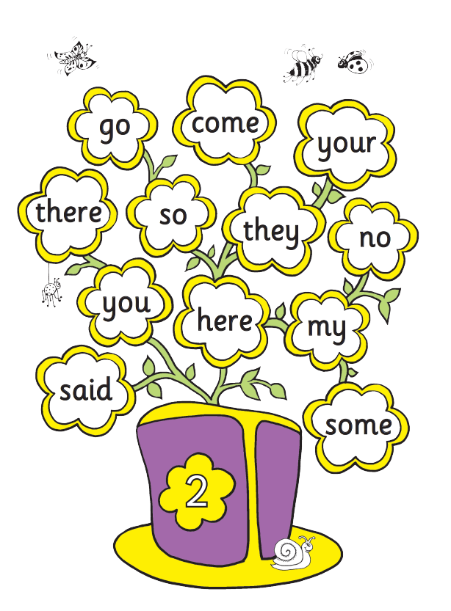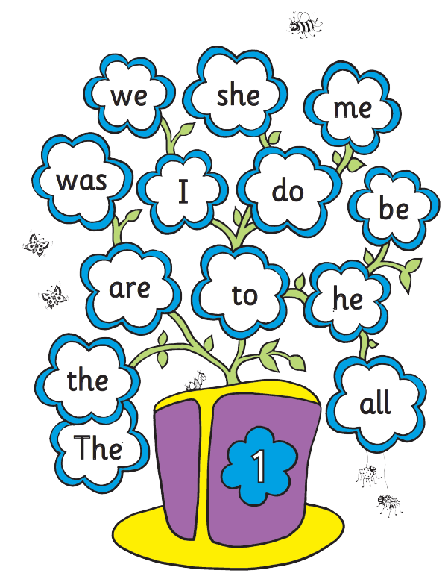

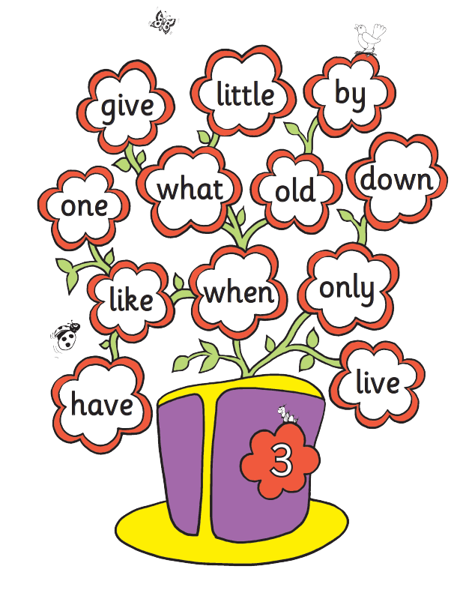

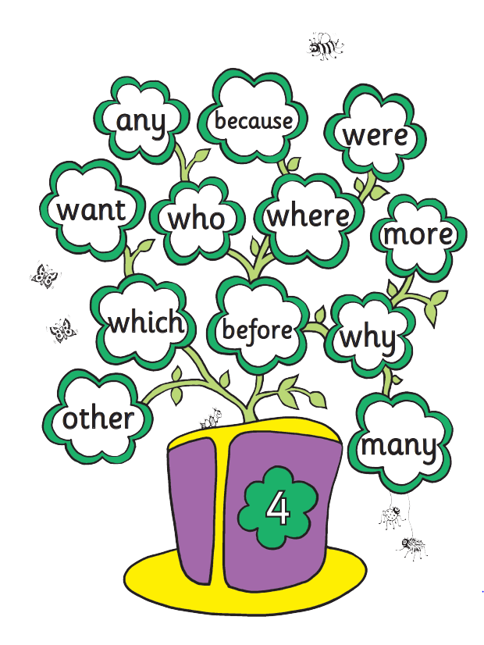

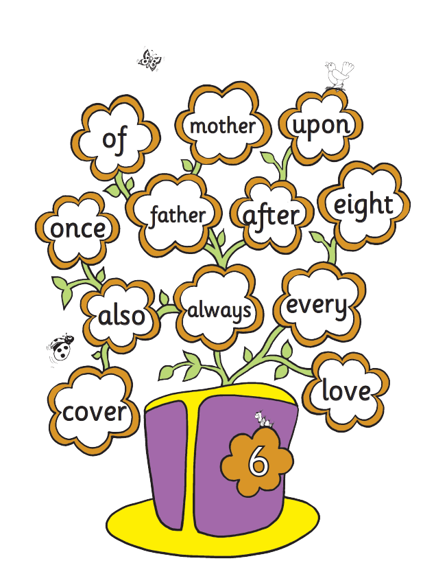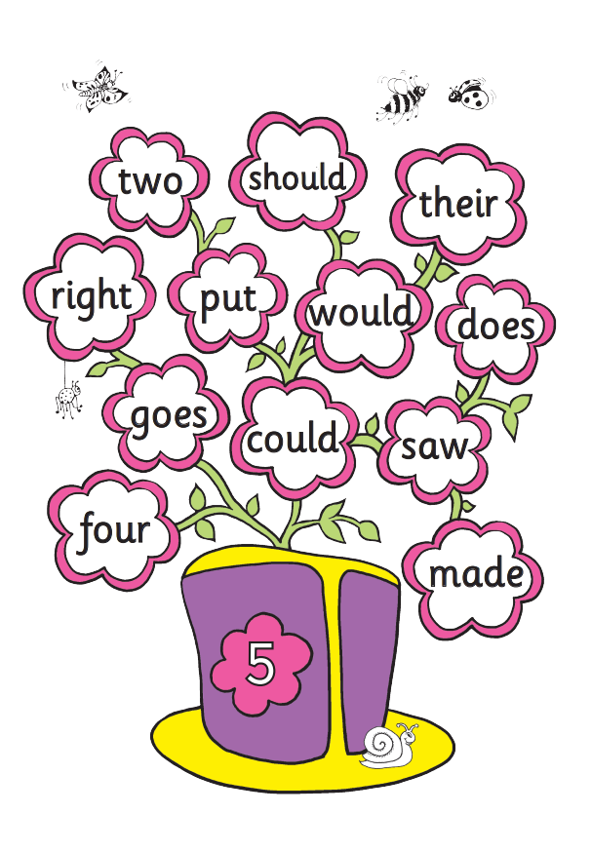

**Zero Tolerance Words: Year 1**

**Your child must know how to spell the following words**

|  |
| --- |
| all |
| come |
| you |
| want |
| what |
| they |
| are |
| out |
| here |
| once |
| some |
| there |
| asked |
| when |
| little |

**Zero Tolerance Words: Year 2**

**Your child must know how to spell the following words**

|  |
| --- |
| very |
| about |
| after |
| because |
| should |
| great |
| really |
| could |
| where |
| called |
| people |
| fast |
| poor |
| every |
| any |