Rush Green Primary School
First Aid Policy

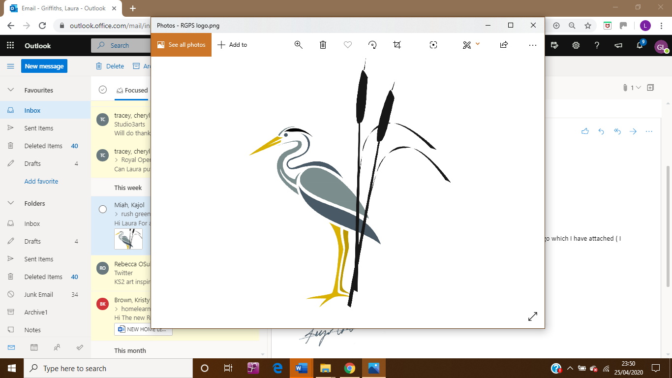
Rush Green Primary

Date: 04/26
Review: 09/29

First Aid Policy

Contents

1. Aims .................................................................................................................................. 3
2. Roles and responsibilities ..................................................................................................3
5. First aid procedures including dental injuries……..............................................................4
6. First aid equipment ............................................................................................................6
7-8. Record-keeping and reporting.........................................................................................8
10. Training.............................................................................................................................7
11. Monitoring arrangements .................................................................................................7
12. Links with other policies ...................................................................................................7

Appendix 1: list of [appointed persons(s) for first aid and/or trained first aiders]

1. Aims

The aims of our first aid policy are to:

Ensure the health and safety of all staff, pupils and visitors

Ensure that staff and governors are aware of their responsibilities with regards to health and
safety

Provide a framework for responding to an incident and recording and reporting the outcomes

2. Roles and responsibilities

2.1 Appointed person(s) and first aiders

The school’s appointed first aiders Mrs Christine Strizovic and Miss Lisa Fellowes are responsible for:

Taking charge (as appropriate) when someone is injured or becomes ill

Ensuring there is an adequate supply of medical materials in first aid kits, and replenishing the contents of these kits

Ensuring that an ambulance or other professional medical help is summoned when appropriate

First aiders are trained and qualified to carry out the role and are responsible for:

- Acting as first responders to any incidents; they will assess the situation where there is an injured or ill person, and provide immediate and appropriate treatment

- Sending pupils home to recover, where necessary

- Reporting first aid incidents on the same day after an incident

- Keeping their contact details up to date

Our school’s first aiders are listed in appendix 1. Their names will also be displayed prominently around the school.

3. The headteacher

The Headteacher is responsible for the implementation of this policy, including:

- Ensuring that an appropriate number of first aid personnel are present in the school at all times

- Ensuring that first aiders have an appropriate qualification, keep training up to date and remain competent to perform their role

- Ensuring all staff are aware of first aid procedures

- Ensuring appropriate risk assessments are completed and appropriate measures are put in place

- Undertaking, or ensuring that managers undertake, risk assessments, as appropriate, and that appropriate measures are put in place

- Ensuring that adequate space is available for catering to the medical needs of pupils

- Reporting specified incidents to the HSE when necessary

4. Staff

School staff are responsible for:

- Ensuring they follow first aid procedures

- Ensuring they know who the first aiders in school are

- Completing Medical Tracker reports for all incidents

- Informing the headteacher, Mrs Strizovic or Mrs Fellowes of any specific health conditions or first aid needs

5. First aid procedures

5.1 In-school procedures

In the event of an accident resulting in injury:

- The closest member of staff present will assess the seriousness of the injury and seek the assistance of a qualified first aider, if appropriate, who will provide the required first aid treatment

- The first aider, if called, will assess the injury and decide if further assistance is needed from a colleague or the emergency services. They will remain on the scene until help arrives

- The first aider will also decide whether the injured person should be moved or placed in a recovery position

- If the first aider judges that a pupil is too unwell to remain in school, parents will be contacted and asked to collect their child. Upon their arrival, the first aider will recommend next steps to the parents

- If emergency services are called, Mrs Strizovic or Miss Fellowes will contact parents immediately

- The first aider will complete a Medical Tracker report form on the same day after an incident resulting in an injury

- There will be at least 1 person who has a current paediatric first aid (PFA) certificate on the premises at all times.

The school has a Nursery, Reception, KS1 and KS2 First Aid station filled with medical supplies to complete minor first aid.

5.2 Off-site procedures

When taking pupils off the school premises, staff will ensure they always have the following:

- A mobile phone to access contact numbers on the risk assessment or call 999 in an emergency

- A portable first aid kit including assorted adhesive dressings, cold packs, sterile wipes, eye wash, disposable gloves, foil blanket, triangular bandage, pen, scissors, sick bag at minimum:

- Information about the specific medical needs of pupils (Healthcare Plans including Asthma)

- Parents’ contact details

Risk assessments will be completed by the Trip Organiser prior to any educational visit that
necessitates taking pupils off school premises.

There will always be at least 1 paediatric first aider with a first aid certificate on school trips and visits, as required by the statutory framework for the Early Years Foundation Stage.

5.3 Notes for the care of children with a dental injury. Onsite and Offsite.

A full injury report must be completed on Medical Tracker, by the member of staff supervising the child at the time the injury occurred. Head teacher to also be informed and a report to the local authority must be completed. Any conversations with the parents or dental professionals must be documented on Medical Tracker, including all details discussed.

It is important to immediately look for and save the tooth and/or any fragments.

Broken, Chipped or knocked out tooth, after a blow to the face

- If the tooth is chipped, parents should make a dental appointment to have it checked by a dentist. Dentist to be contacted on the day of the tooth being chipped or broken.
- If the tooth has been knocked out, or is badly broken, the child will need to see a dentist immediately (within an hour).

Action to be taken with knocked out tooth that you still have

The earlier a knocked-out tooth is re implanted, the more likely it is to embed itself back into the gum. The child should ideally be seen by a dentist within one hour of a tooth being knocked out.

- Handle the tooth by the white part at the top (the crown) and avoid touching the root.
- Do not scrape or brush the tooth
- If the tooth is dirty, rinse it with milk or a saline solution and try to put the tooth back into its socket in the mouth as soon as possible. Do not rinse the tooth with water.
- If you cannot re- implant the tooth, the tooth should be held in between the cheek and gum until a dentist is seen or store the tooth in a clean container and cover it with milk or a small amount of child saliva.
- If the tooth is broken/chipped, then retrieve the fragment immediately (if it can be found). Keep the broken piece of tooth clean and store it in a container with milk or saliva. Do not let it dry out.

The above advice only applies to adult teeth. Children’s milk teeth should not be re- implanted as an adult tooth will soon grow in its place. If it has already been re-implanted, the dentist will check that the tooth is in place correctly.

6. First aid equipment

A typical first aid kit in our school will include the following:

A leaflet giving general advice on first aid
Individually wrapped sterile adhesive dressings (assorted sizes)
Individually wrapped triangular bandages (preferably sterile)
Individually wrapped sterile unmedicated wound dressings (assorted sizes)
Pairs of disposable gloves
Scissors

No medication is kept in first aid kits.

First aid kits are stored in:

- The medical room
- The KS1 school hall (breakfast and after school club)
- Nursery, Reception, KS1 and KS2 first aid stations

Emergency grab bags are located at the KS1 and KS2 first aid stations. There is an additional emergency grab bag in the school office.

7. Record-keeping and reporting

7.1 The school uses Medical Tracker to record, track and manage the health of students and staff. In the rare occasion where Medical Tracker is unavailable, first aid books will be used to record first aid incidents.

An incident form on Medical Tracker will be completed by the first aider on the same day as the incident.
As much detail as possible should be supplied when reporting an accident.

8. Reporting to the Local Authority

The Headteacher will keep a record of any accident which results in a reportable injury, disease, or dangerous occurrence as defined in the RIDDOR 2013 legislation (regulations 4, 5, 6 and 7).

Reportable injuries, diseases or dangerous occurrences include:

- Death
- Specified injuries, which are:
- Fractures, other than to fingers, thumbs and toes
- Amputations
- Any injury likely to lead to permanent loss of sight or reduction in sight
- Any crush injury to the head or torso causing damage to the brain or internal organs
- Serious burns (including scalding)
- Any scalding requiring hospital treatment
- Any loss of consciousness caused by head injury or asphyxia
- Any other injury arising from working in an enclosed space which leads to hypothermia or heat-induced illness, or requires resuscitation or admittance to hospital for more than 24 hours
- Injuries where an employee is away from work or unable to perform their normal work duties for more than 7 consecutive days (not including the day of the incident)
- Where an accident leads to someone being taken to hospital
- Near-miss events that do not result in an injury, but could have done. Examples of near-miss events relevant to schools include, but are not limited to:

• The collapse or failure of load-bearing parts of lifts and lifting equipment
• The accidental release of a biological agent likely to cause severe human illness
• The accidental release or escape of any substance that may cause a serious injury or
damage to health
• An electrical short circuit or overload causing a fire or explosion

9. Notifying parents
The school, via Medical Tracker, will inform parents of any accident or injury sustained by a pupil, and any first aid treatment given, on the same day.

10. Training
All first aiders must have completed a training course, and must hold a valid certificate of
competence to show this. The school will keep a register of all trained first aiders, what training they have received and when this is valid until (see appendix 1).

The school will arrange for first aiders to retrain before their first aid certificates expire. In cases where a certificate expires, the school will arrange for staff to retake the full first aid course before being reinstated as a first aider.

The First Aid at Work and Paediatric First Aid certificate will be renewed every 3 years.

11. Monitoring arrangements

This policy will be reviewed by the school every four years.

12. Links with other policies
This first aid policy is linked to the:
Health and safety policy
Medication Policy (including Asthma Policy)

Signed: Headteacher
Date: December 2023

Appendix 1

STAFF WITH FIRST AID CERTIFICATES

FIRST AID TRAINED STAFF – February 2026
TEACHERS
Danielle Egan 15/01/2029 (2 Day Paediatric)
Nicola Coggin 15/01/2029 (2 Day Paediatric)
Laura Griffiths 15/01/2029 (2 Day Paediatric)
Georgia Tamasa- 11/07/2028 (Paediatric)
Tredgett
Cheryl Tracey 16/10/2028 (2 Day Paediatric)
Minhaj Begum Ullah 16/10/2028 (2 Day Paediatric)

TA's
Tamay Brown 17/09/2027 (Paediatric)
Anne Barlow Harris 13/02/2027
Lisa Clark 27/09/2026
Julia Dow 27/09/2026
Sonya Edgar 13/02/2027
Shpresa Gjoni 13/02/2027
Melanie Gotobed 13/02/2027
Jacquie Colton 27/09/2026
Joanne Jarvis 13/02/2027
Angela Ketchell 16/07/2027
Ackelia McKen 15/01/2029 (Paediatric)
Sandra Mottram 16/07/2027
Tina Treble 13/02/2027
Syeda Begum 11/07/2028 (Paediatric)
Kirsty Otto 27/09/2026
Katy Moore 17/09/2027 (Paediatric)
Charlie Retter 17/09/2027 (Paediatric)
Abi George 15/01/2029 (Paediatric)
Jessica Hewitt 13/02/2027
Terri West 27/09/2026
Toni Hazell 27/09/2026
Deborah Taylor 17/09/2027 (Paediatric)
Siobhan Hayes 16/07/2027
Tanjima Khandaker 16/07/2027
Cristina Sava 16/07/2027
Maria Bucovanu 16/07/2027
Kirsty Taylor 13/02/2027
Jamie Sansom 16/07/2027
Sifa Begum 17/09/2027 (Paediatric)
Amanda Perkins 17/09/2027 (Paediatric)
Melanie Derrick 17/09/2027 (Paediatric)
Sophie Rebeiro 16/10/2028 (Paediatric)

PASTORAL TEAM
Christine Strizovic 17/09/2027 (Paediatric)
Kim Brooks (PSA) 11/07/2028 (Paediatric)

MDA's
Julie Chambers 15/11/2027 (Paediatric)
Lesley D'Arcy 13/02/2027
Joanne Swain 17/09/2027 (Paediatric)
Denise Rigu 16/07/2027
Nazma Begum 11/07/2028 (Paediatric)
Hosai Shojaei 11/07/2028 (Paediatric)
Joanne Nicholl 15/01/2029 (Paediatic)

OFFICE STAFF
Claire Hosier 16/07/2027
Stacey Seabrook 13/02/2027
Lisa Fellowes 17/09/2027 (Paediatric)
Nikkie Cameron 15/11/2027 (Paediatric)
Lauren Brown 17/09/2027 (Paediatric)

BREAKFAST/ASC
Georgina Mansfield 15/11/2027 (Paediatric)
Louise Day 15/11/2027 (Paediatric)
SITE TEAM
Daren Colton 15/01/2029 (Paediatric)
Barry Jackson 13/02/2027
Colin Philpot 16/07/2027

